Contents

FHRP 1

TCP/UDP 10

IPv6 Addressing 17

IPv6 (Part 1) 17

IPv6 (Part 2) 21

Access Control Lists (ACLs) 38

Standard ACL 38

Extended ACLs 45

Layer 2 Discovery Protocols (CDP & LLDP) 54

Network Time Protocol (NTP) 63

Domain Name System (DNS) 73

Dynamic Host Configuration Protocol (DHCP) 80

Simple Network Management Protocol (SNMP) 90

# FHRP

Things covered

* The purpose of FHRPs
* HSRP (Hot Standby Router Protocol)
* VRRP (Virtual Router Redundancy Protocol)
* GLBP (Gateway Load Balancing Protocol)
* HSRP config

**Purpose of FHRP**

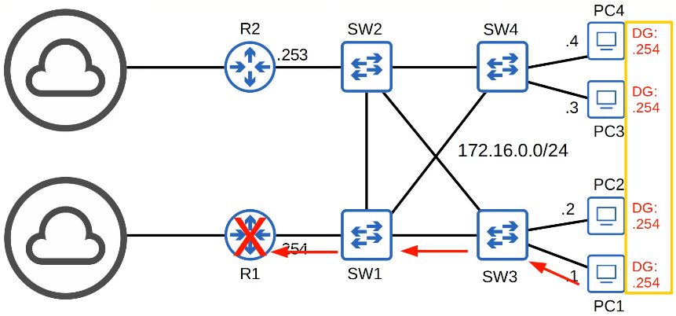

* Problem: Although there is an alternate route to the internet, default gateway of the PCs is to R1
* FHRP is designed to protect the default gateway used on a subnetwork by allowing 2 or more routers to provide backup for that address; in the event of a failure of an active router, the backup router will take over the address, usually within a few seconds

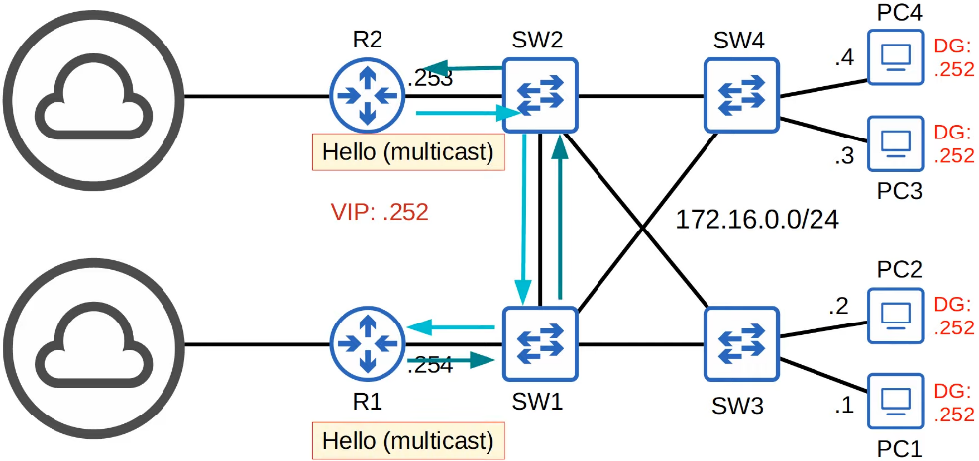

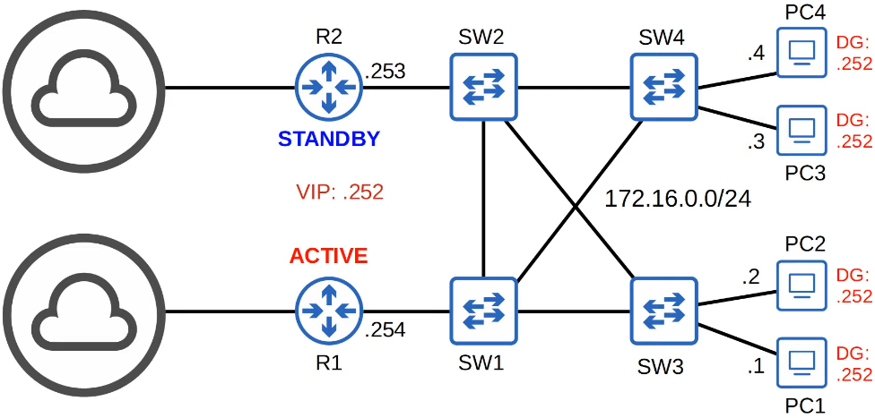

* The routers negotiate the roles by sending multicast messages to each other

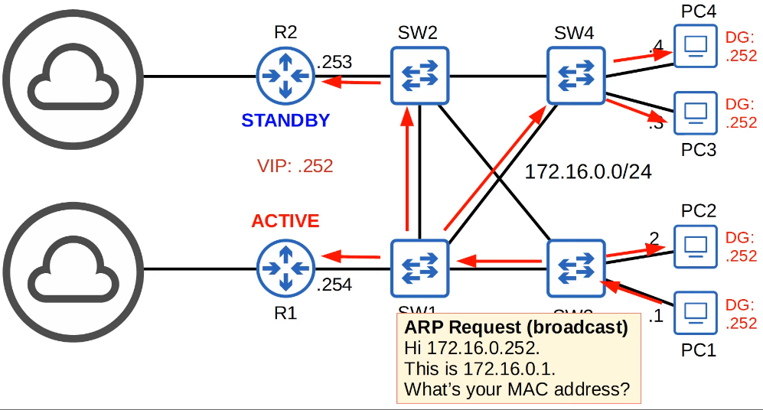

* PC1 wants to send traffic to a destination in another network, needs to send ARP request to get the MAC address of the default gateway (.252)

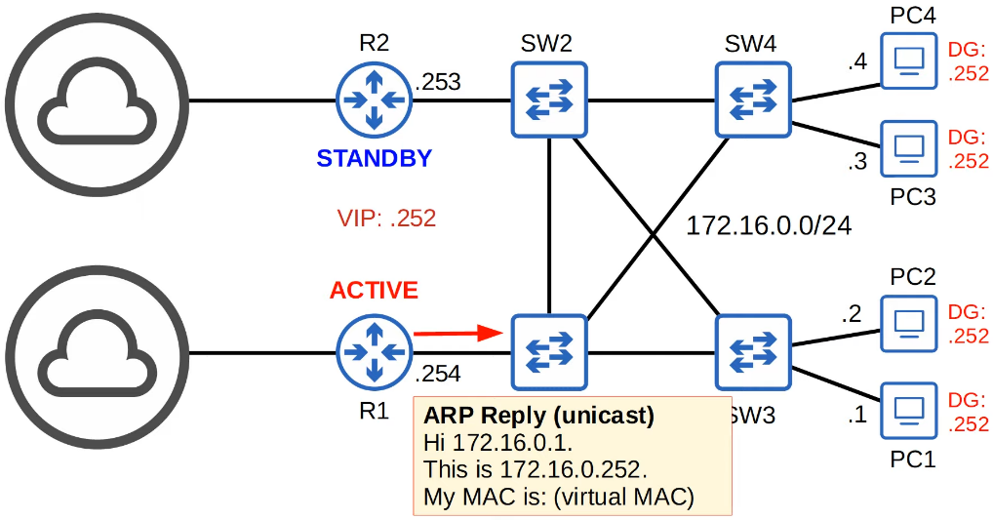

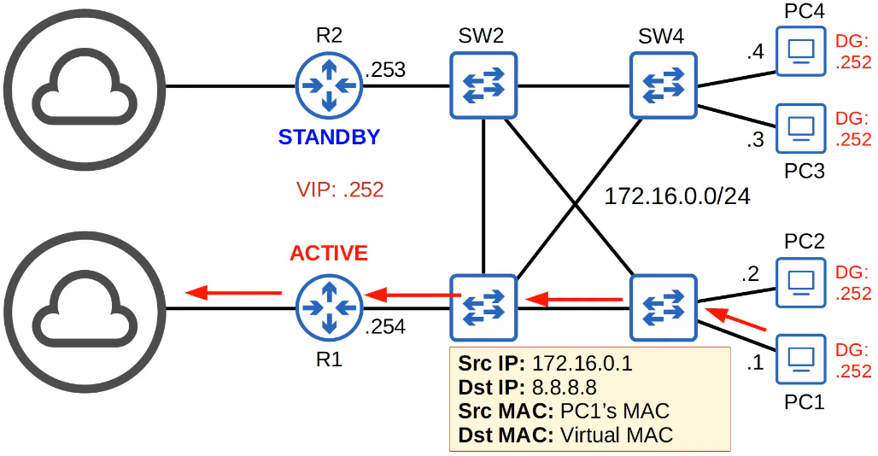

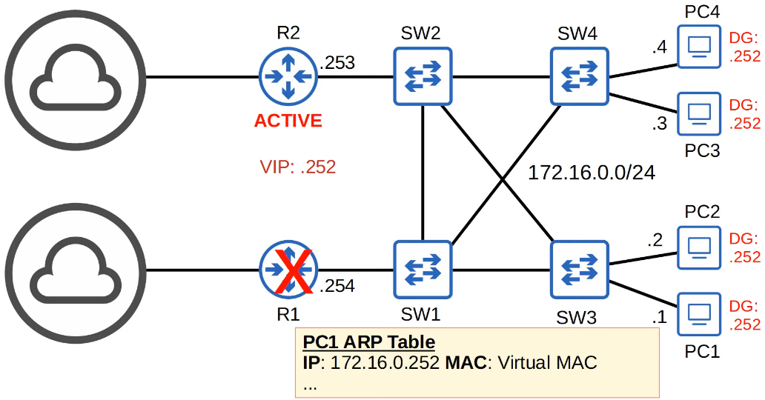

* When R1 fails, no need to change anything for the PC
  + Their ARP table maps the virtual IP to the virtual MAC
* R2 will realise that it is not receiving Hello messages from R1 and assumes that it is down, R2 will then become the active router
* Need to change the switches MAC address table
* R2 will send a gratuitous ARP
  + ARP replies that are sent without receiving an ARP request
  + Frames are broadcast to FFFF.FFFF.FFFF (instead of unicast)

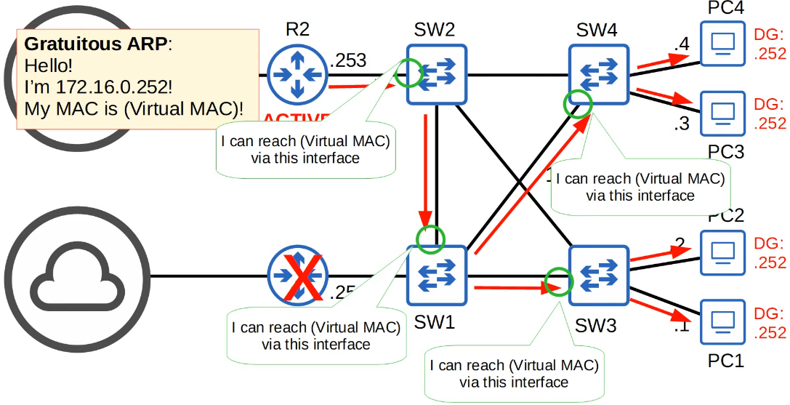

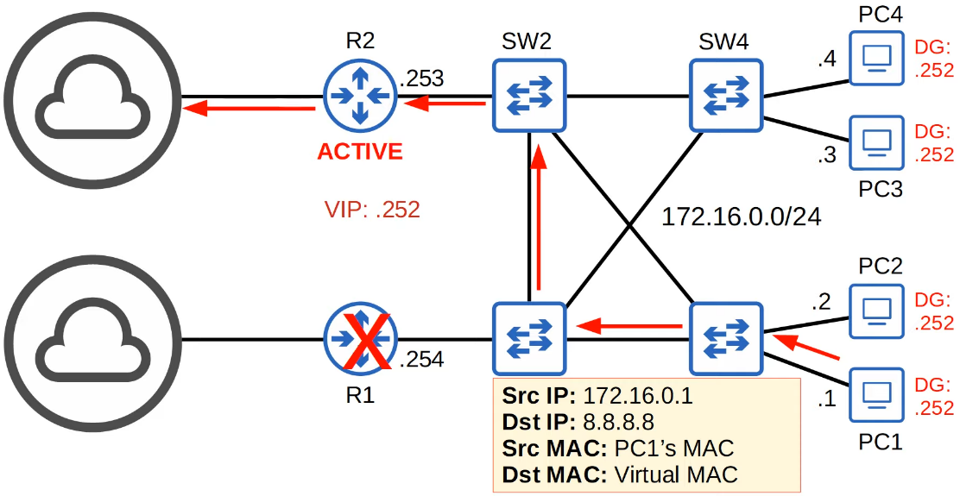

* If R1 comes back online, it will become standby
* FHRPs are pre-emptive
  + Current active routers will not auto give up its role, even if the former active router returns
* However, can change this setting

**Overview**

* A virtual IP is configured on the two routers, and a virtual MAC is generated for the virtual IP (each FHRP uses a different format for the virtual MAC)
* An active router and a standby router are elected. (different FHRPs use different terms)
* End hosts in the network are configured to use the virtual IP as their default gateway.
* The active router replies to ARP requests using the virtual MAC address, so traffic destined for other networks will be sent to it.
* If the active router fails, the standby becomes the next active router.

The new active router will send gratuitous ARP messages so that switches will update their MAC address tables. It now functions as the default gateway.

* If the old active router comes back online, by default it won't take back its role as the active router. It will become the standby router.
* You can configure 'preemption', so that the old active router does take back its old role.

**HSRP (Hot Standby Router Protocol)**

* Cisco proprietary
* Standby and Active router are selected
* 2 versions
  + Version 1
  + Version 2: support IPv6 and more groups can be configured
* Multicast IPv4
  + V1: 224.0.0.2
  + V2: 224.0.0.102
* Virtual MAC address
  + V1: 0000.0c07.ac**xx**
  + V2: 0000.0c9f.f**xxx**
  + 'x': HSRP group number
* In a situation with multiple subnets/VLANs, can configure a different active router in each subnet/VLAN to load balance

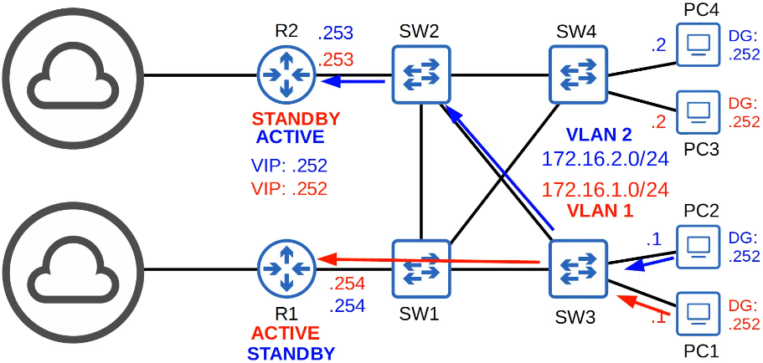

**VRRP (Virtual Router Redundancy Protocol)**

* Open standard
* A 'master' and 'backup' router are elected
* Multicast IPv4: 224.0.0.18
* Virtual MAC address: 0000.5e00.01**xx** (xx: VRRP group number)
* In a situation with multiple subnets/VLANs, can configure a different master router in each subnet/VLAN to load balance

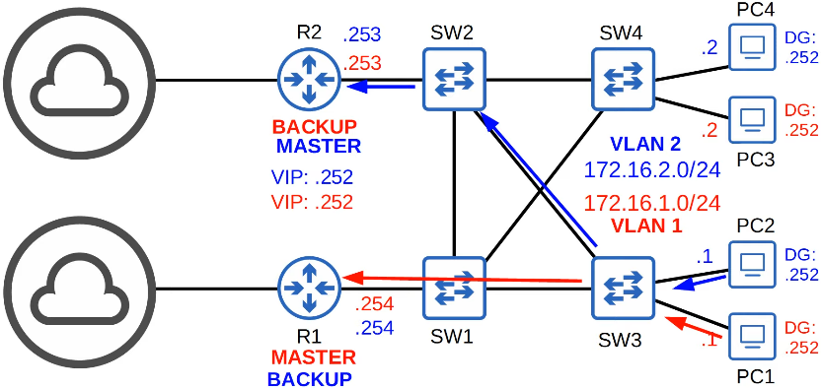

* Note about VLAN and Subnet
  + All hosts in VLAN1 is in the same subnet (172.16.1.0/24)
  + All hosts in VLAN2 is in the same subnet (172.16.2.0/24)
  + Subnets divide the network in layer 3 and VLANs divide the network in layer 2
  + They work together, with each subnet being its own VLAN

**GLBP (Gateway Load Balancing Protocol)**

* Cisco proprietary
* Load balance across multiple routers within a single subnet
* An AVG (Active Virtual Gateway) is elected
* Up to 4 AVFs (Active Virtual Forwarders) are assigned by the AVG (the AVG itself can be an AVF, too)
* Each AVF acts as the default gateway for a portion of the hosts in the subnet
* Multicast IPv4: 224.0.0.102
* Virtual MAC address: 0007.b400.**XXYY**
  + **X**: GLBP group number
  + **Y**: AVF number

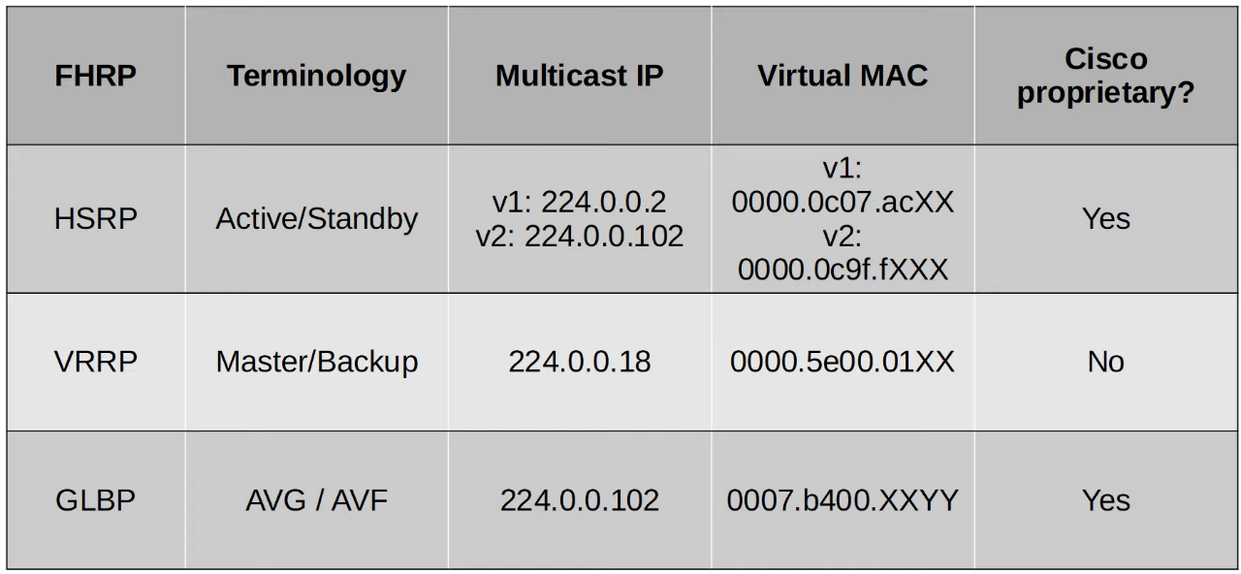

**Config**

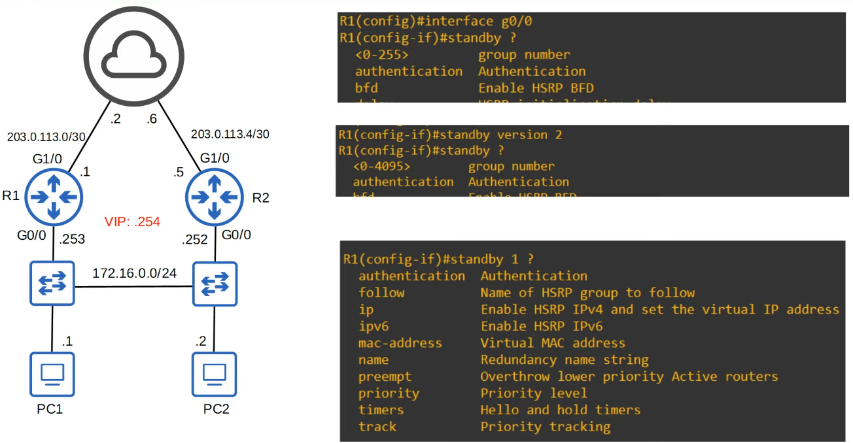

* Group number must match on the routers

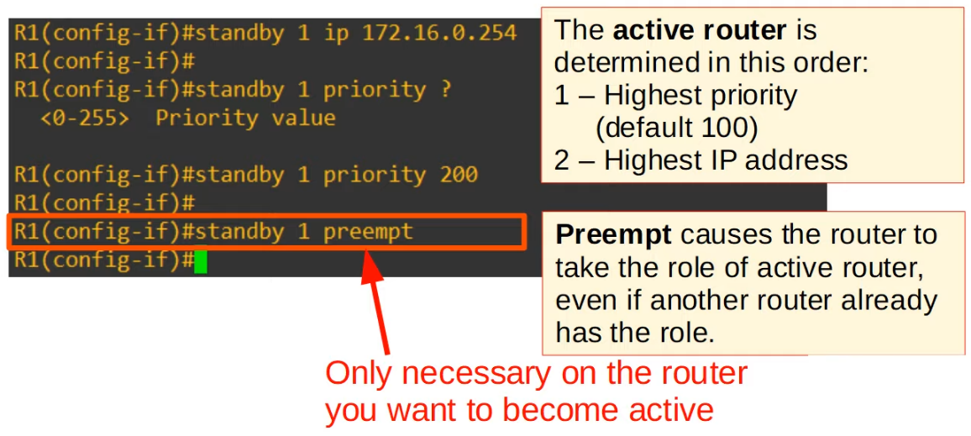

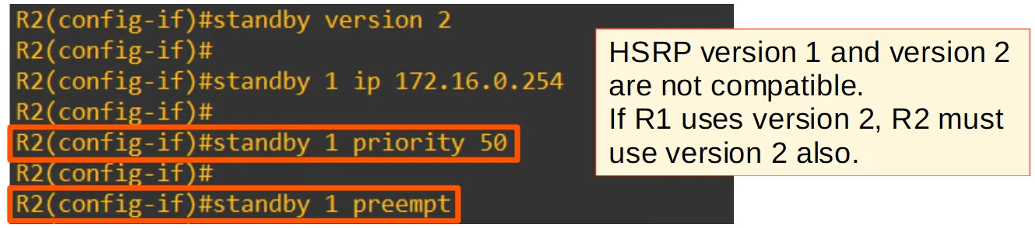

* 'priority 50'
  + Not needed since set the priority on R1 to higher than default
* 'preempt'
  + Not needed since only for the active router, can do to standardise the config btw both routers

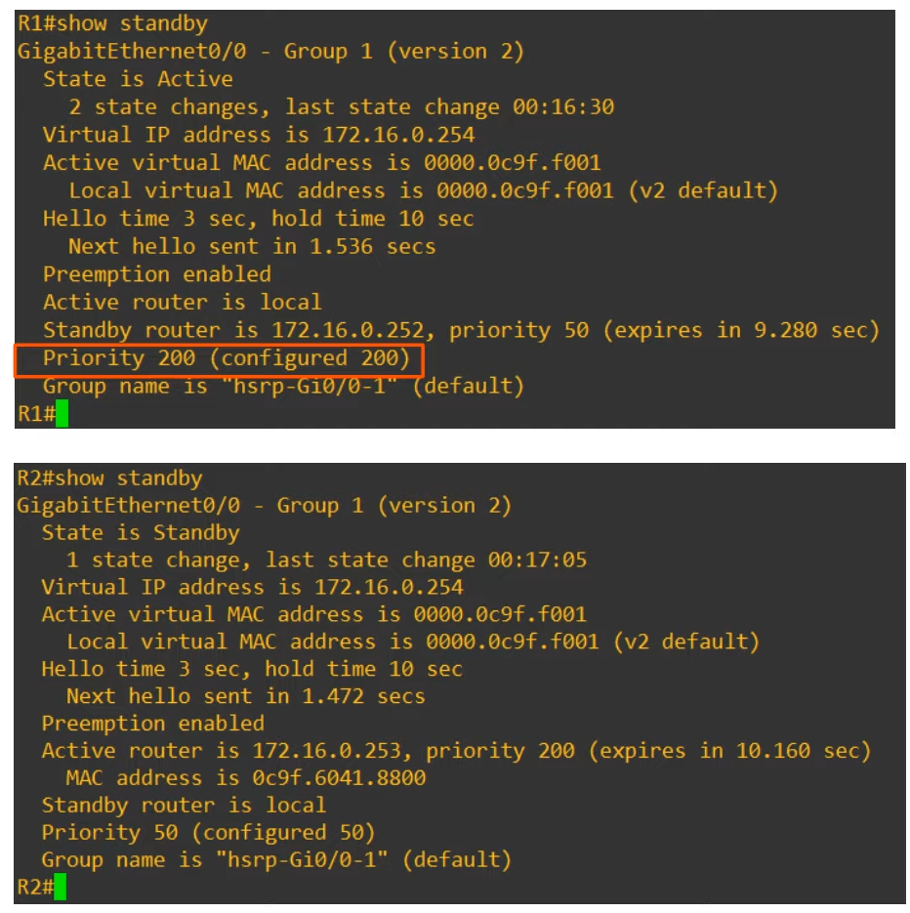

* R1(config-if)# **standby version 2**
* R1(config-if)# **standby <group-num> ip <virtual-ip>**
* R1(config-if)# **standby <group-num> priority <priority>**
* R1(config-if)# **standby <group-num> preempt**

# TCP/UDP

Things covered

* Basics of Layer 4
* TCP (Transmission Control Protocol)
* UDP (User Datagram Protocol)
* Comparing TCP and UDP

**Functions of Layer 4 (Transport Layer)**

* Provides transparent transfer of data btw end hosts
* Provides (or don't provide) various services to applications
  + Reliable data transfer
  + Error recovery
  + Data sequencing
  + Flow control
* Provide Layer 4 addressing (port numbers)
  + Port: NOT the physical interfaces/ports on network devices
  + Identify the Application layer protocol
  + Provides session multiplexing
  + The following ranges have been designated by IANA (Internet Assigned Numbers Authority)
    - **Well known** port numbers: 0 - 1023
    - **Registered port** numbers: 1024 - 49151
    - **Ephemeral/private/dynamic** port numbers: 49152 - 65535

**Port Numbers / Session Multiplexing**

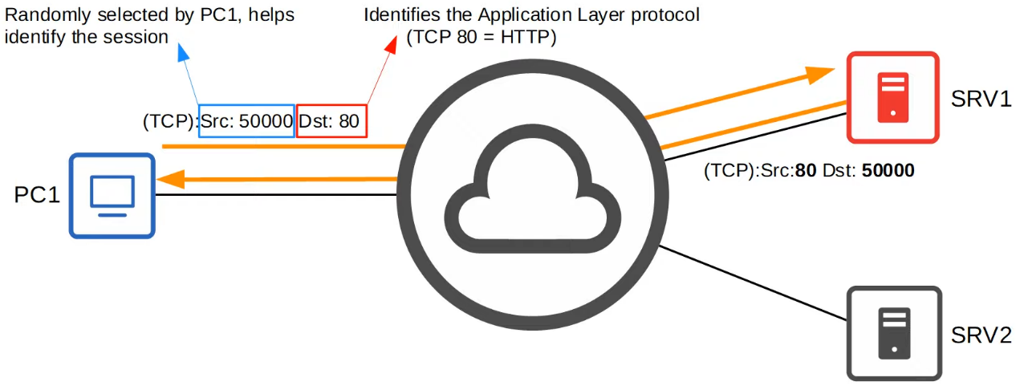

* A session is an exchange of data between 2 or more communicating devices
* The response from SRV1 to PC1 will be opposite for the Src and Dst ports
  + Allows PC1 to know it is from that particular session

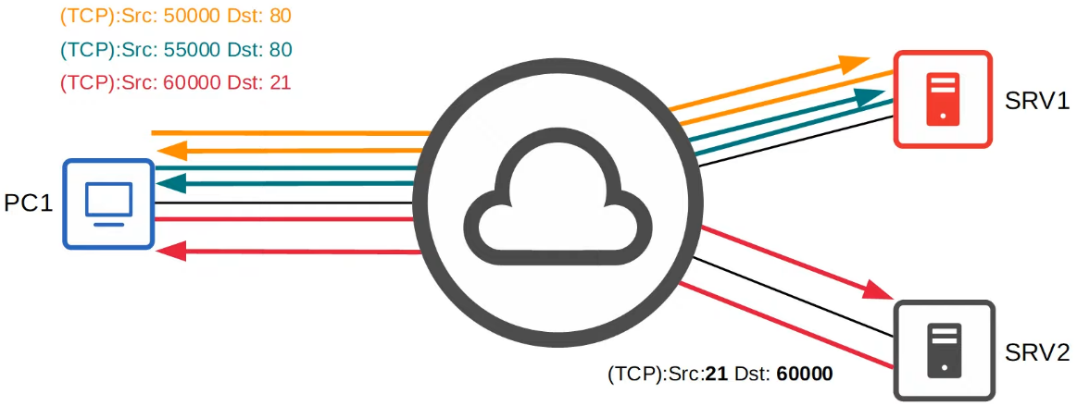

* Can have multiple sessions running at the same time

**TCP**

* It is connection oriented
  + The 2 hosts communicate to establish a connection before sending data
  + Once established, data exchange begins
* Provides reliable connection
  + Destination host must acknowledge that it received each TCP segment (layer 4 PDU)
  + It not acknowledged, it is sent again
* Provides sequencing
  + Sequence numbers in the TCP header allow destination hosts to put segments in the correct order even if they arrive out of order
* Provides flow control
  + Destination host can tell source host to increase/decrease the rate that data is sent

**TCP Header**

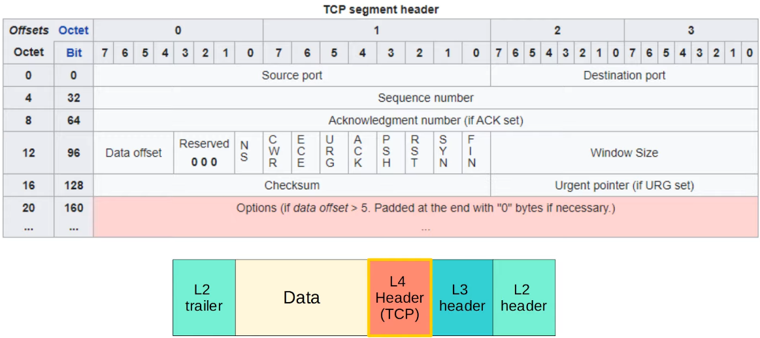

* Source/Destination Port
  + 16 bits = 65536 available port numbers
* Sequence/Ack Number
  + Provide sequencing and reliable communication
* Flags: ACK, SYN, FIN
  + Used to establish and terminate communications
* Window size
  + Used for flow control

**Establishing Connections: 3 way handshake**

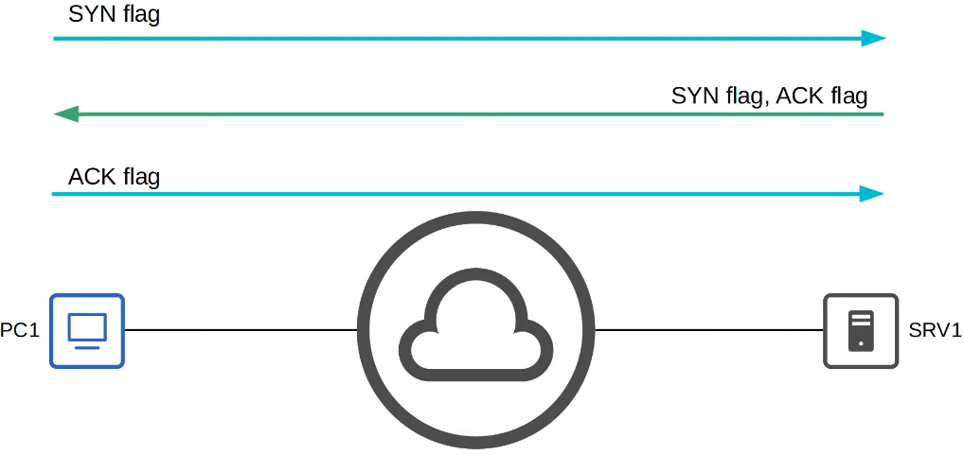

**Terminating Connections: 4 way handshake**

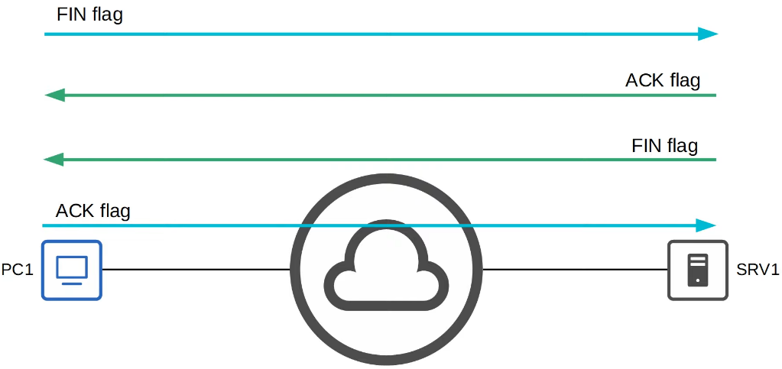

**Sequencing/Acknowledgment**

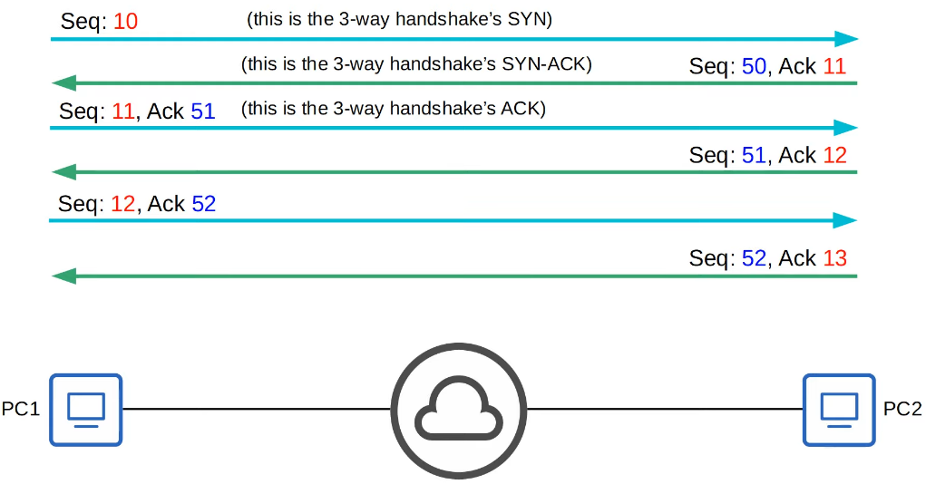

* Hosts set a random initial sequence number
* Forward acknowledgment is used to indicate the sequence number of the next segment it expects to receive

**Retransmission**

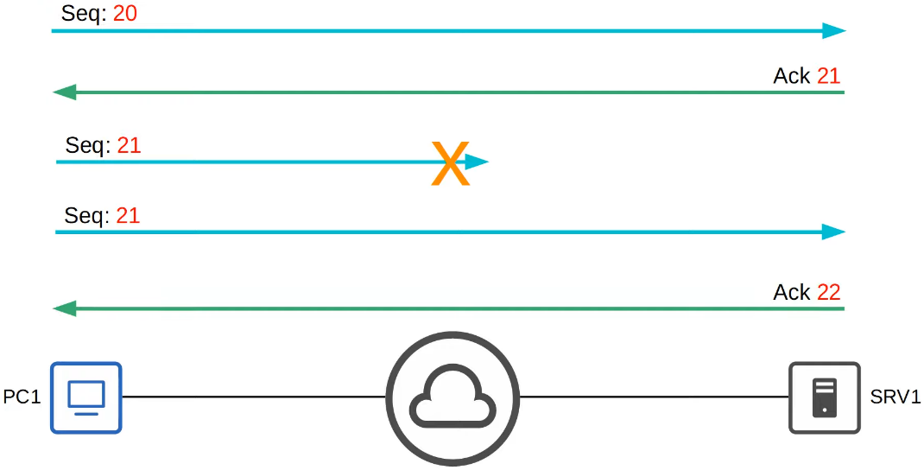

**Flow Control: Window size**

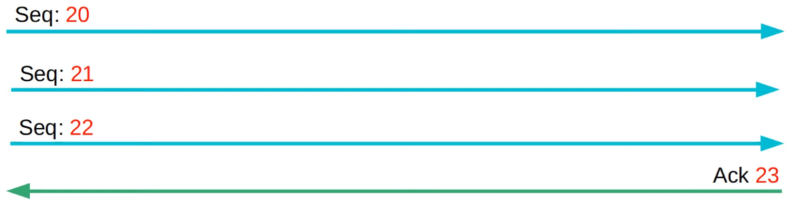

* Acknowledging every single segment is inefficient
* The TCP header's 'Window Size' field allows more data to be sent before an acknowledgment is required
* A 'sliding window' can be used to dynamically adjust how large the window size is
* Note:
  + In all these examples, simple sequence numbers are used. In reality, the seq numbers can get much larger and do not increase by 1 with each message.
  + For CCNA, just understand the concepts and don't worry about the exact numbers

**UDP**

* Not connection oriented
  + Sending host does not establish a connection with destination host before sending data
  + Data is simply sent
* Does not provide reliable communication
  + Ack are not sent for received segments
  + If segment lost, no mechanism for retransmission
  + Segments are sent 'best-effort'
* Does not provide sequencing
  + No seq number field in header
  + If arrive out of order, no mechanism to put them back in order
* Does not provide flow control
  + No mechanism like TCP's window size to control flow of data

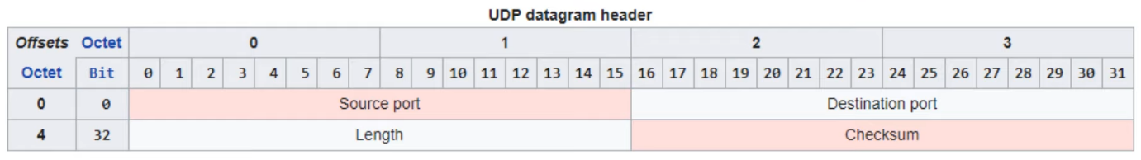

**Comparing TCP & UDP**

* TCP provides more features than UDP, but at the cost of additional overhead.
* For applications that require reliable communications (for example downloading a file), TCP is preferred.
* For applications like real-time voice and video, UDP is preferred.
* There are some applications that use UDP, but provide reliability etc within the application itself.
* Some applications use both TCP & UDP, depending on the situation.

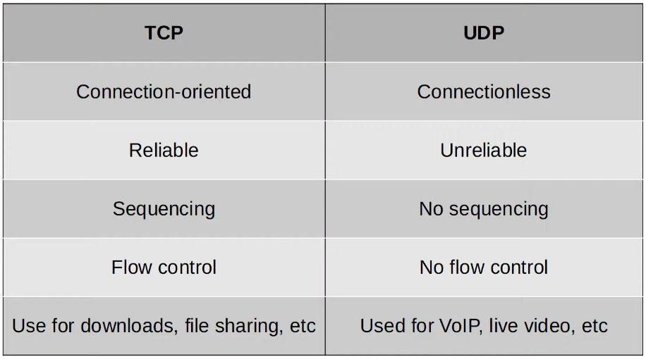

**Port Numbers**

TCP

* FTP Data: 20
* FTP Control: 21
* SSH: 22
* Telnet: 23
* SMTP: 25
* HTTP: 80
* POP3: 110
* HTTPS: 443

UDP

* DHCP server: 67
* DHCP client: 68
* TFTP: 69
* SNMP agent: 161
* SNMP manager: 162
* Syslog: 514

UDP & TCP

* DNS: 53

# IPv6 Addressing

## IPv6 (Part 1)

Things covered

* Hexadecimal review
* Why IPv6
* Basics of IPv6
* Config

What about IPv5

* 'Internet Stream Protocol', never introduced for public use
* Used a value of 5 in Version field of IP header
* So, when successor of IPv4 was developed, named IPv6

Hexadecimal

* Binary / Base 2 / 0b01
* Decimal / Base 10 / 0d23
* Hexadecimal / Base 16 / 0xA3

Why IPv6

* Not enough IPv4 addresses available
* 4,294,967,296 (2^32) available IPv4 addresses
* VLSM, private IPv4 addresses, and NAT has been used to conserve the use of IPv4 address space
* Those are short term solutions
* Long term solution is IPv6
* IPv4 address assignments are controlled by IANA (Internet Assigned Numbers Authority)
* IANA distributes IPv4 address space to various RIRs (Regional Internet Registries), which then assign them to companies that need them

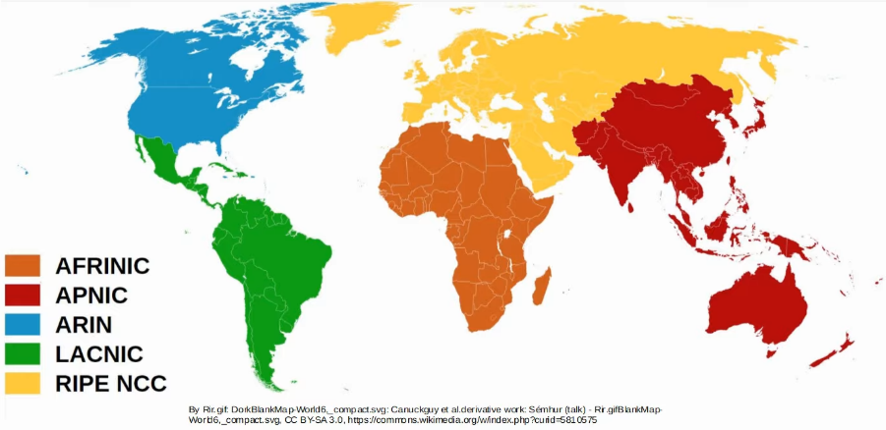

IPv6

* Address is 128 bits
* Example
  + 2001:0D88:5917:EABD:6562:C923:59BD / 64

Shortening IPv6 addresses

* **Leading 0s** can be removed

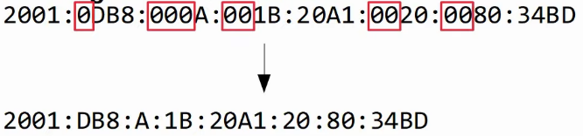

* **Consecutive quartets of all 0s** can be replaced by '::'

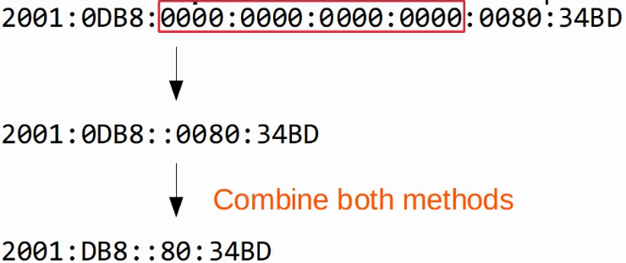

* However, can only do it once
* Else don't know how many quartets of 0 for each '::'

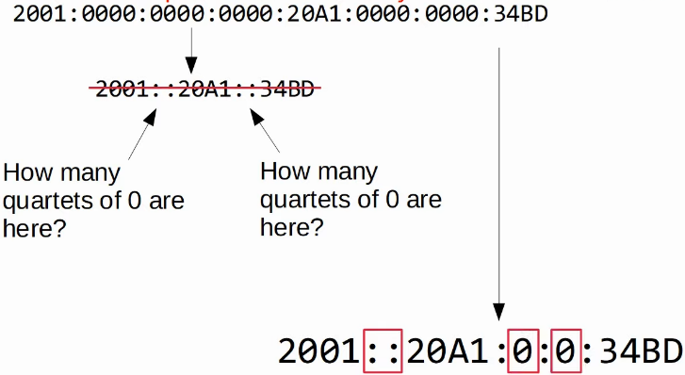

Expanding shortened IPv6 address

* Put leading 0s where needed
* If double colon used, replace with all 0s quartet
* Make sure there is 8 quartets

Finding the IPv6 prefix (global unicast addresses)

* Typically, an enterprise requesting IPv6 addresses from their ISP will receive a /48 block
* Typically, IPv6 subnets use a /64 prefix length
* That means an enterprise has 16 bits to use to make subnets
* The remaining 64 bits can be used for hosts

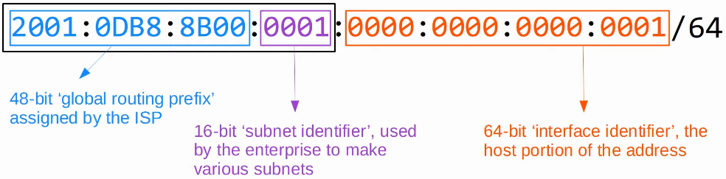

Examples

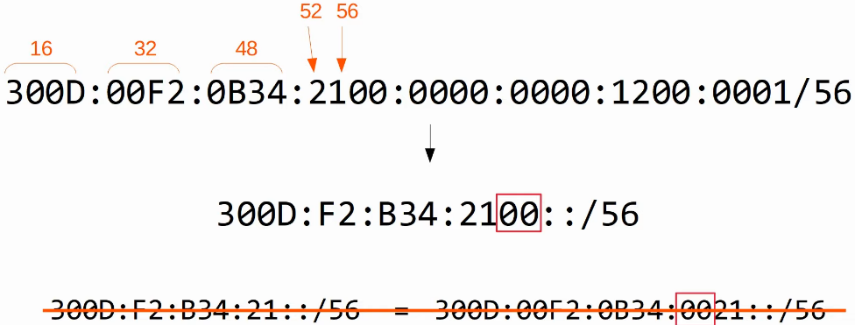

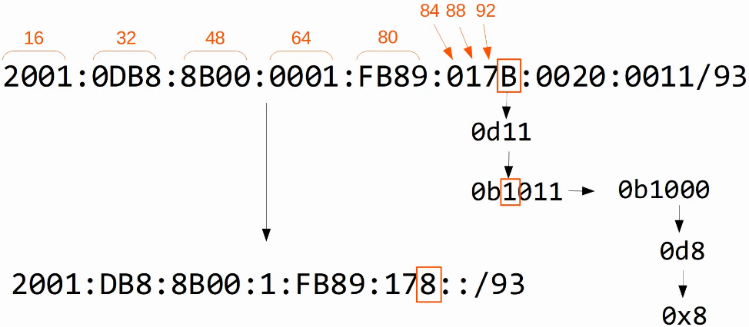

Config

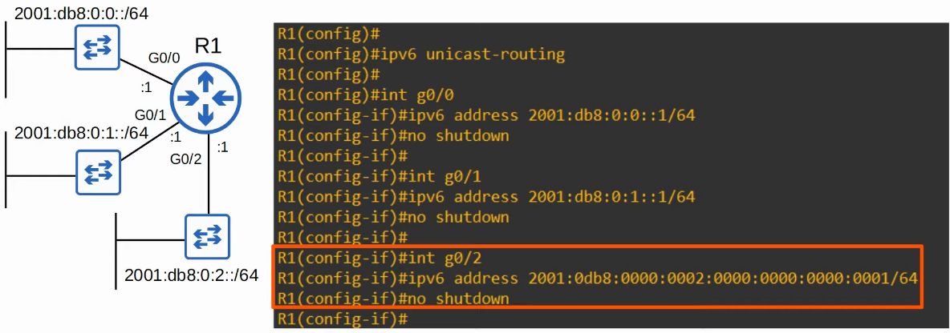

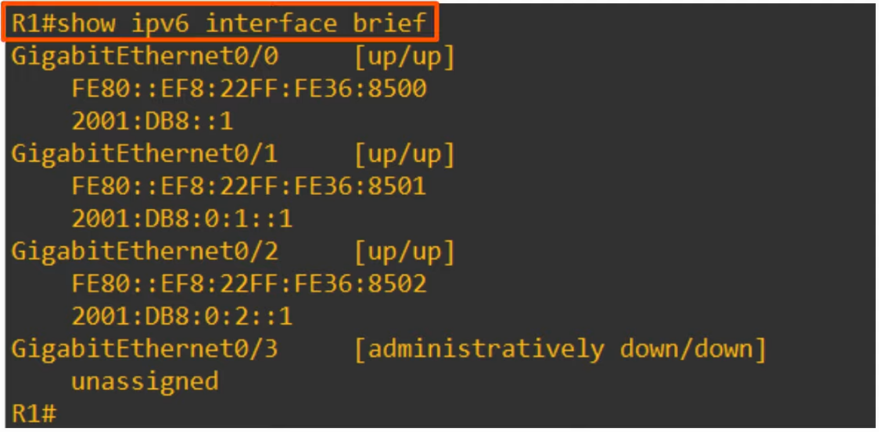

* Link-local Addresses
  + Auto enabled on IPv6 interfaces

Commands

* R1(config)# ipv6 unicast-routing
* R1(config-if)# ipv6 <ipv6 address>/<subnet mask>

## IPv6 (Part 2)

Things covered

* IPv6 Config
  + Modified EUI-64
* IPv6 address types
  + Global unicast
  + Unique local
  + Link local
  + Multicast
  + Others

Configuring IPv6 addresses (EUI-64)

* EUI: Extended Unique Identifier
* (Modified) EUI-64 is a method of converting a MAC address (48 bits) into a 64-bit interface identifier
* This interface identifier can then become the 'host portion' of a /64 IPv6 address
* How to convert MAC address
  1. Divide the MAC address in half
  2. Insert FFFE in the middle
  3. Invert the 7th MSB



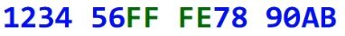

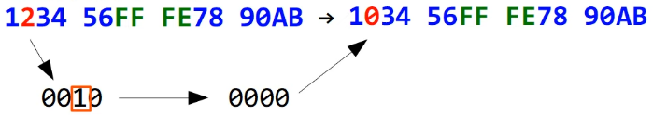

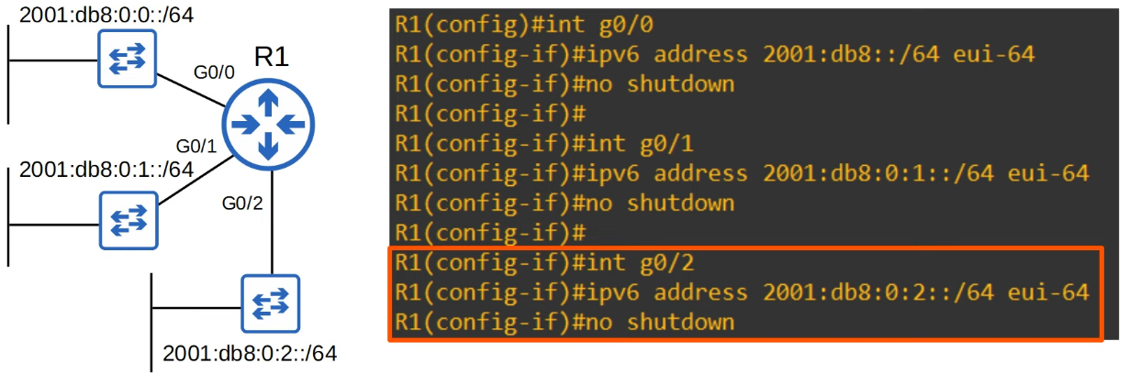

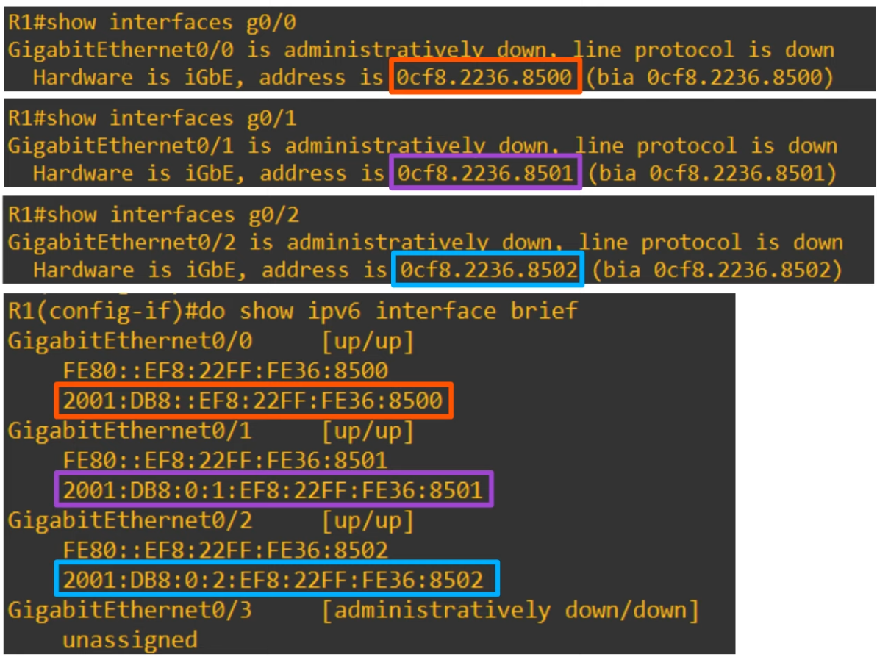

* EUI-64 allows routers to auto generate an IPv6 address by expanding their MAC address to a 64 bit ID which is then combined with a specified IPv6 prefix

Why invert the 7th bit?

* MAC addresses can be divided into 2 types
  + UAA (Universally Administered Address)
    - Uniquely assigned to the device by the manufacturer
  + LAA (Locally Administered Address)
    - Manually assigned by an admin (with 'mac-address' command on the interface) or protocol
    - Doesn't have to be globally unique
* Can identify a UAA or LAA by the 7th bit of the MAC address
  + Called the U/L bit (Universal/Local bit)
  + 0: UAA
  + 1: LAA
* In the context of IPv6 addresses/EUI-64, the meaning of the U/L bit is reversed
  + 0: MAC address of the EUI-64 interface was an LAA
  + 1: MAC address of the EUI-64 interface was an UAA

Global Unicast Address

* Global unicast IPv6 addresses are public addresses which can be used over the Internet
* Must register to use them
  + Because they are public addresses, it is expected that they are globally unique
* Originally defined as the 2000::/3 block (2000:: to 3FFF:FFFF:FFFF:FFFF:FFFF:FFFF:FFFF:FFFF)
* Now defined as all addresses which are not reserved for other purposes

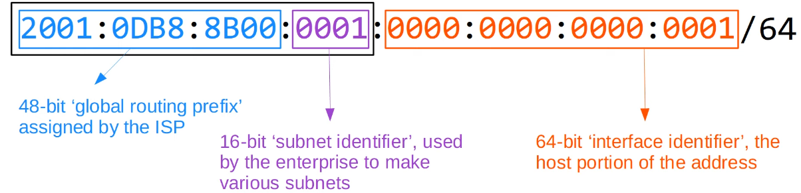

Unique Local Address

* Private addresses that cannot be used over the Internet
* Do not need to register them
  + Can be freely used within internal networks and don't need to be globally unique
  + Can't be routed over Internet, will be dropped by router
  + Note: Global ID should be unique so that addresses don't overlap when companies merge
* Uses the address block FC00::/7 (FC00:: to FDFF:FFFF:FFFF:FFFF:FFFF:FFFF:FFFF:FFFF)
* However, a later update requires the 8th bit to be set to 1
  + So, the first 2 digits are FD

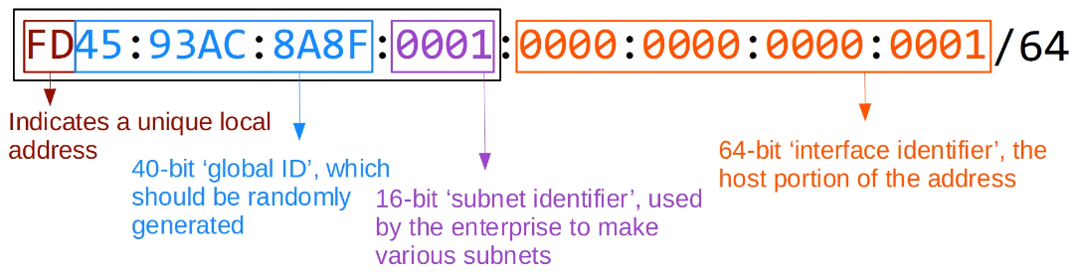

Link Local Addresses

* Link-local IPv6 addresses are automatically generated on IPv6-enabled interfaces.
* Use command **R1(config-if)# ipv6 enable** on an interface to enable IPv6 on an interface.
  + Won't need to configure an actual IPv6 address on the interface
  + Will generate a Link Local IPv6 address
* Uses the address block FE80::/10 (FE80:: to FEBF:FFFFF:FFFF:FFFF:FFFF:FFFF:FFFF:FFFF)
* However, the standard states that the 54 bits after FE80/10 should be all 0, so you won't see link local addresses beginning with FE9, FEA, or FEB. Only FE8.
* The interface ID is generated using EUl-64 rules.
* Link-local means that these addresses are used for communication within a single link (subnet).

Routers will not route packets with a link-local destination IPv6 address.

* Common uses of link-local addresses:
  + routing protocol peerings (OSPFv3 uses link-local addresses for neighbour adjacencies)
  + next-hop addresses for static routes
  + Neighbour Discovery Protocol (NDP, IPv6's replacement for ARP) uses link-local addresses to function

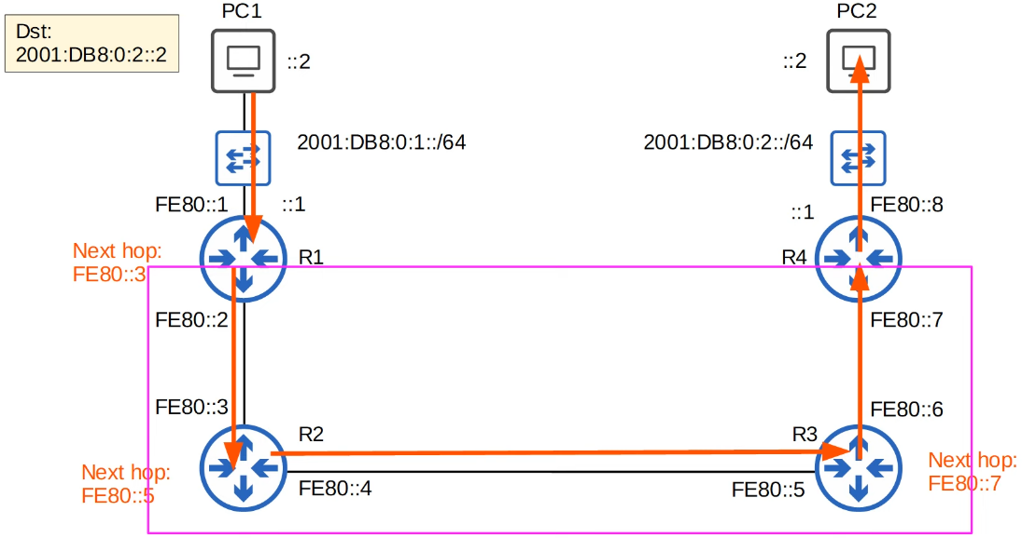

Multicast Addresses

* Multicast addresses are one-to-many
  + 1 source to multiple destinations (that have joined the specific multicast group)
* IPv6 uses the range FF00::/8 for multicast
* IPv6 doesn't use broadcast (there is no 'broadcast address' in IPv6)

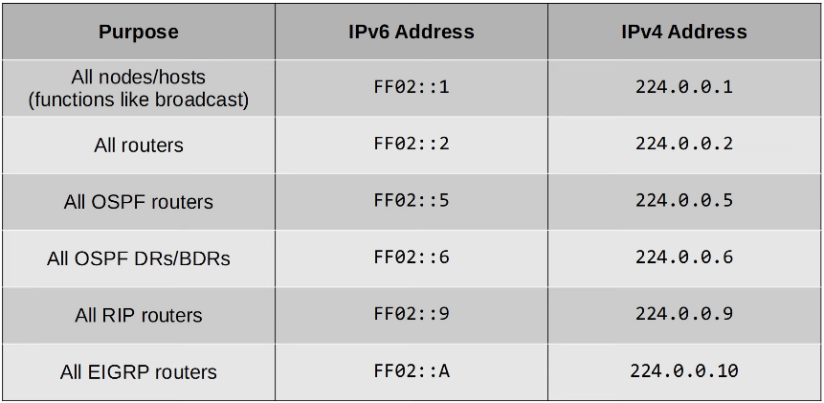

Multicast address scopes

* IPv6 defines multiple multicast 'scopes' which indicate how far the packet should be forwarded.
* The addresses in the previous slide all use the 'link-local' scope (FF02), which stays in the local subnet.
* IPv6 multicast scopes:
  + Interface-local (FFO1): The packet doesn't leave the local device. Can be used to send traffic to a service within the local device.
  + Link-local (FF02): The packet remains in the local subnet. Routers will not route the packet between subnets.
  + Site-local (FF05): The packet can be forwarded by routers. Should be limited to a single physical location (not forwarded over a WAN)
  + Organization-local (FF08): Wider in scope than site-local (an entire company/organization).
  + Global (FFOE): No boundaries. Possible to be routed over the Internet.

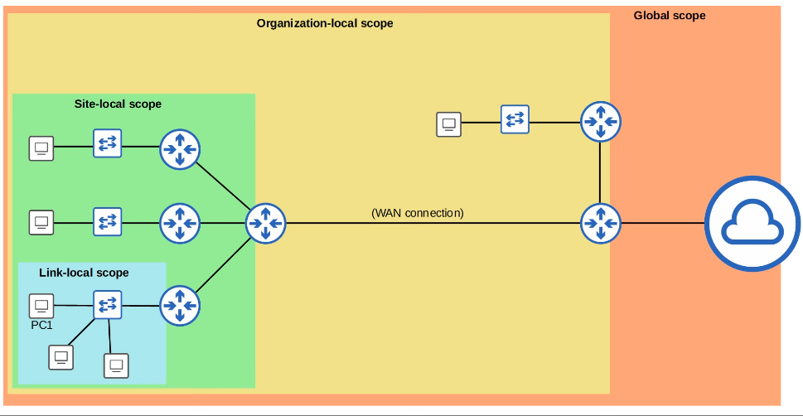

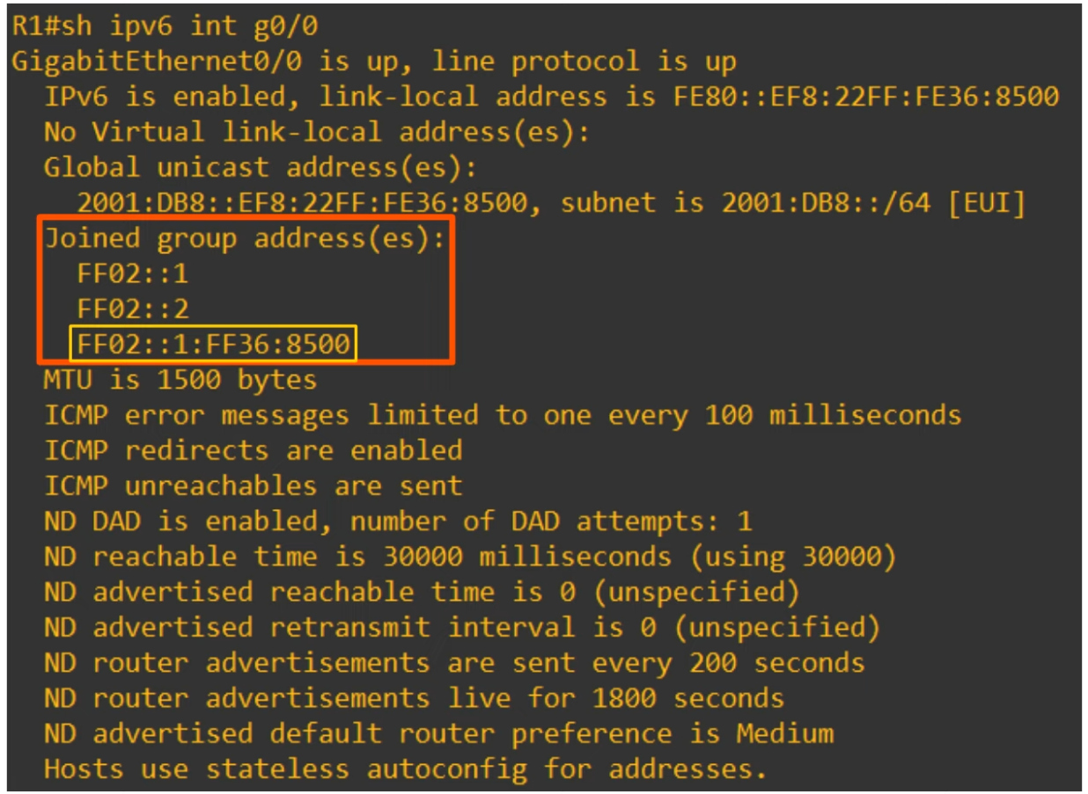

Anycast Addresses

* New feature of IPv6
* Anycast is 'one to one-of-many'
* Multiple routers are configured with the same IPv6 address
  + They use a routing protocol to advertise the address
  + When hosts sends a packet to that destination address, routers will forward it to the nearest router configured with the IP address (based on routing metric)
* There is no specific address range for anycast addresses
  + Use a regular unicast address (global unicast/unique local etc) and specify it as an anycast address
  + R1(config-if)# **ipv6 address 2001:db8:1:1::99/128 anycast**

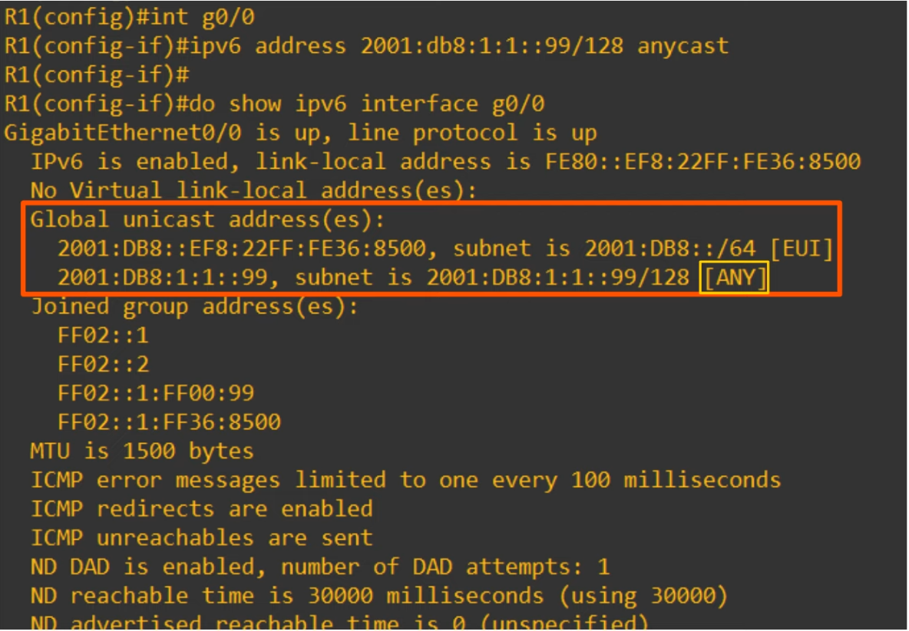

* Although under 'Global unicast address(es)', it is an anycast address

Other IPv6 addresses

* Unspecified IPv6 addresses
  + :: (all 0s)
  + Can be used when a device doesn't yet know its IPv6 address
  + IPv6 default routes are configured to ::/0
  + IPv4 equivalent: 0.0.0.0
* Loopback address
  + ::1
  + Used to test the protocol stack on the local device
  + Messages sent to this address are processed within the local device, but not sent to other devices
  + IPv4 equivalent: 127.0.0.0/8 address range

Things covered

* Correction
* IPv6 Header
* Neighbour Discovery Protocol
* SLAAC
* IPv6 Routing

Correction (IPv6 Address Representation)

* RFC 5952
  + Recommendation for IPv6 Address Text Representation
* Recommendations
  + Leading 0s must be removed
  + '::' must be used for the longest consecutive quartets of 0
    - If equal length, use the left one
  + Hexadecimal in lower-case

Header

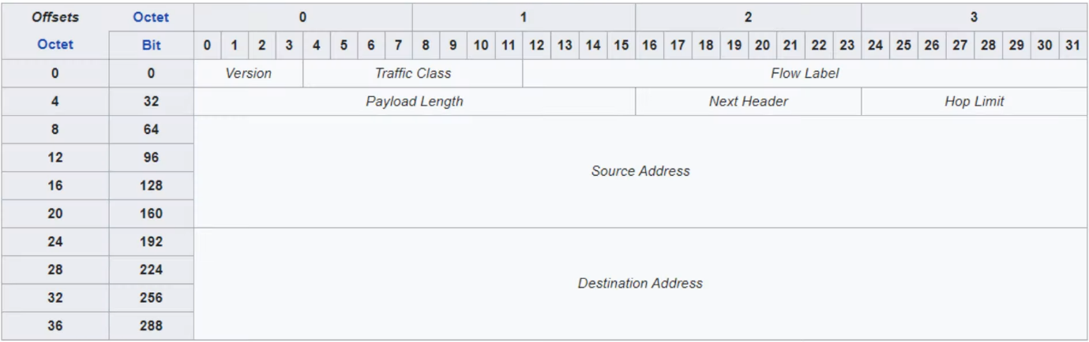

* Fixed size: 40B
* Version
  + 4 bits
  + Indicates the version of IP used
  + Fixed value of 6 (0x0110) to indicate IPv6
* Traffic Class
  + 8 bits
  + Used for QoS (Quality of Service), to indicate high-priority traffic
  + E.g. IP phone traffic, live video calls, etc, will have a Traffic Class value which gives them higher priority over other traffic
* Flow Label
  + 20 bits
  + Used to identify specific traffic 'flows' (communications btw a specific source and destination)
* Payload Length
  + 16 bits
  + Indicates the length of the payload (the encapsulated Layer 4 segment) in bytes
  + The length of the IPv6 header is not included since it is fixed at 40 bytes
* Next Header
  + 8 bits
  + Indicates the type of the 'next header' (header of the encapsulated segment), for example, TCP or UDP
  + Same function as the IPv4 header's 'Protocol' field
* Hop Limit
  + 8 bits
  + The value of the field is decremented by 1 by each router that forwards it
  + If value reaches 0, the packed is discarded
  + Same function as IPv4 header's 'TTL' field
* Source/Destination
  + 128 bits each

Solicited-Node Multicast Address

* An IPv6 solicited-node multicast address is calculated from a unicast address
* Method to get the address

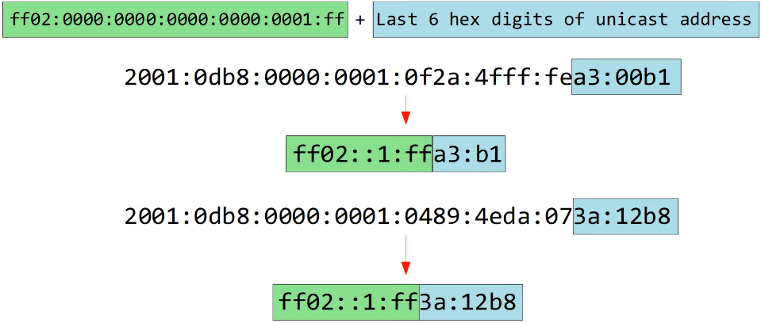

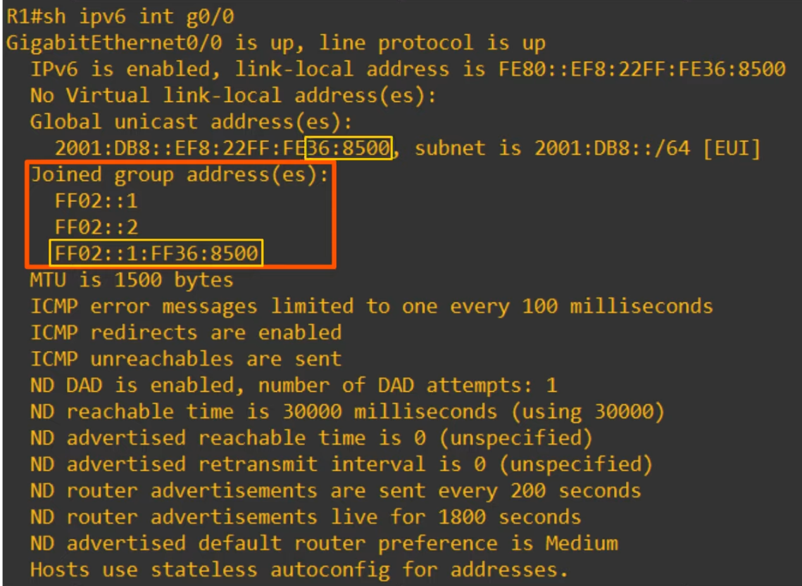

Neighbour Discovery Protocol

* NDP is a protocol used with IPv6
* Has various functions, 1 of those is to replace ARP, which is not used in IPv6
* The ARP-like function of NDP uses ICMPv6 and solicited-node multicast addresses to learn the MAC address of other hosts

*(ARP in IPv4 uses broadcast message)

* 2 messages types used
  + Neighbour Solicitation (NS) - ICMPv6 type 135
  + Neighbour Advertisement (NA) - ICMPv6 type 136

Neighbour Solicitation

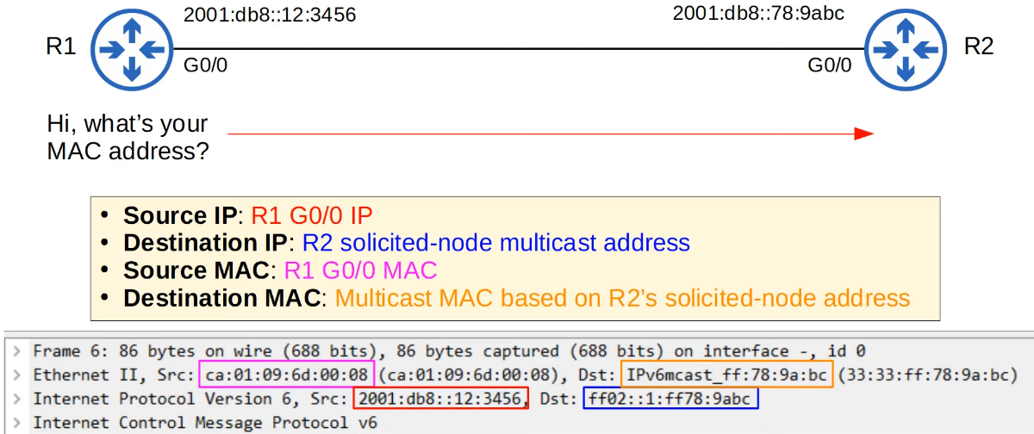

Neighbour Advertisement

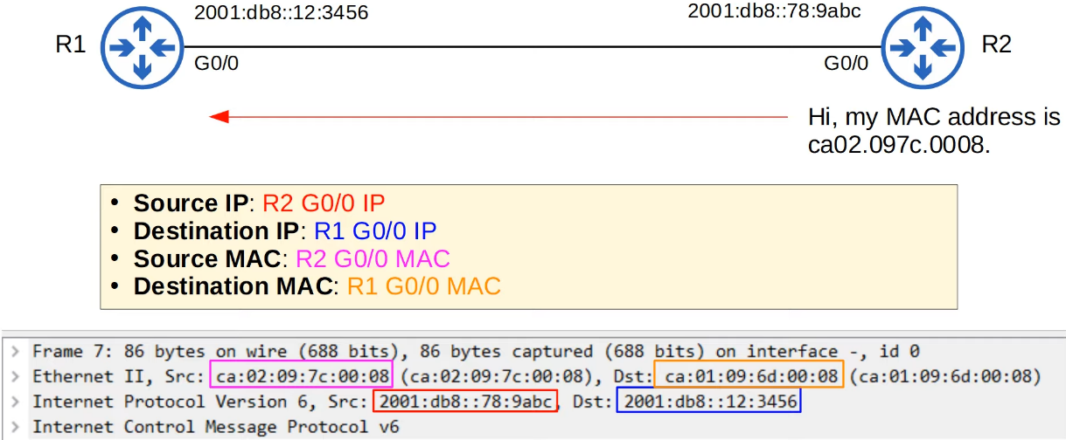

* R2 knows the destination MAC address since it received the NS which has the source MAC address of R1 G0/0

IPv6 Neighbour Table

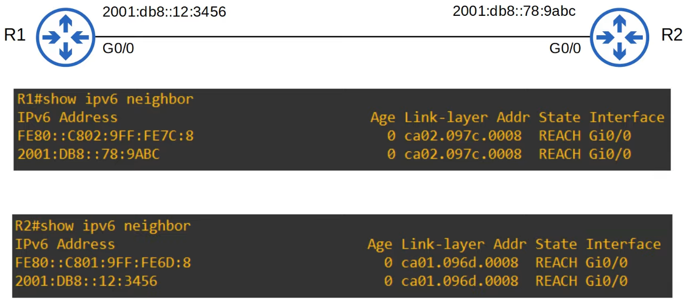

 Neighbour Discovery Protocol

* Another function of NDP allows hosts to automatically discover routers on the local network
* 2 messages are used for this process
  + Router Solicitation (RS)
    - ICMPv6 type 133
    - Send to multicast address FF00::2 (all routers)
    - Asks all routers on the local link (local network) to identify themselves
    - Sent when an interface is enabled/host is connected to the network
  + Router Advertisement (RA)
    - ICMPv6 type 134
    - Sent to multicast address FF02::1 (all nodes)
    - The router announces its presence, as well as other info about the link
    - These messages are sent in response to RS messages
    - They are also sent periodically, even if the router hasn't received an RS

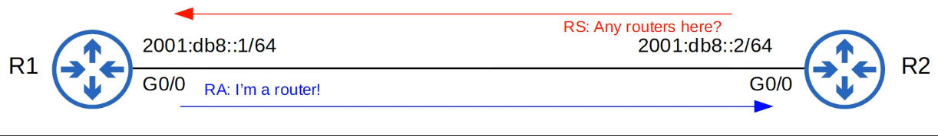

SLAAC

* Stateless Address Auto-Configuration
* Hosts use the RS/RA messages to learn the IPv6 prefix of the local link (i.e. 2001:db8::/64) and then automatically generate an IPv6 address
* Using the 'eui-64' command, need to manually config the IPv6 address
* Using 'ipv6 address autoconfig' command, you don't need to enter the prefix. The device uses NDP to learn the prefix used on the local link
* The device will use EUI-64 to generate the interface ID, or it will be randomly generated (depending on the device/maker)

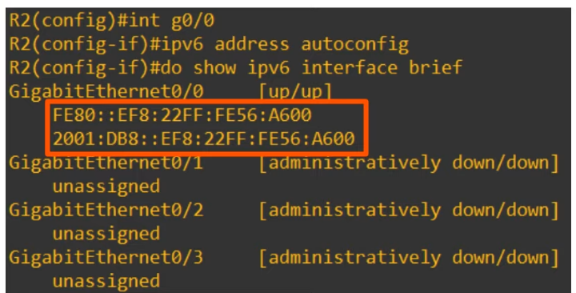

Duplicate Address Detection (DAD)

* DAD allows hosts to check if other devices on the local link are using the same IPv6 address
* Any time an IPv6-enabled interface initializes ('no shutdown' command), or an IPv6 address is configured on an interface (by any method: manual, SLAAC etc), it performs DAD
* DAD uses 2 messages (learnt earlier)
  + NS
  + NA
* The host will send an NS to its own IPv6 address
  + If it doesn’t get a reply, it knows the address is unique
* If it gets a reply, it means another host on the network is already using the address



IPv6 Routing

* Same as Ipv4 routing
* However, the 2 processes are separate, and their routing tables are also separate
* IPv4 routing is enabled by default, IPv6 is not
  + Must be enabled with 'ipv6 unicast-routing'
  + If disabled, able to send and receive IPv6 traffic, but cannot route them (will not forward btw networks)

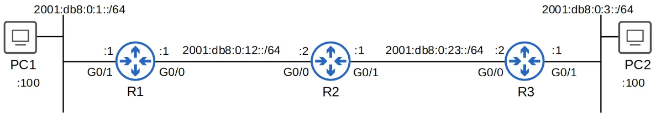

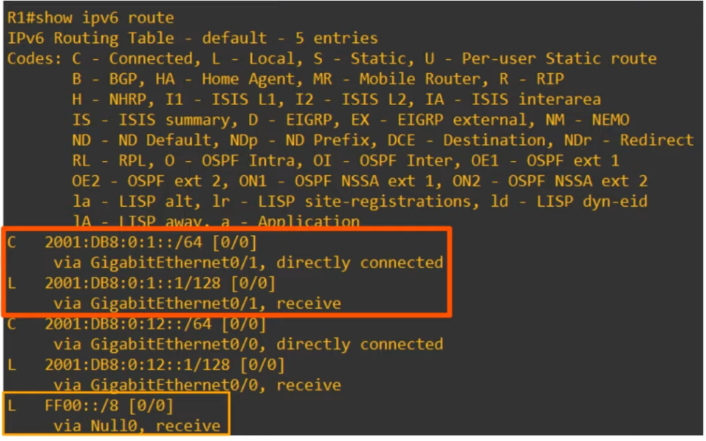

* A connected network route and local host route are auto added for each address configured on the router
* Routes for link-local addresses are not added to the routing table

Commands

"**ipv6 route** *destination*/*prefix-length* {*next-hop* | *exit-interface* [*next-hop*]} [*ad*]"

* Directly attached static route
  + Only the exit interface is specified
  + Cannot work on Ethernet interface (e.g. Serial can)
    - Will still accept the command, but won't work
  + R1(config)# **ipv6 route 2001:db8:0:3::/64 s0/0**
* Recursive static route
  + Only the next hop is specified
  + Called recursive as has to look up the routing table again to find the interface the next hop address is connected to
  + R1(config)# **ipv6 route 2001:db8:0:3::/64 2001:db8:0:12::2**
* Fully specified
  + Both the exit interface and the next hop specified
  + R1(config)# **ipv6 route 2001:db8:0:3::/64 g0/0 2001:db8:0:12::2**

Network route

* R1(config)# ipv6 route 2001:db8:0:3::/64 2001:db8:0:12::2

Host route

* R2(config)# ipv6 route 2001:db8:0:1::100/128 2001:db8:0:12::1
* R2(config)# ipv6 route 2001:db8:0:3::100/128 2001:db8:0:23::2

Default route

* R3(config)# ipv6 route ::/0 2001:db8:0:23::1

Link-local

* Need to use fully specified static route
* Router don't know which interface the link-local address is connected to

# Access Control Lists (ACLs)

## Standard ACL

Things covered

* What are ACLs?
* ACL logic
* ACL types
* Standard numbered ACLs
* Standard named ACLs

What are ACLs

* Access Control Lists
* Have multiple uses
* For now, focus from a security perspective
* ACLs function as a packet filter, instructing the router to permit or discard specific traffic
* ACLs can filter based on
  + source/destination IP addresses
  + Source/destination Layer 4 ports
  + Etc

How ACLs work

* ACLs are configured globally on the router (global config mode)
* They are an ordered sequence of ACEs (Access Control Entries)
* Configuring an ACL in global config mode will not make the ACL take effect
* The ACL must be applied to an interface
* ACLs are applied either inbound or outbound
  + Inbound - check when traffic entering interface
  + Outbound - check when traffic exiting the interface
* When the router checks a packet against the ACL, it processes the ACEs in order, from top to bottom
* If packet matches one of the ACEs in the ACL, router takes action and stop processing the ACL. All entries below the matching entry will be ignored

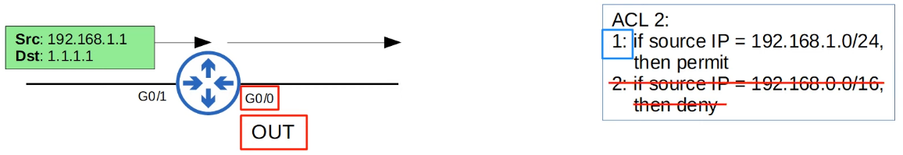

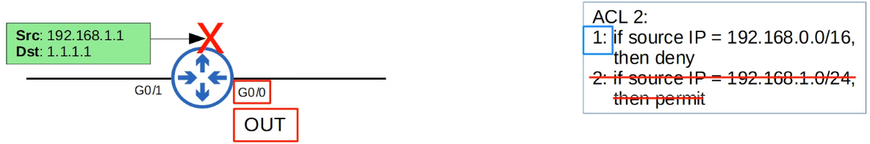

* Note: A max of 1 ACL per direction can be applied to a single interface
  + 1 interface - 1 inbound, 1 outbound
* Implicit deny
  + If traffic does not match any of the ACEs, it will be dropped
  + There is an 'implicit deny' at the end of all ACLs

Example

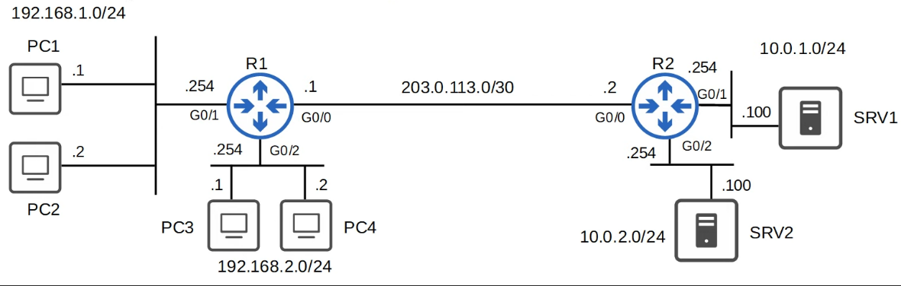

* Requirements
  + Hosts in 192.168.1.0/24 can access the 10.0.1.0/24 network
  + Hosts in 192.168.2.0/24 cannot access the 10.0.1.0/24 network
* ACE of ACL 1:
  + If source IP = 192.168.1.0/24, permit
  + If source IP = 192.168.2.0/24, deny
  + If source IP = any, permit

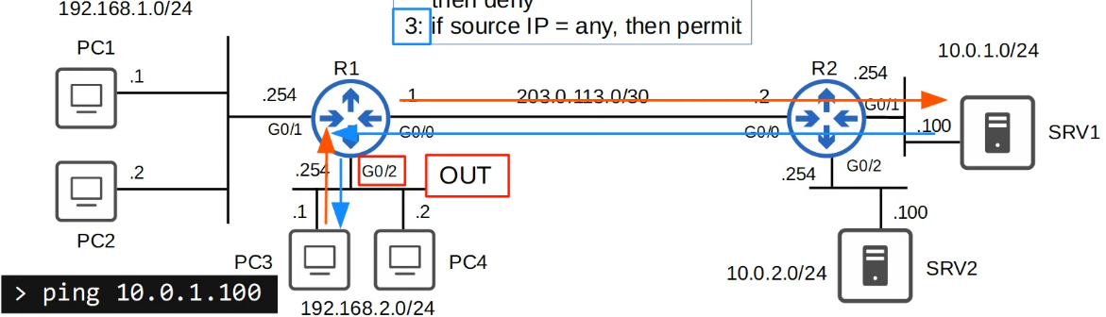

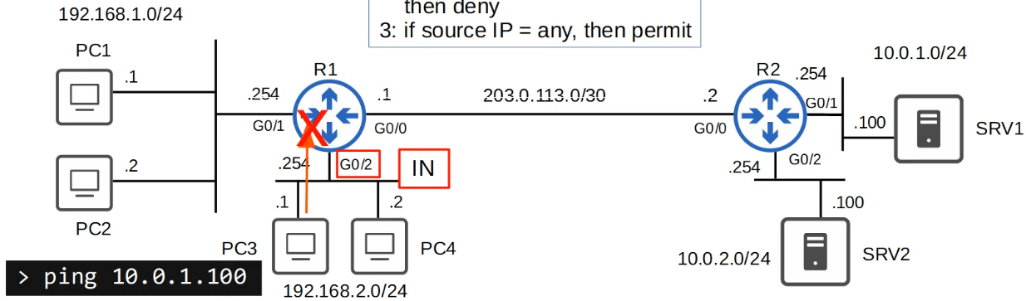

* Applying ACL inbound for R1 G0/2 may not be the best
  + PC3 can only communicate within its subnet
  + PC3 cannot communicate with PC1 and its subnet

Best Method

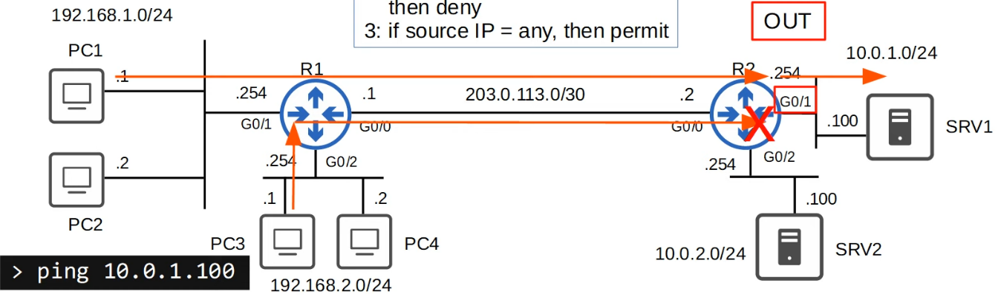

ACL Types

* Standard ACLs
  + Match based on Source IP address only
  + Types
    - Standard Numbered ACLs
    - Standard Named ACLs
* Extended ACLs
  + Match based on Source/Destination IP, Source/Destination Port, etc
  + Type
    - Extended Numbered ACLs
    - Extended Named ACLs

Standard Numbered ACLs

* Match traffic based on Source IP address only
* Identified with a number (i.e. ACL 1, ACL 2)
* Different type of ACLs have a different range of numbers that can be used
  + Standard ACLs: 1-99 and 1300-1999
* Basic command to config a standard numbered ACL
  + R1(config)# **access-list** *number* {**deny** | **permit**} *ip-address wildcard-mask*

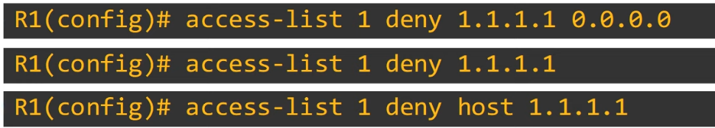

* The above 3 methods have the same effect of denying a host (/32)
* If not /32, only the first one

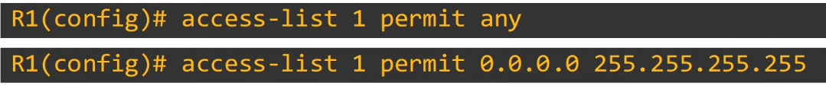

* The above 2 methods used to permit all other hosts



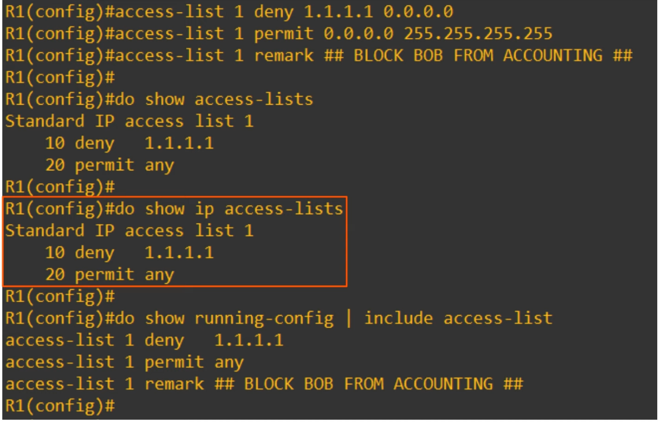

* Applying on interface
  + R1(config-if)# **ip access-group** *number* {**in** | **out**}

Example

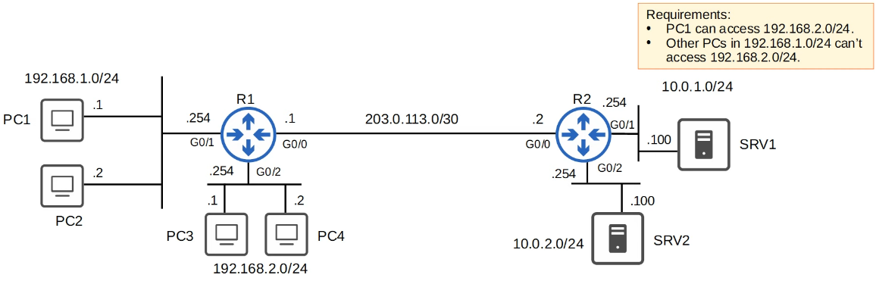

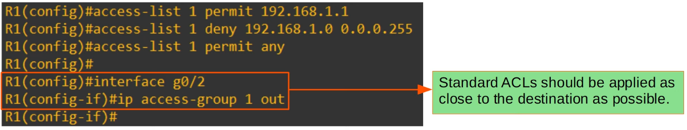

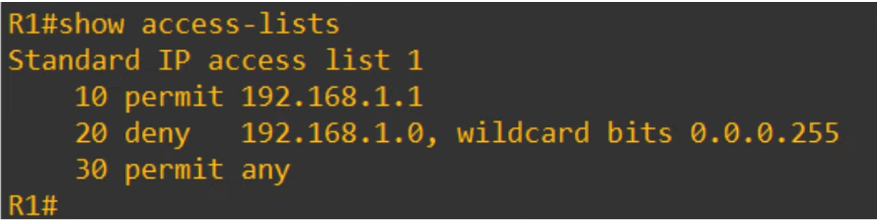

Standard Named ACLs

* Match traffic based on source IP address only
* Identified with a name (i.e. "BLOCK_BOB")
* Configured by entering "standard named ACL config mode", then configuring each entry within that mode
  + R1(config)# **ip access-list standard** *acl-name*
  + R1(config-std-nacl)# [*entry-number*] {**deny** | **permit**} *ip-address wildcard-mask*
* If no entry-number, it will be in interval of 10

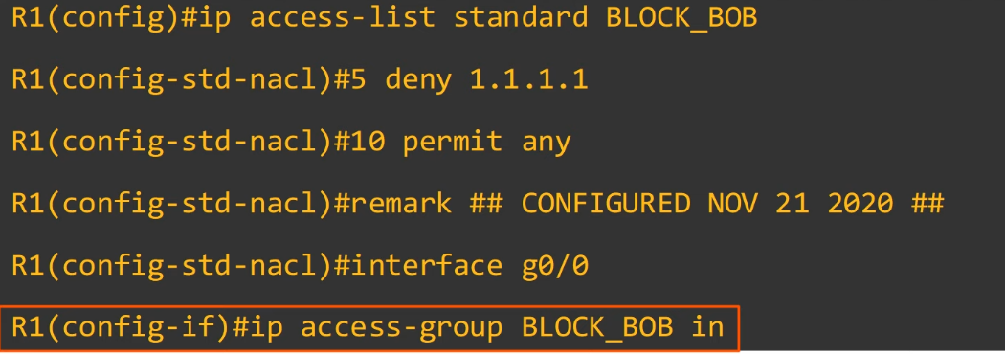

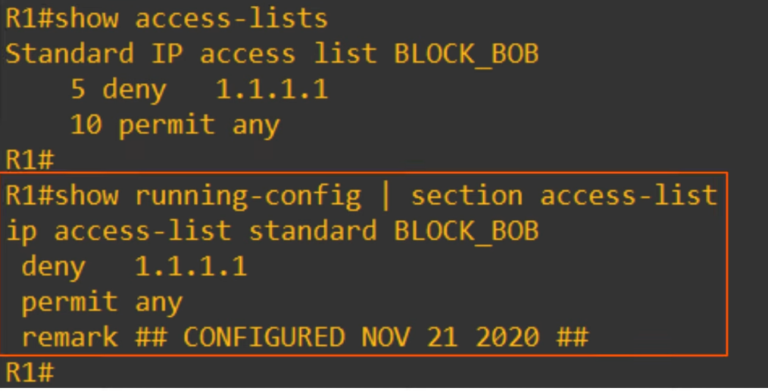

Example

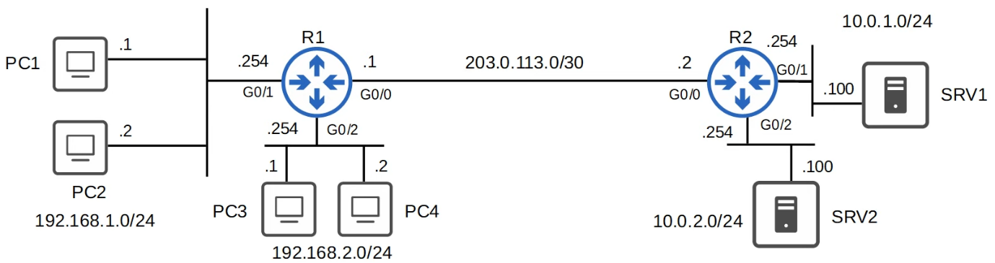

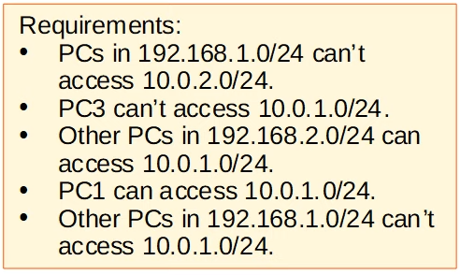

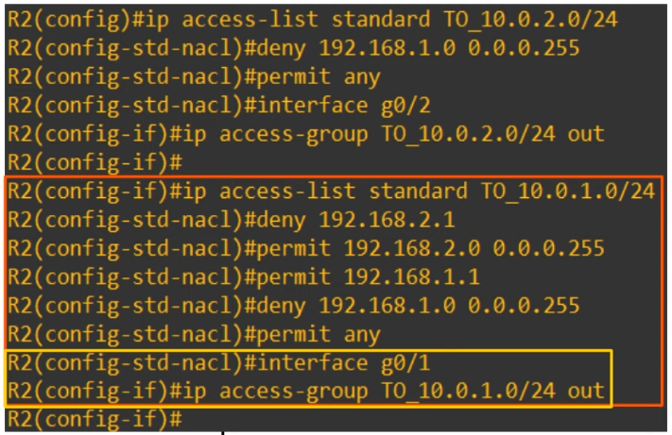

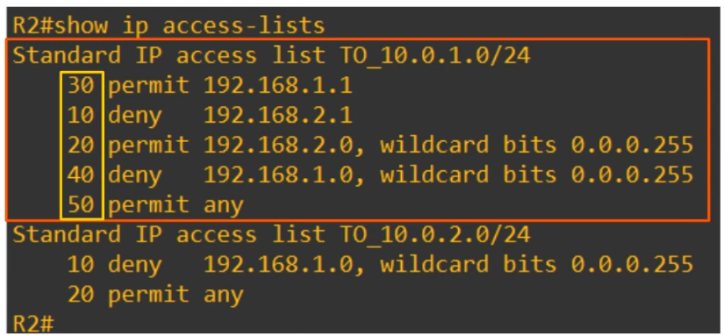

* Not in CCNA
  + Router may reorder /32 entries
  + Improves the efficiency of processing the ACL
  + Does not change the effect of the ACL
  + Applies to both standard named and standard numbered ACLs
  + Packet Tracer does not do this

## Extended ACLs

Things Covered

* Another way to config numbered ACLs
* Editing ACLs
* Extended numbered and named ACLs

Configuring Numbered ACLs

* In modern IOS, can config numbered ACLs the same way as named ACLs

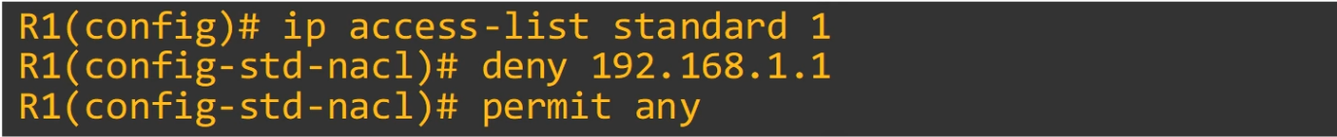

* This is just another way
* However, in the running-config the ACL will display as if it was configured using the traditional method

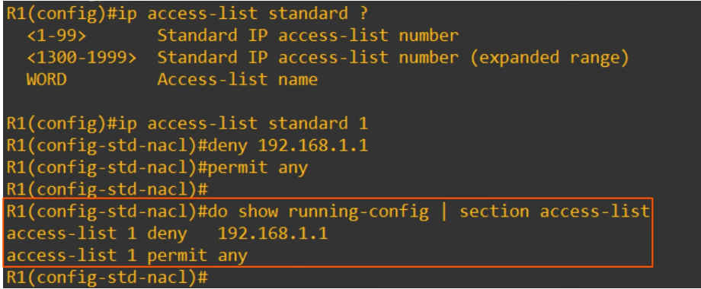

Advantages

* Can easily delete individual entries in the ACL with 'no <entry-number>'

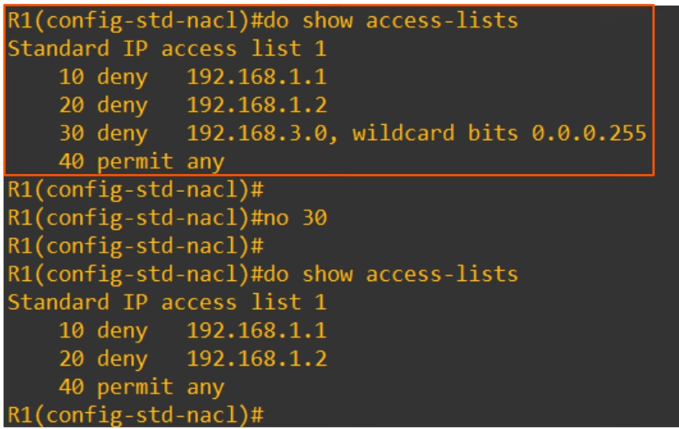

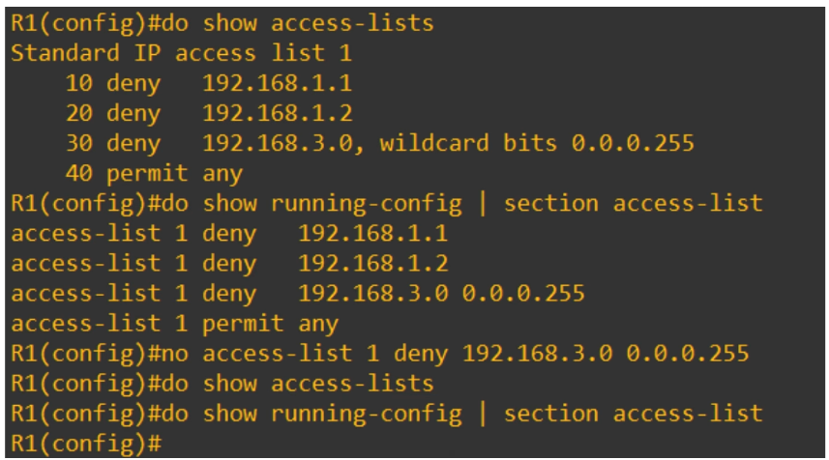

* When configuring/editing numbered ACLs from global config mode, you cannot delete individual entries, can only delete the entire ACL

* Can insert new entries in btw other entries by specifying the sequence number

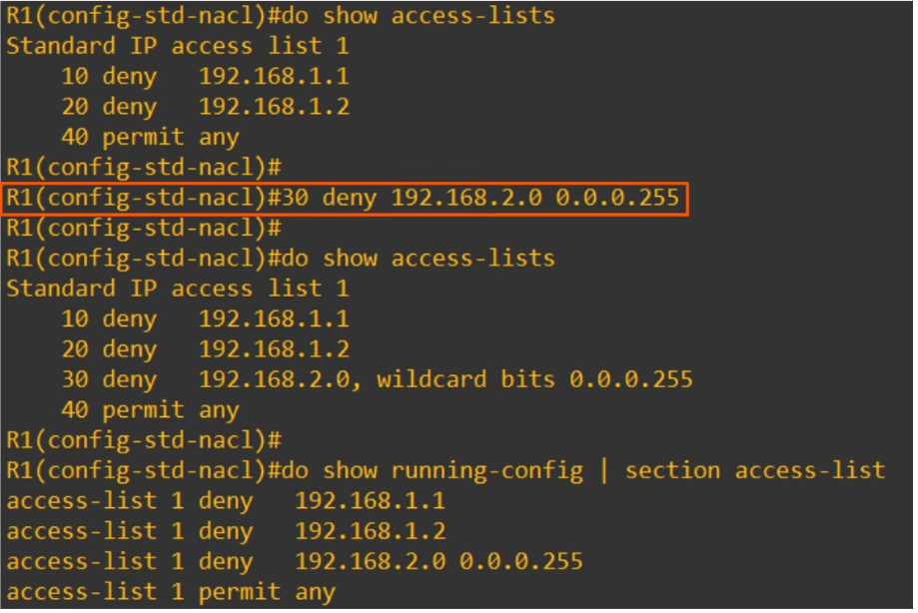

Resequencing ACLs

* There is a resequencing function that helps edit ACLs
* R1(config)# **ip access-list** *resequence acl-id starting-seq-num increment*

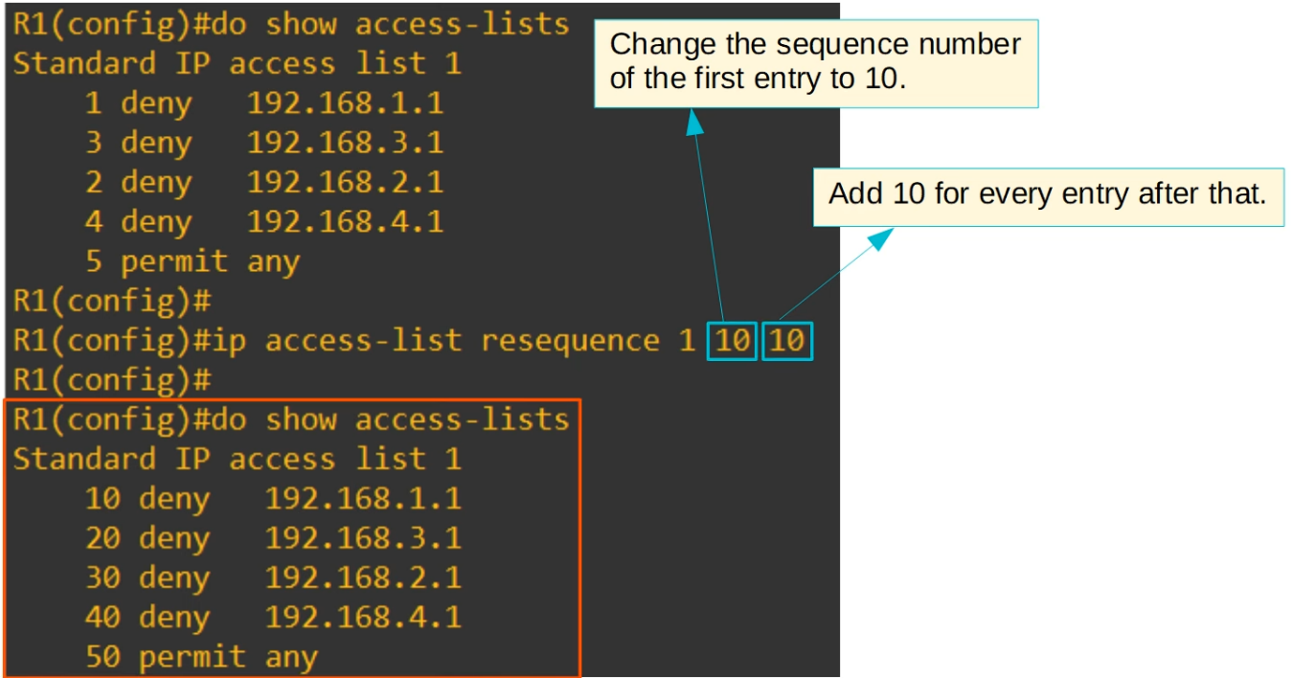

Extended ACLs

* Function mostly the same as standard ACLs
* Can be numbered or named
  + Numbered ACLs range: 100-199, 2000-2699
* Processed from top to bottom
* Can match traffic based on more parameters, so they are more precise (and complex) than standard ACLs
* Focus on these parameters:
  + Layer 4 protocol / port
  + Source address
  + Destination address
* Numbered ACL config
  + R1(config)# **access-list** *number* [**permit** | **deny**] *protocol* *src-ip dest-ip*
* Named ACL config
  + R1(config)# **ip access-list extended** {*name* | *number*}
  + R1(config-ext-acl)# [*seq-num*] [**permit** | **deny**] *protocol src-ip dst-ip*

Protocol

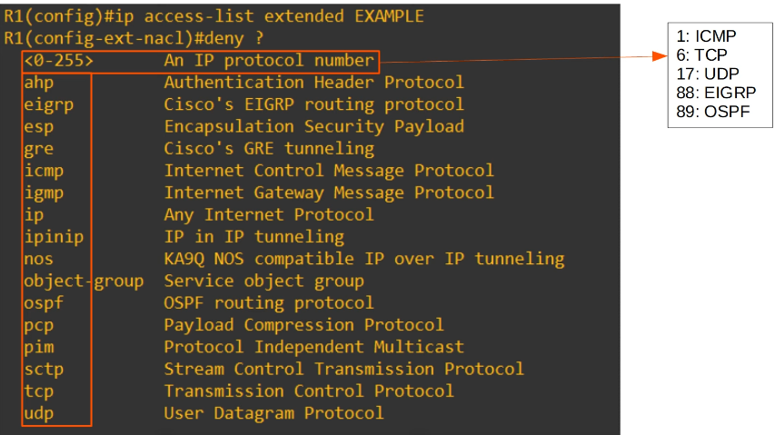

Source & Destination Address

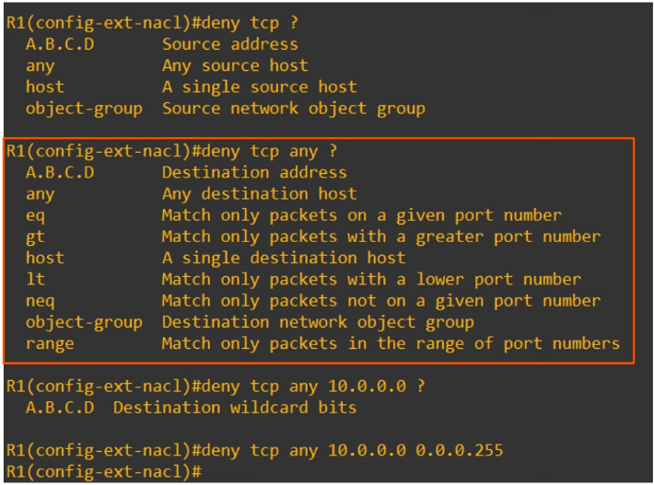

* In extended ACLs, to specify a /32 source or destination, have to use the "host" option or specify the wildcard mask
* Cannot just write the address without either of those like in standard ACLs
* Function of command on last line
  + Deny all packets that encapsulate a TCP segment, from any source, to destination 10.0.0.0/24

Practice

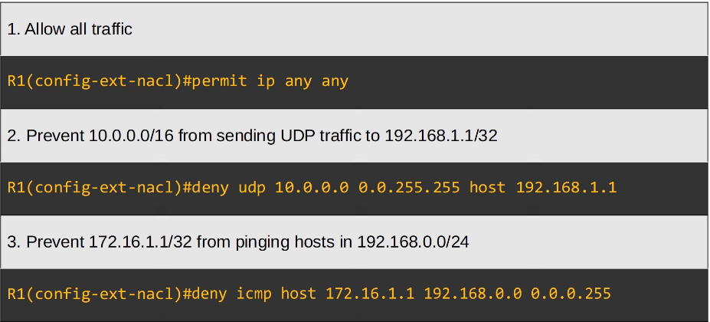

Matching the TCP/UDP port numbers

* When matching TCP/UDP, can optionally specify the source and/or destination port numbers to match
* Without port numbers
  + R1(config-ext-nacl)# **deny tcp** *src-ip dest-ip*
* With port numbers
  + R1(config-ext-nacl)# **deny tcp** *src-*ip [**eq** *src-port-num*] *dest-ip* [**eq** *dst-port-num*]
* "eq 80" = equal to port 80
* "gt 80" = greater than port 80 (81 and greater)
* "lt 80" = less than port 80 (79 and less)
* "neq 80" = not equal port 80
* "range 80 100" = from port 80 to 100

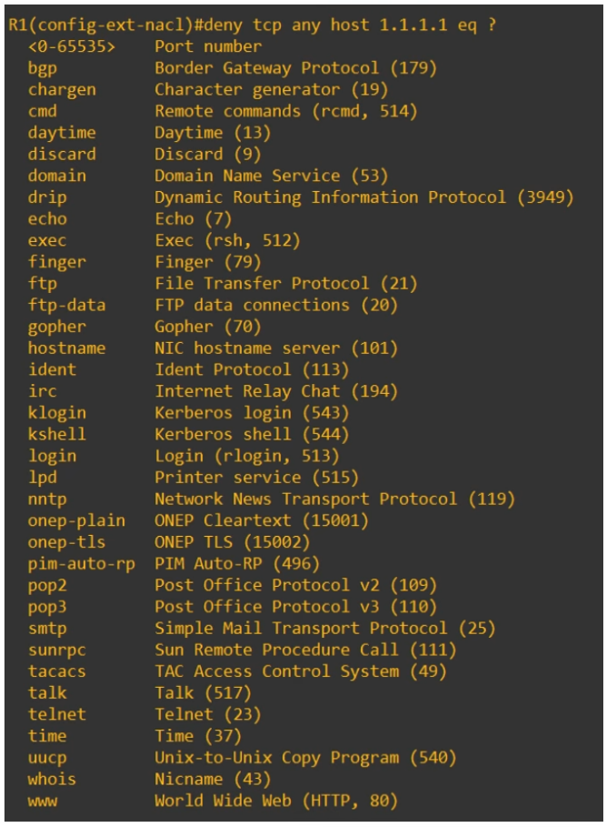



* Deny all packets destined for IP address 1.1.1.1/32, TCP port 80
* There are many more options that can be used to match (not in CCNA).

Some examples:

* "ack": match the TCP ACK flag
* "fin": match the TCP FIN flag
* "syn": match the TCP SYN flag
* "ttl": match packets with a specific TTL value
* "dscp": match packets with a specific DSCP value
* If you specify many fields, the packet must match all of the fields to match the ACL entry. Even if 1 does not match, won't match the ACL entry

Practice

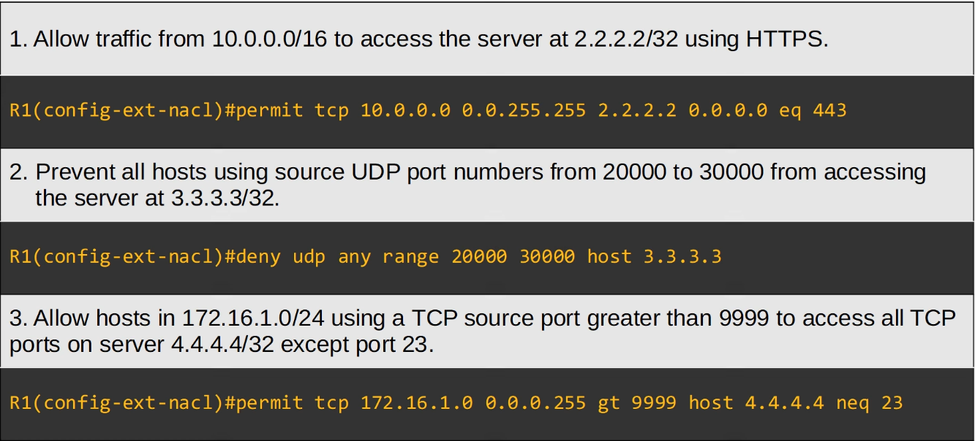

Example

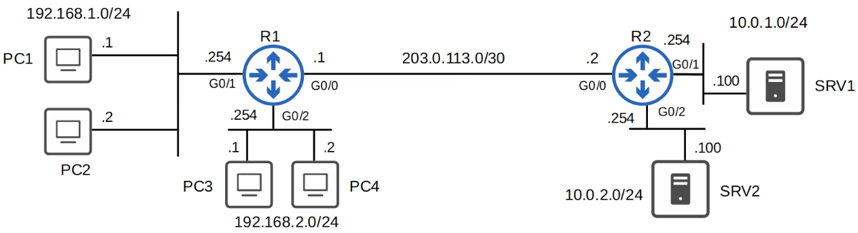

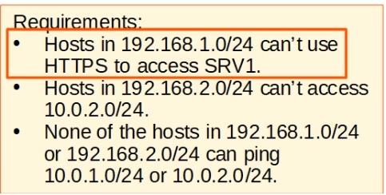

* NOTE: For extended ACLs, since very specific, should be applied closest to the source as possible

Requirement 1

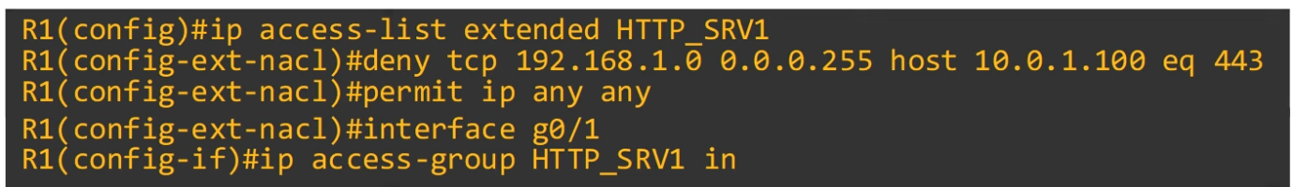

Requirement 2

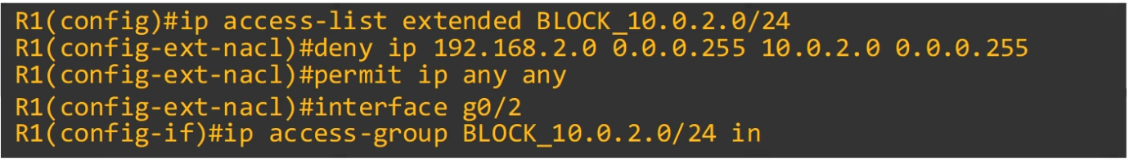

Requirement 3

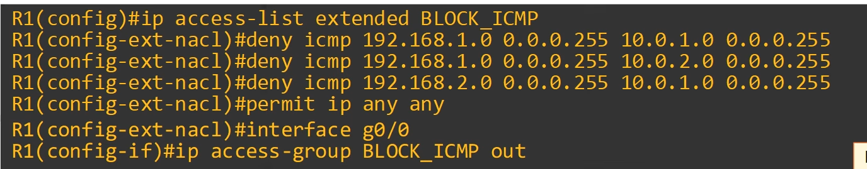

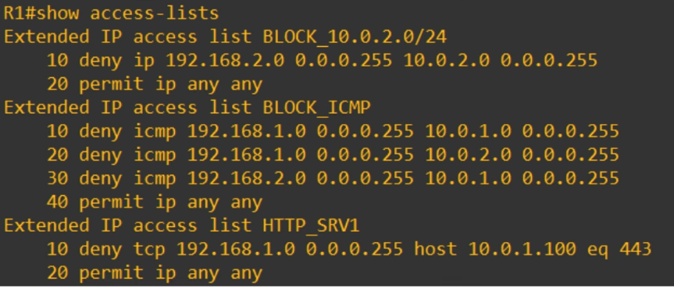

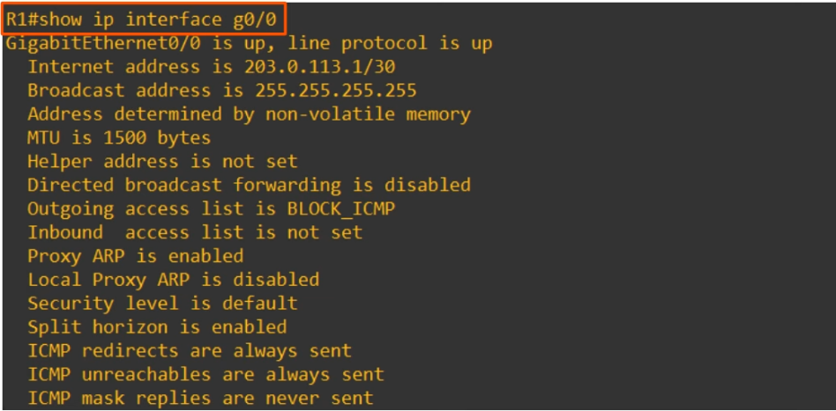

# Layer 2 Discovery Protocols (CDP & LLDP)

Things covered

* Intro
* Cisco Discovery Protocol (CDP)
* Link Layer Discovery Protocol (LLDP)

Intro

* Layer 2 Discovery Protocols such as CDP and LLDP share information with and discover info about neighbouring (connected) devices
* Operate at Layer 2
* The shared information includes: host name, IP address, device type, etc
* CDP is Cisco proprietary
* LLDP is industry standard protocol (IEEE 802.1AB)
* Because they share information about the devices in the network, they can be considered a security risk and are often not used. Up to the network engineer to decide if they want to use them or not

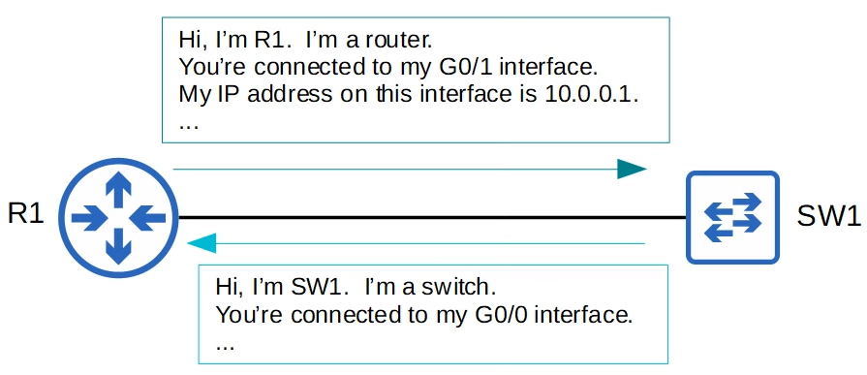

CDP (Cisco Discovery Protocol)

* Cisco proprietary
* Enabled on Cisco devices by default
* CDP messages are periodically sent to multicast MAC address 0100.0CCC.CCCC
* When a device receives a CDP message, it processes and discards the message
  + Does not forward it to other devices
  + Only connected neighbours can be CDP neighbours
  + Interface must be up for device to be neighbours
* By default, CDP messages are sent every 60s
* By default, CDP hold time is 180s
  + If message not received from neighbour after 180s, neighbour removed from CDP table
* CDPv2 messages are sent by default

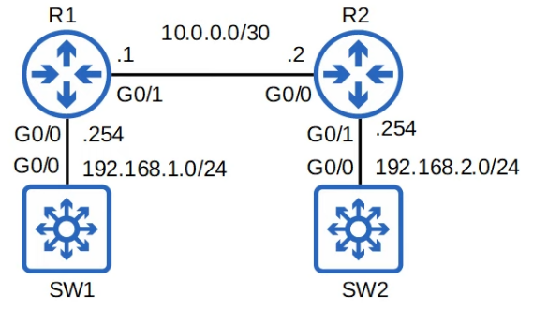

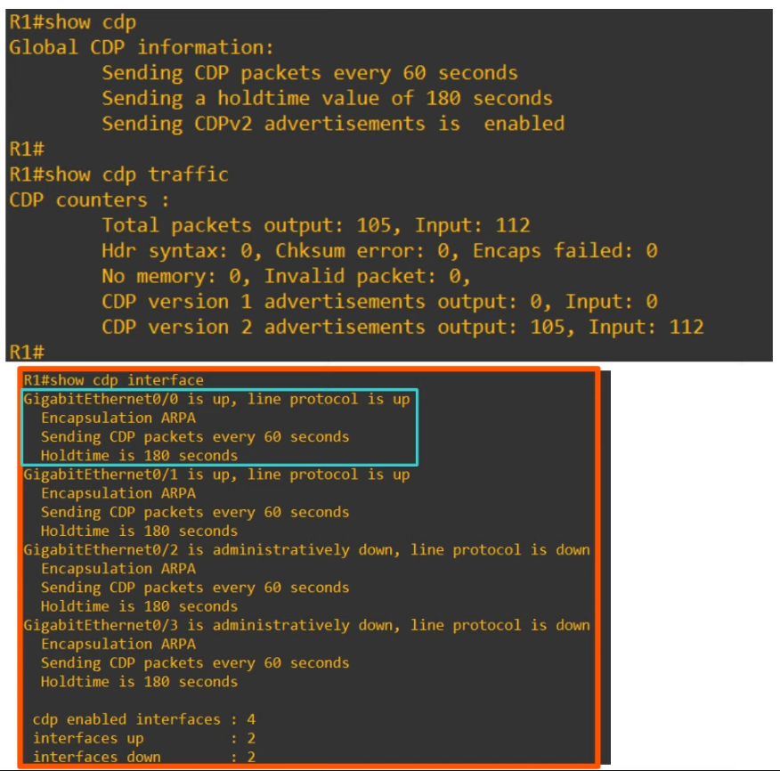

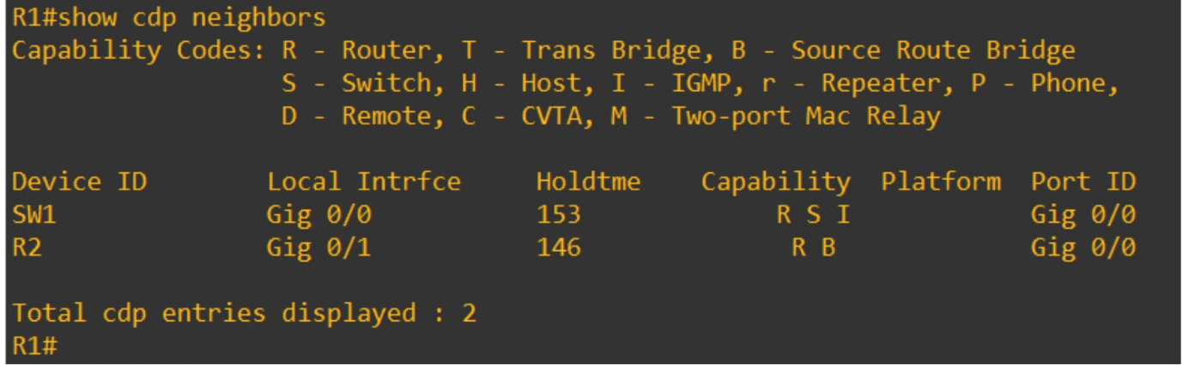

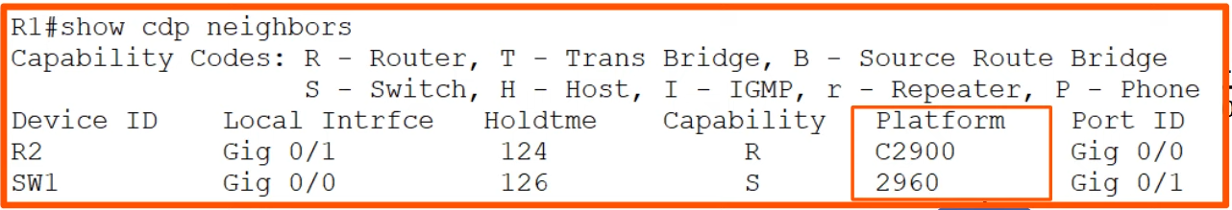

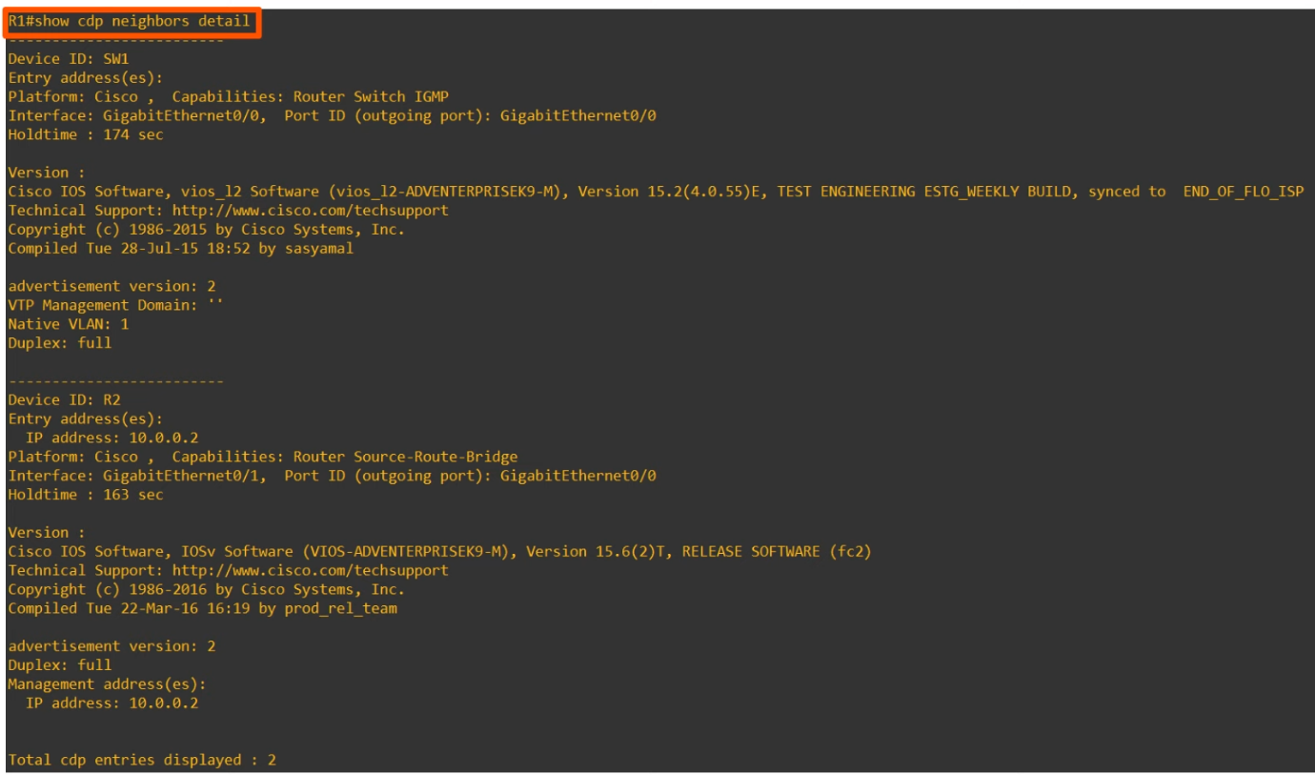

CDP show commands summary

* R1# **show cdp**
  + shows basic information about CDP (timers, version)
* R1# **show cdp traffic**
  + displays how many CDP messages have been sent and received
* R1# **show cdp interface**
  + displays which interfaces CDP is enabled on
* R1# **show cdp neighbors**
  + lists CDP neighbours and some basic information about each neighbour
* R1# **show cdp neighbors detail**
  + lists each CDP neighbour with more detailed information
* R1# **show cdp entry** *name*
  + displays the same info as above, but for the specified neighbour only

Config

* CDP is globally enabled by default
* CDP also enabled on each interface by default
* Enable/Disable CDP globally
  + R1(config)# **[no] cdp run**
* Enable/disable on specific interface
  + R1(config-if)# **[no] cdp enable**
* Configure timer
  + R1(config)# **cdp timer** *seconds*
* Configure holdtime
  + R1(config)# **cdp holdtime** *seconds*
* Enable/disable CDPv2 (if disable, v1 used)
  + R1(config)# **[no] cdp advertise-v2**

Link Layer Discovery Protocol

* Industry standard protocol (IEEE 802.1AB)
* Usually disabled on Cisco devices by default
* Device can run both CDP and LLDP at the same time
* LLDP messages are periodically sent to multicast address 0180.C200.000E
* When device receives LLDP message, it processes and discards the message
  + Does not forward it to others
* By default, message sent every 30s
* By default, LLDP hold time is 120s
* Additional timer called 'reinitialization timer'
  + If LLDP is enabled (globally/interface), this timer will delay the actual initialization of LLDP
  + 2s by default

Config

* LLDP globally disabled by default
* LLDP disabled on interface by default
* Enable globally
  + R1(config)# **lldp run**
* Enable on interface
  + R1(config-if)# **lldp transmit**
  + R1(config-if)# **lldp receive**
* Config timer
  + R1(config)# **lldp timer** *seconds*
* Config hold time
  + R1(config)# **lldp holdtime** *seconds*
* Config re-init timer
  + R1(config)# **lldp reinit** *seconds*

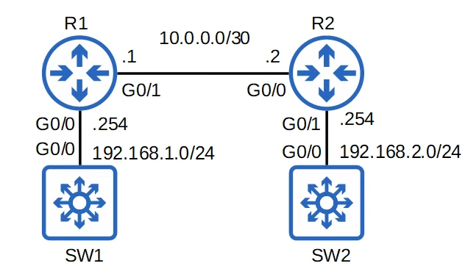

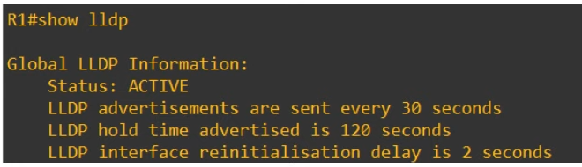

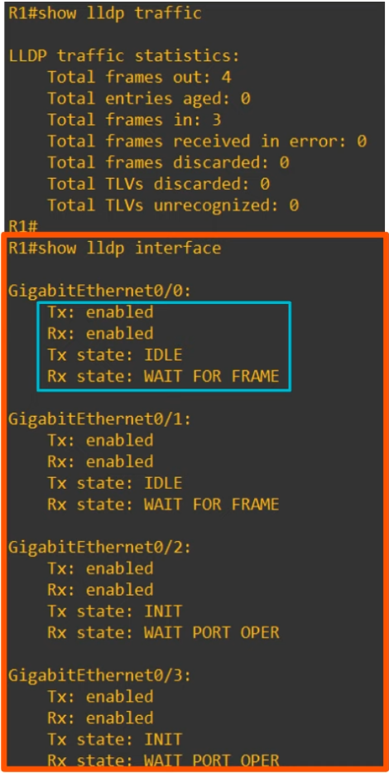

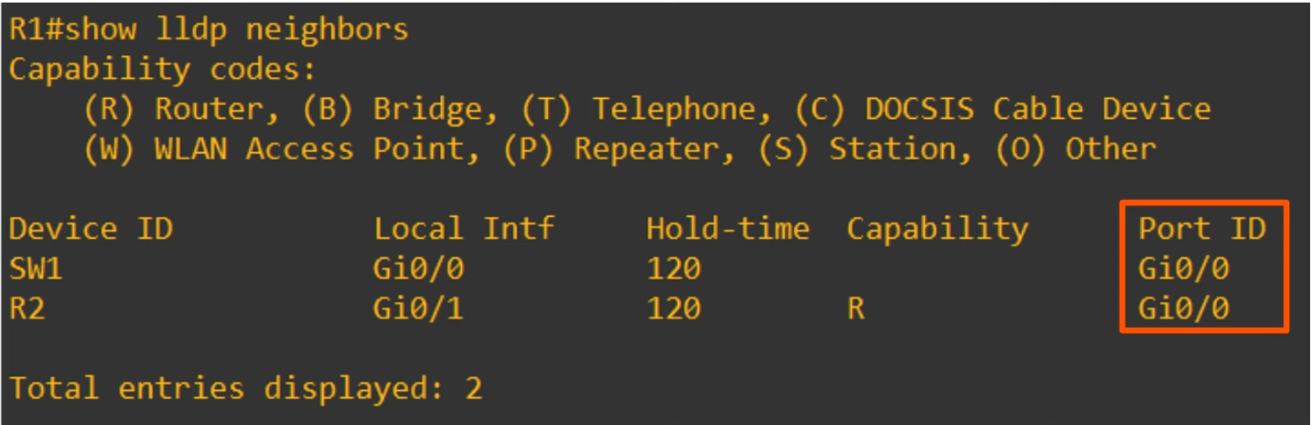

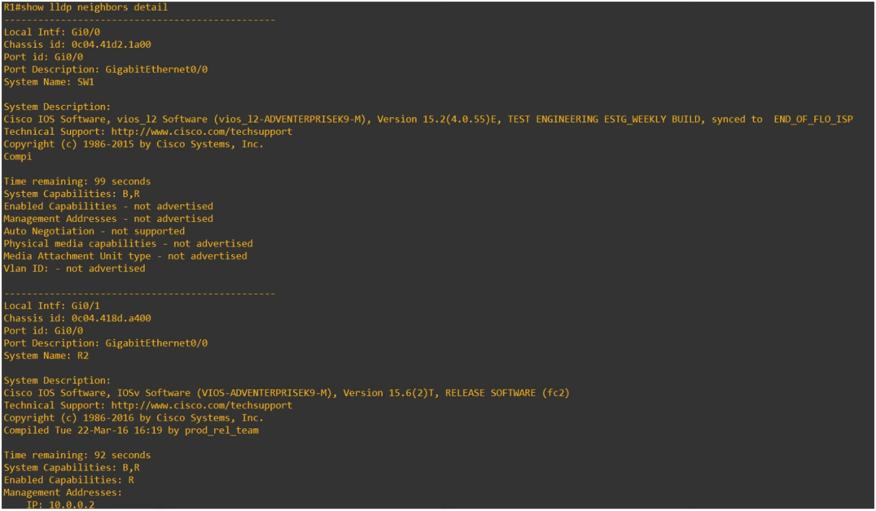

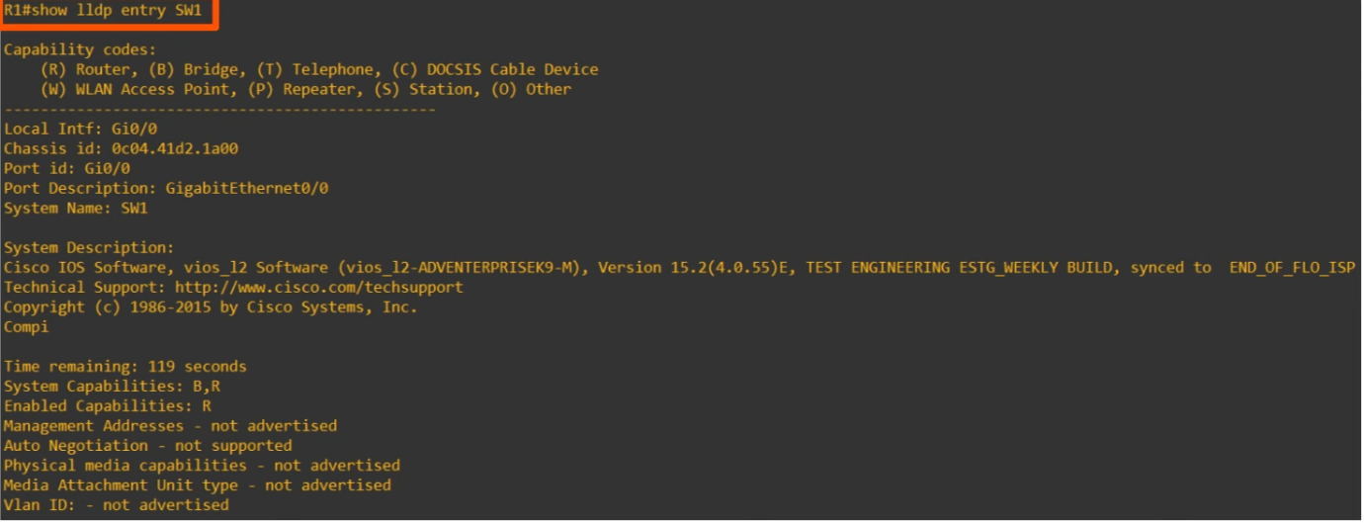

LLDP show commands summary

* R1# **show lldp**
  + shows basic information about LLDP (timers, version)
* R1# **show lldp traffic**
  + displays how many LLDP messages have been sent and received
* R1# **show lldp interface**
  + displays which interfaces LLDP tx/rx is enabled on
* R1# **show lldp neighbors**
  + lists LLDP neighbors and some basic information about each neighbor
* R1# **show lldp neighbors detail**
  + lists each LLDP neighbor with more detailed information
* R1# **show lldp entry** *name*
  + displays the same info as above, but for the specified neighbor only

Wireshark Capture

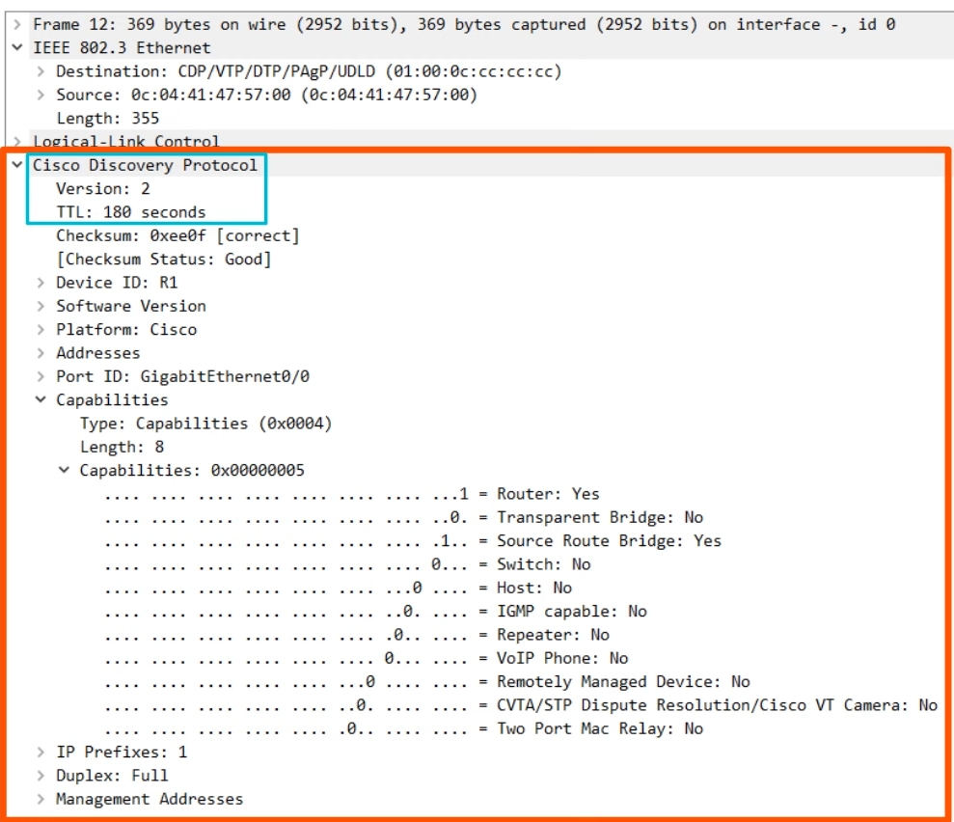

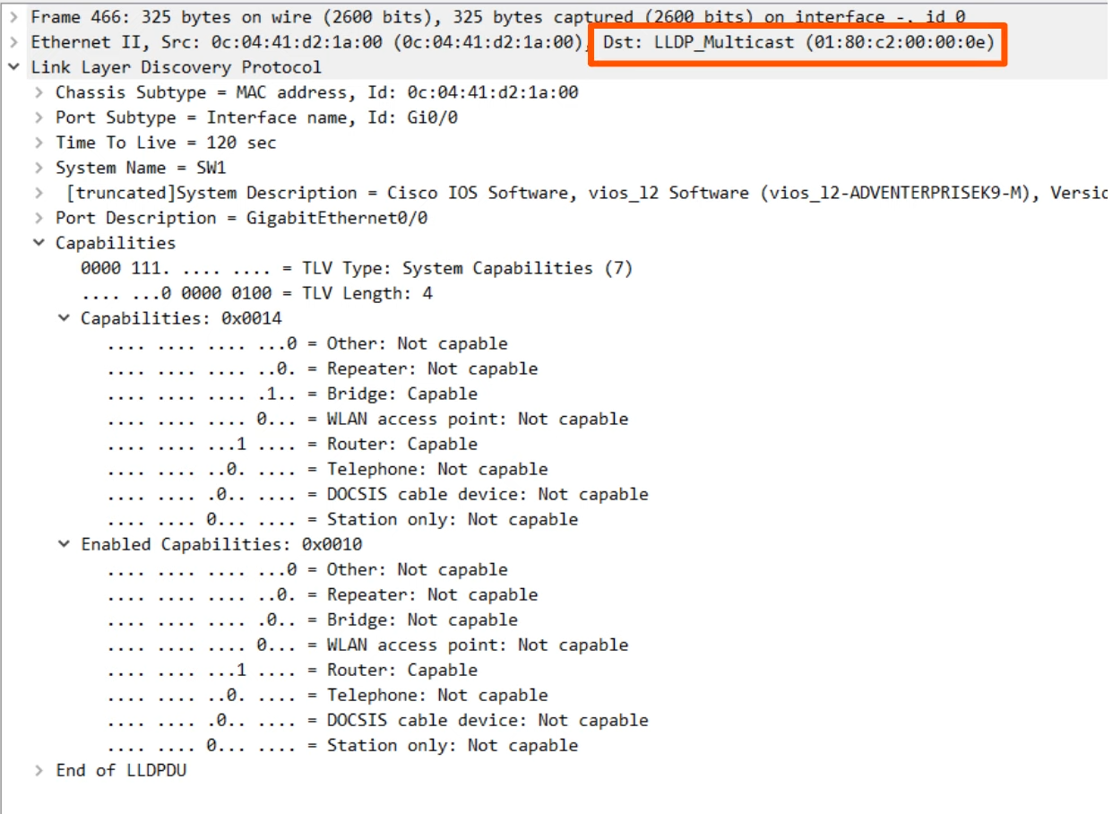

# Network Time Protocol (NTP)

Things covered

* Why is time important for network devices
* Manual time config
* NTP basics
* NTP config

**The importance of time**

* All devices have an internal clock (routers, switches, PC, etc)
* In Cisco can view time
  + "show clock [detail]"



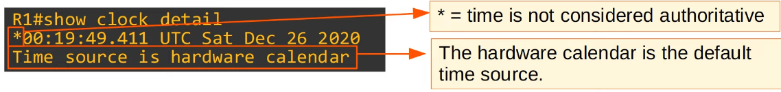

* The internal hardware clock will drift over time, so it is not the ideal time source
* For CCNA, the most important reason to have accurate time on a device is to have accurate logs for troubleshooting
  + Syslog

**"show logging"**

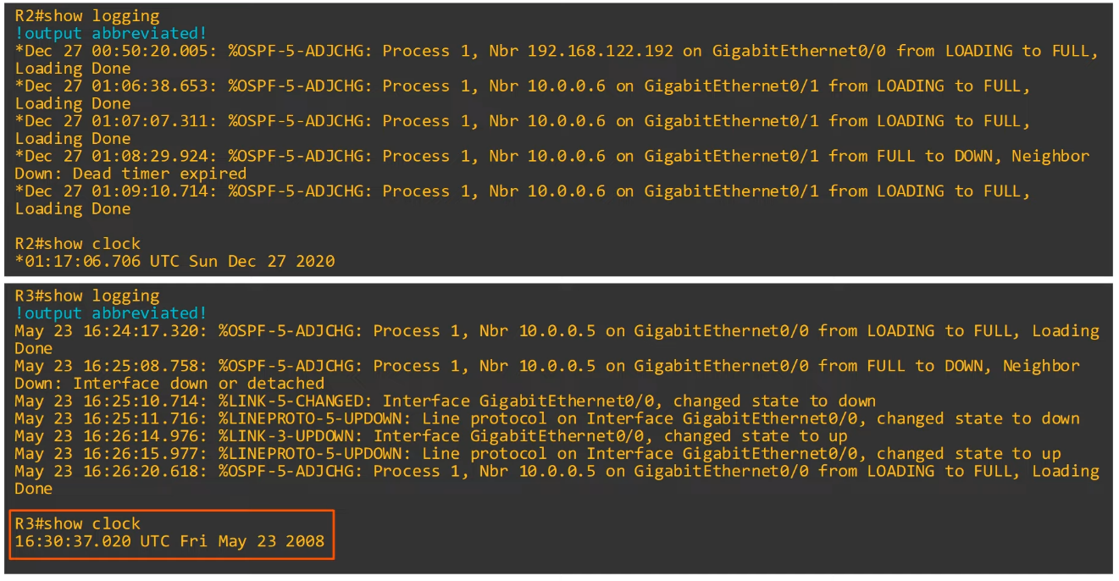

**Manual Time Config**

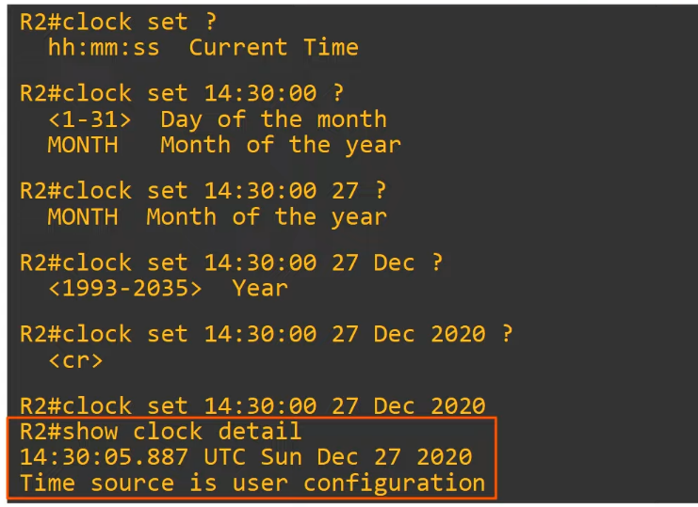

* R1# **clock set** *hh:mm:ss day month year*
* Although the hardware calendar (built-in clock) is the default time-source, the hardware clock and the software clock are separate and can be configured separately

**Hardware Clock (Calendar) Config**

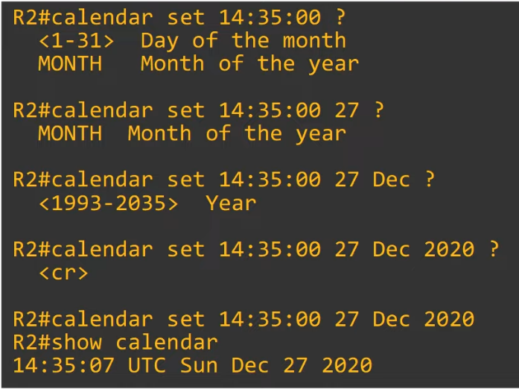

* R1# **calendar set** *hh:mm:ss day month year*
* Typically, you want to sync 'clock' and 'calendar'
* **'clock update-calendar**': sync calendar to clock time
* '**clock read-calendar**': sync clock to calendar time

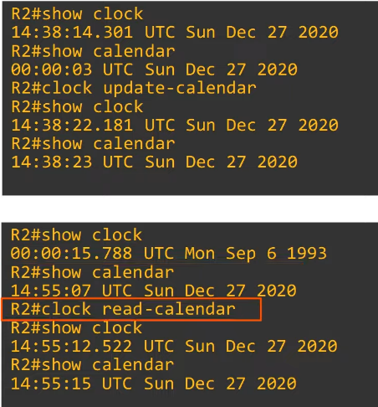

**Config Time Zone**

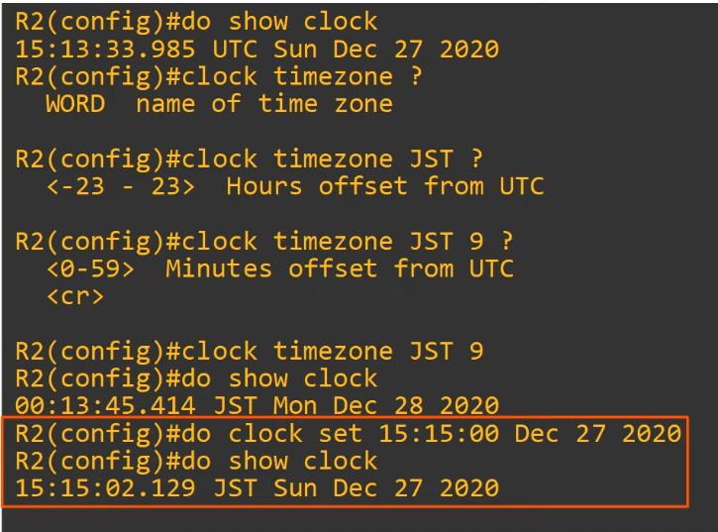

* R1(config)# **clock timezone** *time-zone-name UTC-offset*

**Daylight Saving Time**

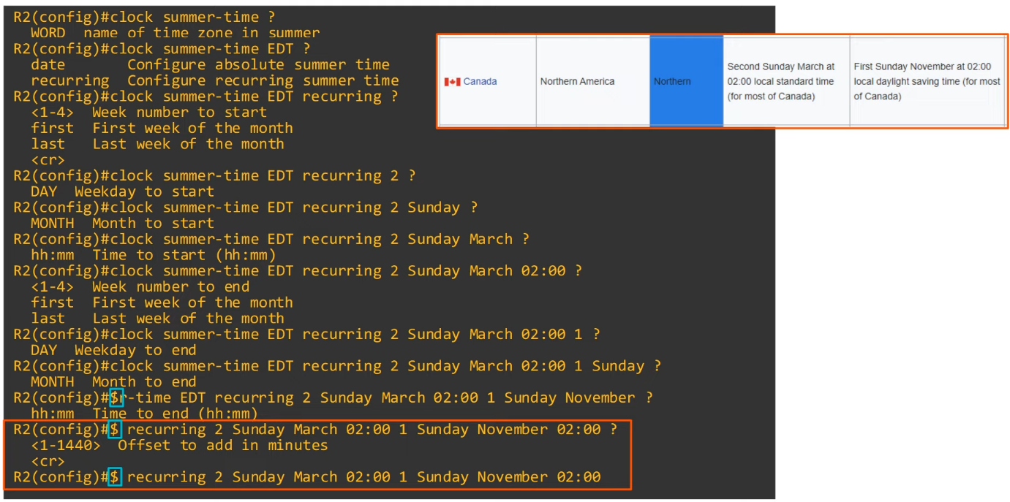

* '$': too long to be shown in one line

**NTP (Network Time Protocol)**

* Manually configuring the time is not scalable
* The manually configured clocks will drift, resulting in inaccurate time
* NTP allows automatic syncing of time over network
* NTP clients request the time from NTP servers
* A device can be an NTP server and client at the same time
* NTP allows accuracy of time
  + Within ~1ms if NTP within same LAN
  + Within ~50ms if NTP connected over a WAN/ the Internet
* Some NTP servers are 'better' than others
  + 'Distance' of an NTP server from the original **reference clock** is called **stratum**
* UPD port 123

**Reference Clock**

* A reference clock is usually a very accurate time device like an atomic clock or a GPS clock
* Reference clocks are **stratum 0** within the NTP hierarchy
* NTP servers directly connected to reference clocks are **stratum 1**

**NTP Hierarchy**

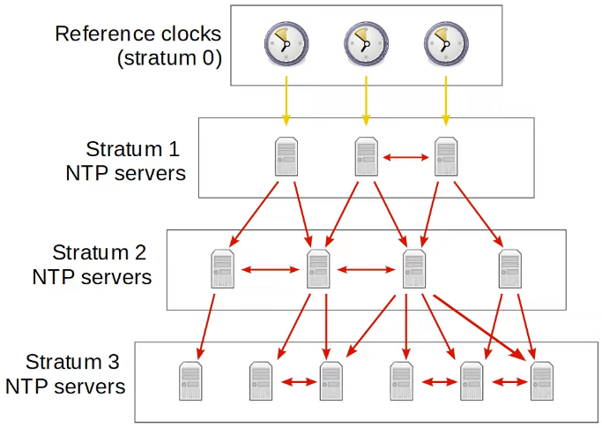

* Reference clocks are stratum 0
* Stratum 1 NTP servers get time from reference clocks
* Stratum 2 NTP servers get time from stratum 1 servers
* Continue on the same
* Max: Stratum 15
  + Anything more is considered unreliable
* Devices can also 'peer' with devices at the same stratum to provide more accurate time
  + Can also act as a backup if lose access to lower stratum server
  + Called 'symmetric active' mode
* Cisco devices can operate in 3 NTP modes
  + Server
  + Client
  + Symmetric Active
* Can be all 3 at the same time
* An NTP client can sync to multiple NTP servers
* Primary Servers
  + NTP servers which get their time directly from reference clocks
  + Stratum 1 servers
* Secondary servers
  + NTP servers that get their time from other NTP servers
  + Stratum 2 or more
  + Operate in server and client mode at the same time

**NTP Config**

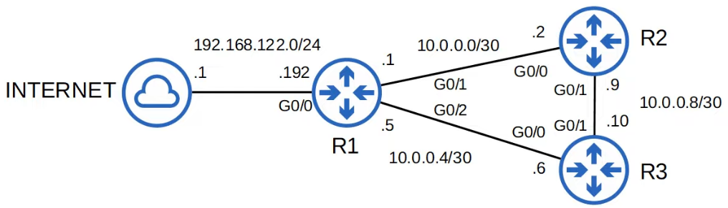

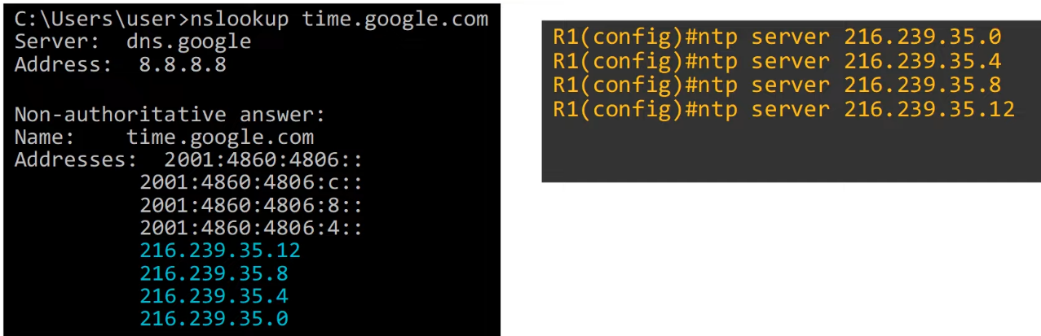

* Good to use multiple servers in case 1 fails
* Device will choose the one with the fastest reply
* Can put 'prefer' at the end of command if want to prefer a particular server

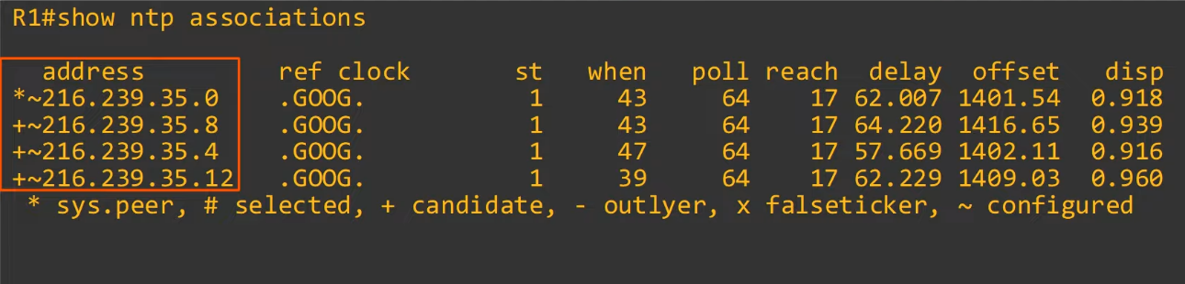

* '*': currently connected to the server
* '+': candidate, but not currently syncing time to that server
* '~': configured, means user key in
* '-'/'x': device will not sync to that server

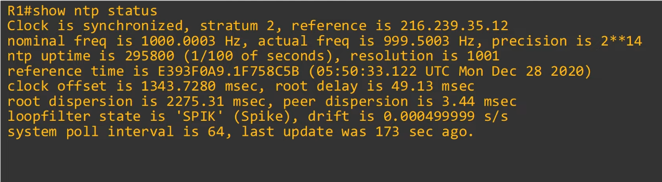

* 'Clock is synchronized': R1 is able to sync to one of the configured servers
* 'stratum 2'
  + Because R1 is syncing its time to Google's NTP servers, it automatically becomes an NTP server itself (stratum lvl 1 higher than Google's NTP servers).
  + Now other devices can sync their time to R1
* 'reference is 216…..': refers to the NTP server IP address

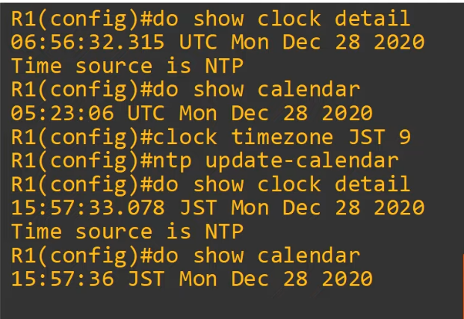

* The hardware clock tracks the date and time on the device even if it restarts, power is lost, etc
  + When the system is restarted, the hardware clock is used to initialize the software clock



* Use loopback address so that other devices can connect to it and when an interface on R1 is down, other devices can use another route since connect to loopback address
  + Configure dynamic routing (e.g. OSPF)

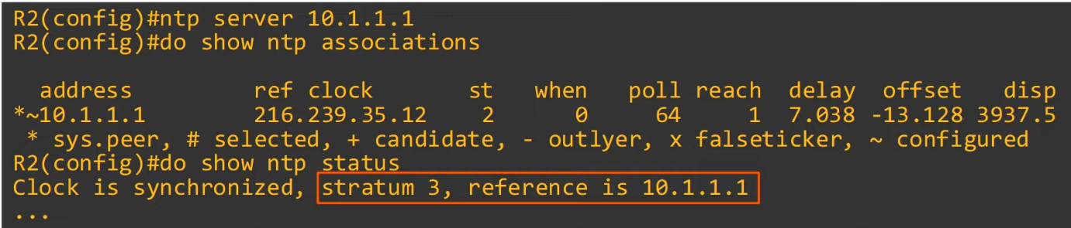

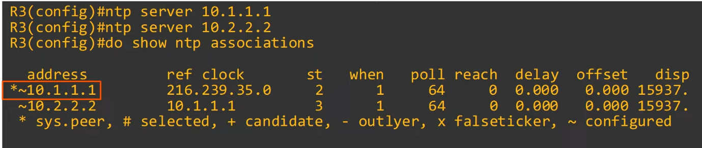

* 10.2.2.2 is R2 loopback interface
* R1 10.1.1.1 is preferred due to its lower stratum level

**Config NTP server mode**

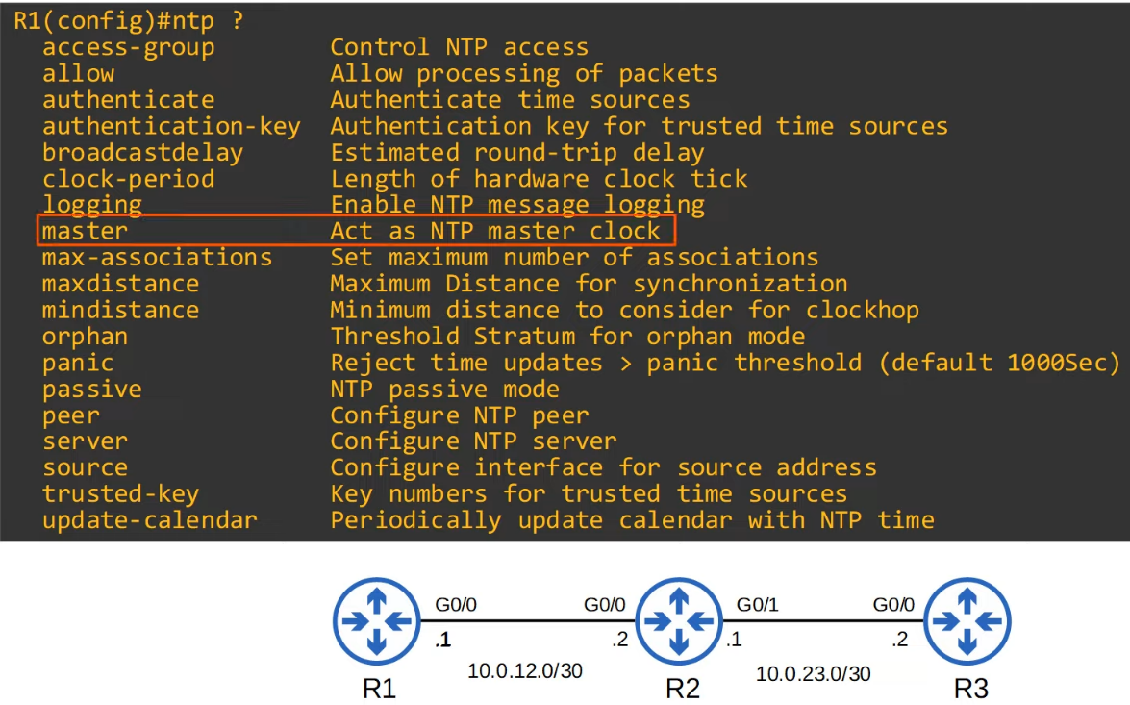

* R1 is not connected to any NTP server but now ones to become an NTP server

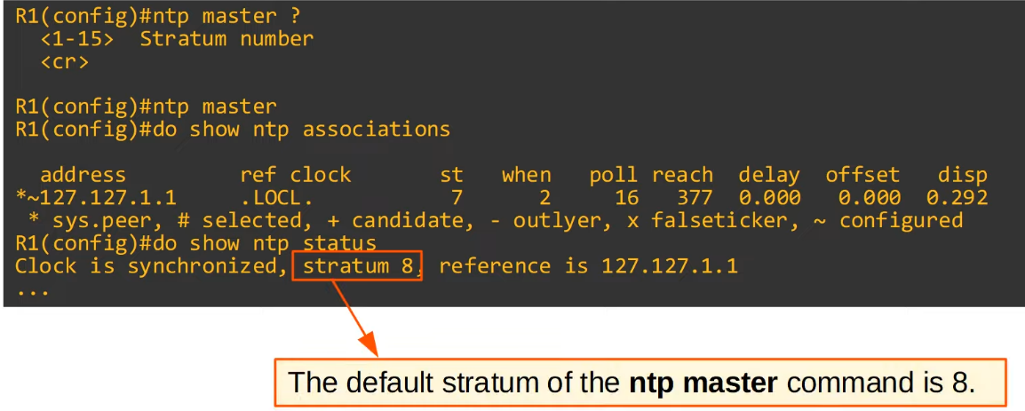

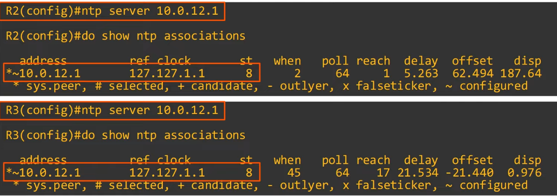

**Config Symmetric Active Mode**

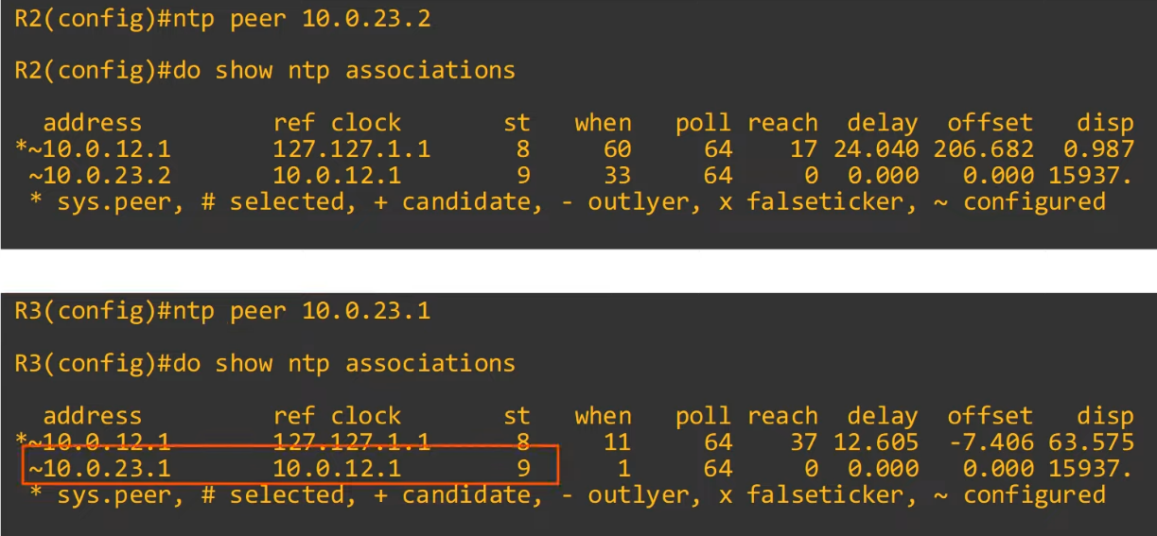

**Config NTP Authentication**

* NTP authentication can be configured, although it is optional
* Allows NTP clients to ensure they only sync to intended servers
* To configure NTP authentication
  + Enable NTP authentication
    - "**ntp authenticate**"
  + Create the NTP authentication key(s)
    - "**ntp authentication-key** *key-number*  **md5** *key"*
  + Specify the trusted key(s)
    - "**ntp trusted-key** *key-number*"
  + Specify which key to use for the server
    - "**ntp server** *ip-address* **key** *key-number*"
    - Config not needed for NTP server (R1)

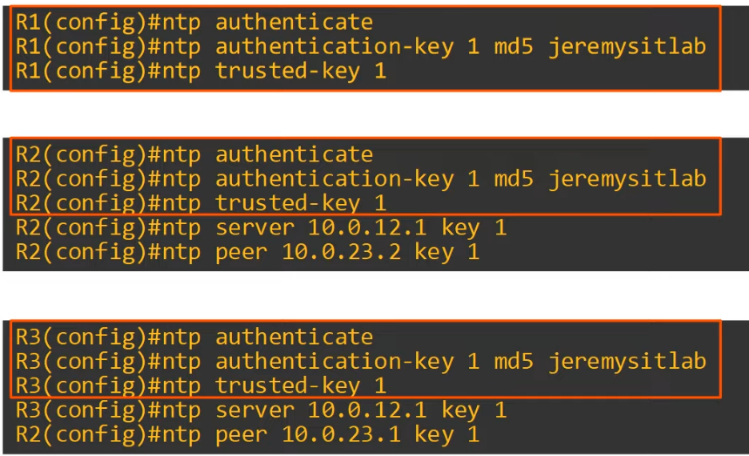

**Summary**

Basic Configuration Commands

* R1(config)# **ntp server** *ip-address* [**prefer**]
* R1(config)# **ntp peer** *ip-address*
* R1(config)# **ntp update-calendar**
* R1(config)# **ntp master** [*stratum*]
* R1(config)# **ntp source** *interface*

Basic Show Commands

* R1# **show ntp associations**
* R1# **show ntp status**

Basic Authentication Commands

* R1(config)# **ntp authenticate**
* R1(config)# **ntp authentication-key** *key-number* **md5** *key*
* R1(config)# **ntp trusted-key** *key-number*
* R1(config)# **ntp server** *ip-address* **key** *key-number*
* R1(config)# **ntp peer** *ip-address* **key** *key-number*

# Domain Name System (DNS)

Things covered

* Purpose of DNS
* Basic functions of DNS
* Config DNS

**Purpose of DNS**

* Used to resolve human-readable names (google.com) to IP addresses
* Machines such as PCs don't use names, they use addresses (i.e. IPv4/IPv6)
* Names are much easier for us to use and remember than IP address
* When you type 'youtube.com' into a web browser, your device will ask a DNS server for the IP address of youtube.com
* The DNS server(s) your device uses can be manually configured or learned via DHCP

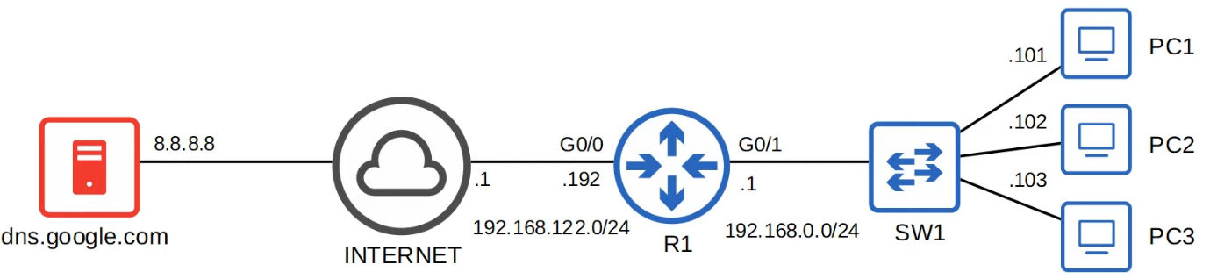

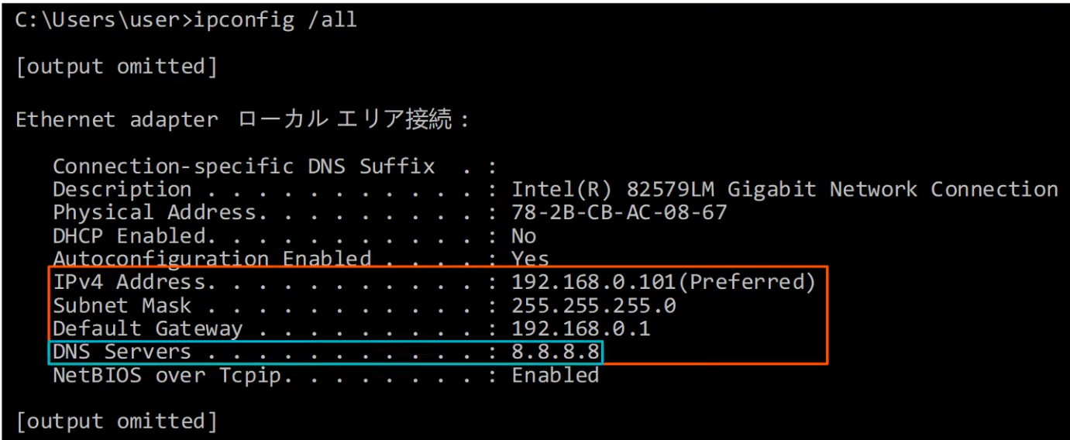

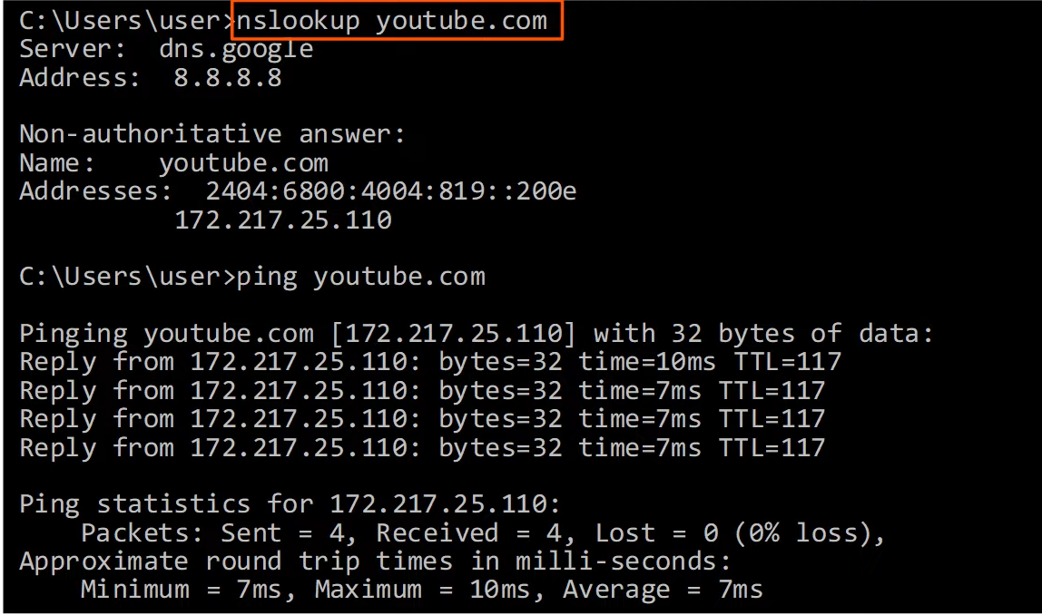

* Don't have to use the 'nslookup' command before sending a ping.
  + If your device don't know the correct IP address, it will automatically ask the server

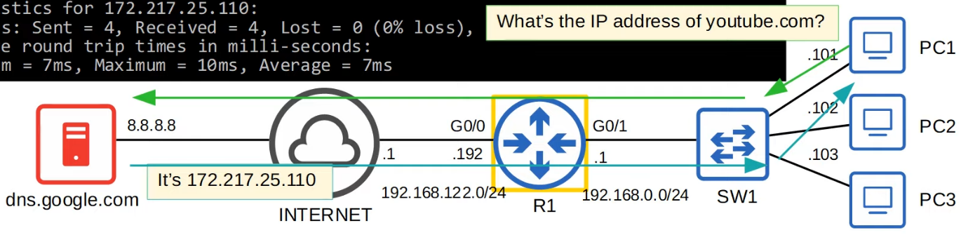

* R1 is not acting as a DNS server or client. It simply forwarding packets
* NO DNS configuration is required for R1

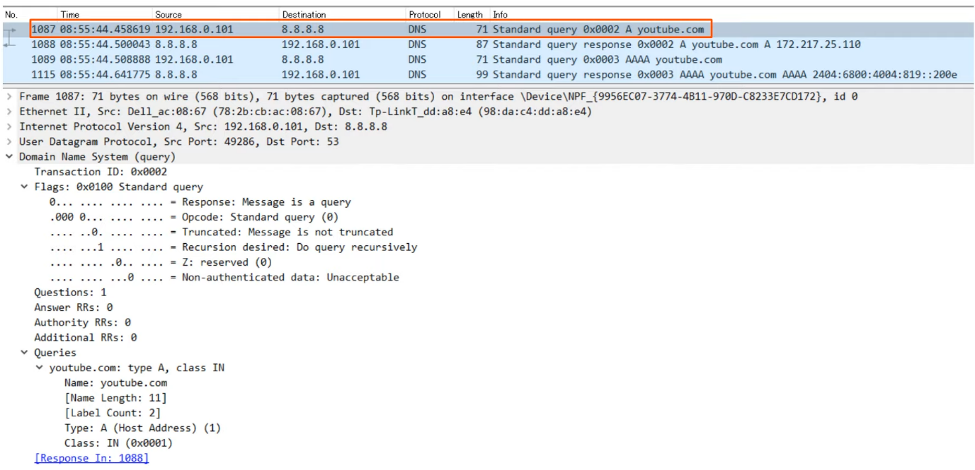

* DNS 'A' record = Used to map names to IPv4 addresses
* DNS 'AAAA' record = Used to map names to IPv6 addresses
* Standard DNS queries/responses typically use UDP
  + TCP is used for DNS messages greater than 512 bytes
  + In either case, port 53 is used

**DNS Cache**

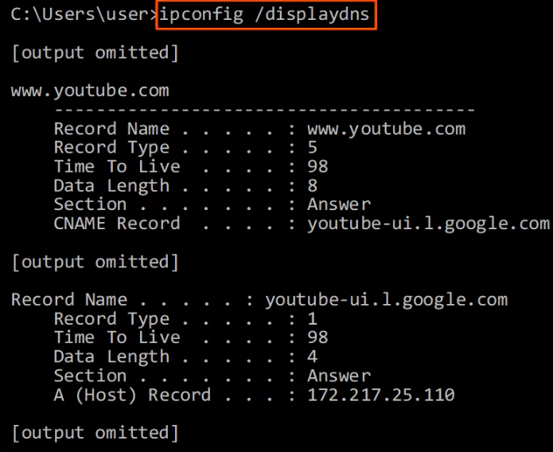

* Devices will save the DNS server's responses to a local DNS cache
* Devices don't have to query the server every single time they want to access a particular destination
* "ipconfig /displaydns"

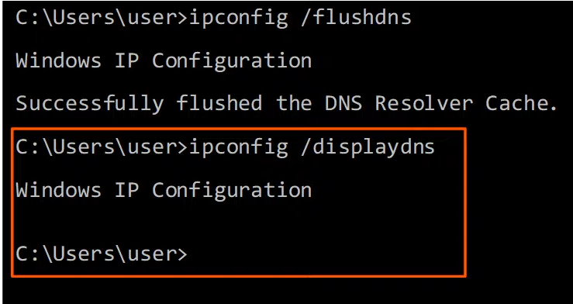

* "ipconfig /flushdns" used to clear the DNS cache

**Host file**

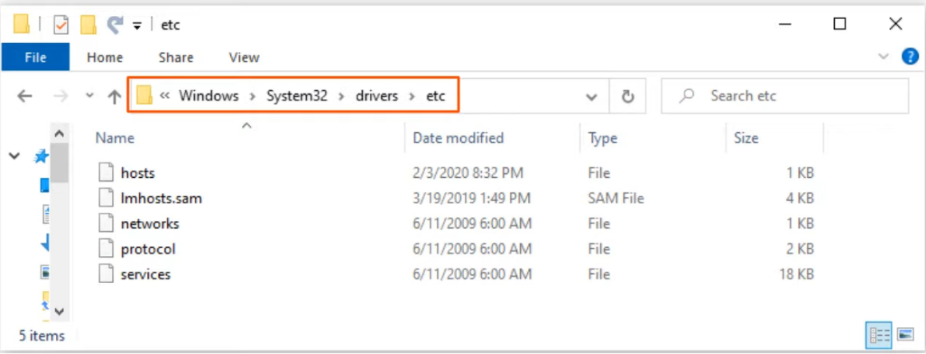

* Most computers have a list of host files which stores a list of hosts and IP addresses

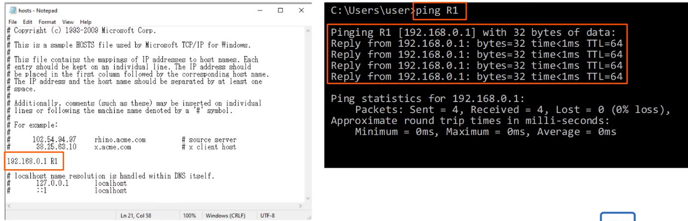

**DNS in Cisco IOS**

* For hosts in a network to use DNS, you don't need to configure DNS on the routers
  + They will simply forward the DNS messages like any other packets
* However, a Cisco router can be configured as a DNS server, although it is rare
  + If an internal (within a LAN) DNS server is used, usually it's a windows or Linux server
* A Cisco router can also be configured as a DNS client

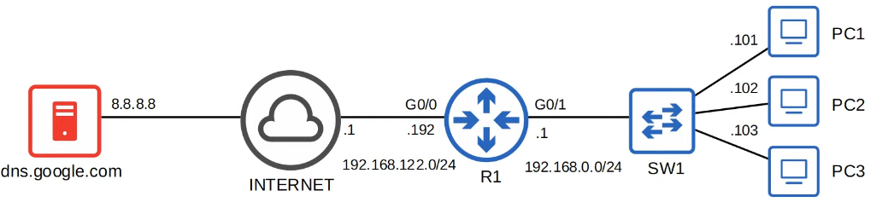

**Set as server**

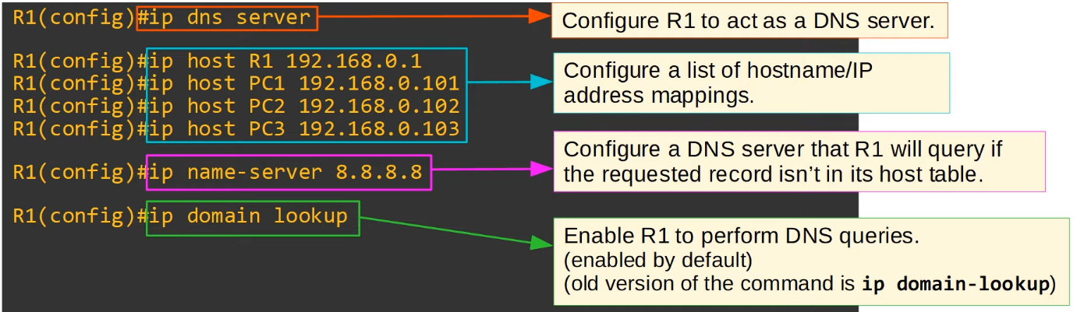

**Ping**

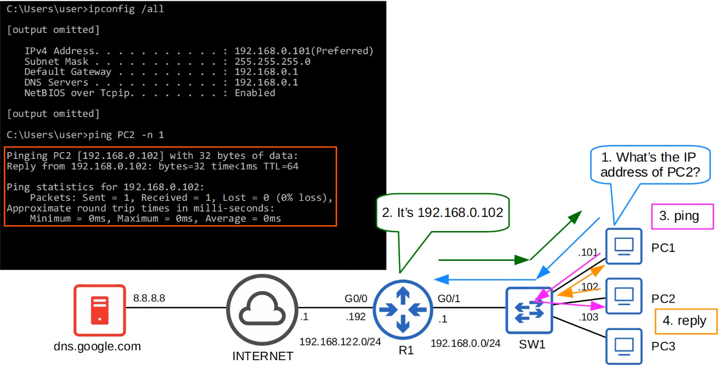

* After the reply from R1 (step 2), PC1 will have the IP address of R2 in its cache table
  + Won't need to send a request anymore for IP address of R2

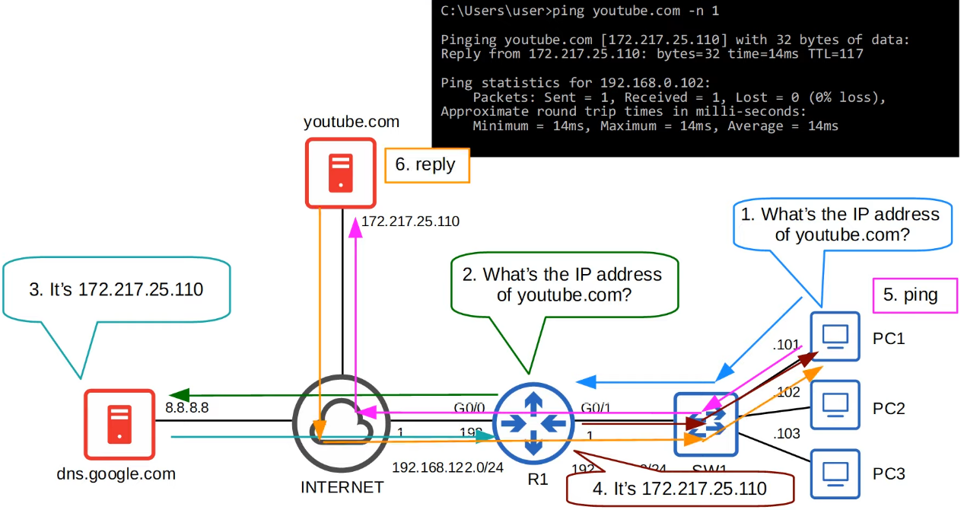

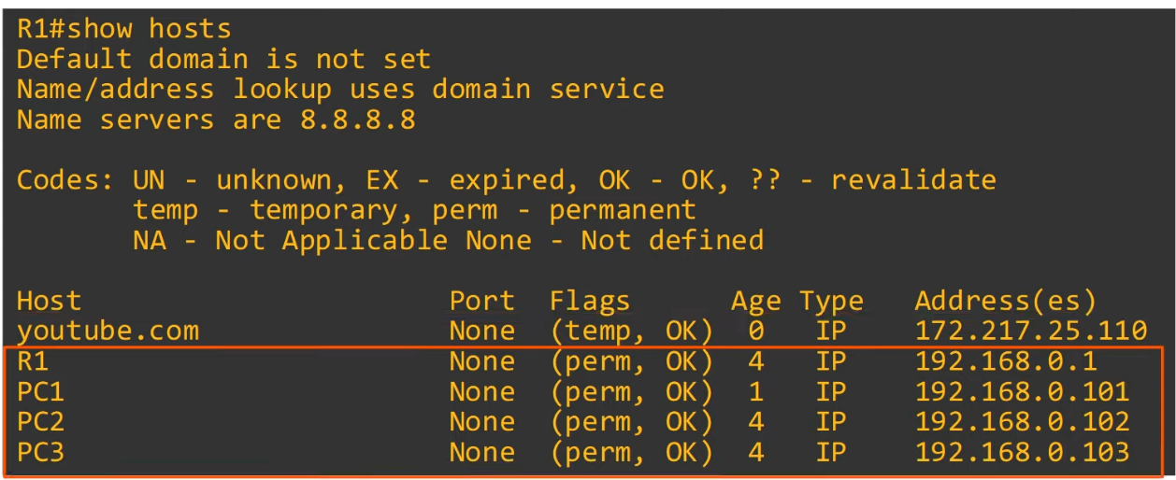

**Set as client**

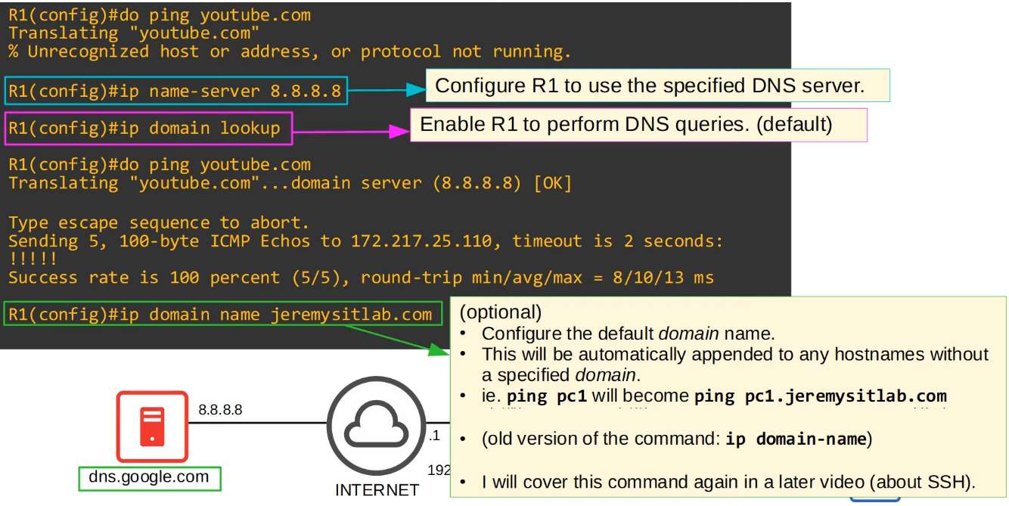

**Review**

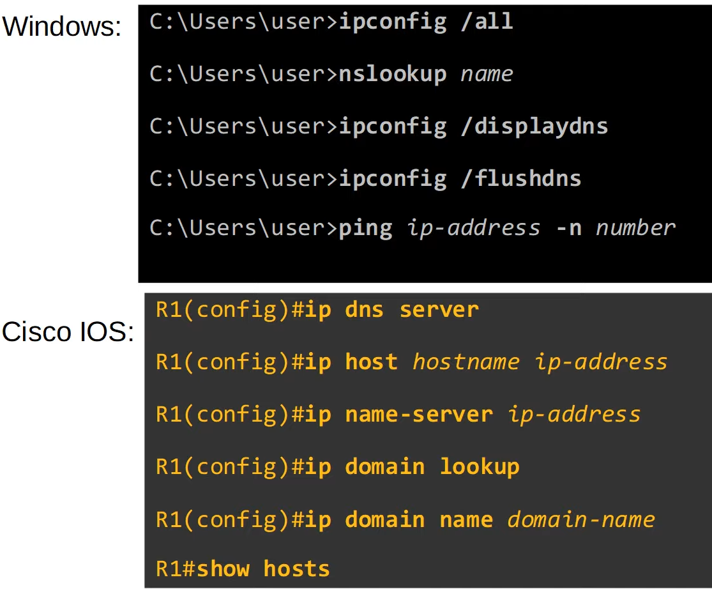

# Dynamic Host Configuration Protocol (DHCP)

Things Covered

* Purpose of DHCP
* Basic functions of DHCP
* Config

**Purpose of DHCP**

* DHCP is used to allow hosts to automatically/dynamically learn various aspects of their network configuration (i.e. IP address, subnet mask, default gateway, DNS server) without manual/static configuration
* It is an essential part of modern networks
* Typically used for 'client devices' such as workstations (PC), phones, etc
* Devices such as routers, servers, etc are usually manually configured
* In small networks (such as home networks), the router typically acts as the DHCP server for the hosts in the LAN
* In larger networks, the DHCP server is usually a Windows/Linux server

**Basic Functions of DHCP**

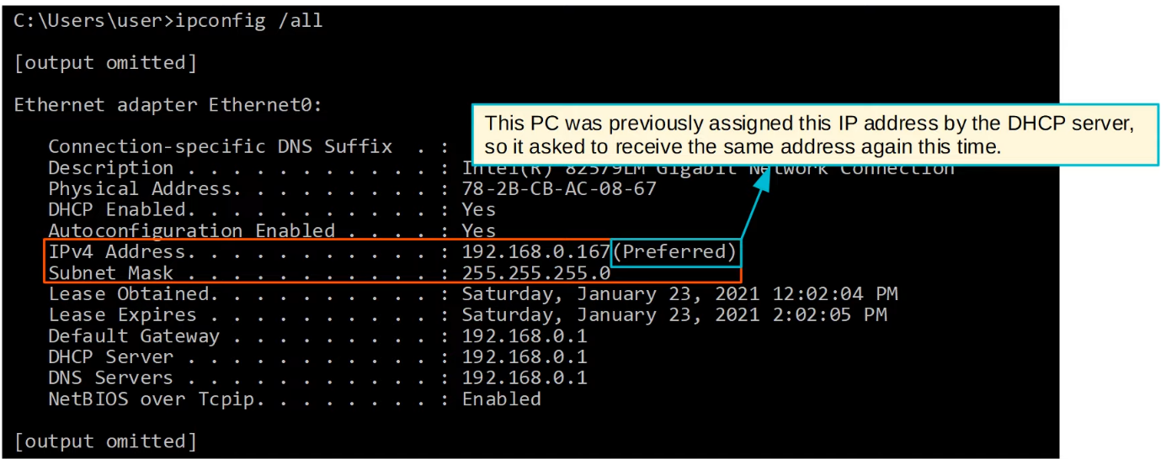

* Lease Obtained/Expires
  + DHCP server 'lease' IP addresses to clients
  + These leases are usually not permanent, and the client must give up the address at the end of the lease

**"ipconfig /release"**

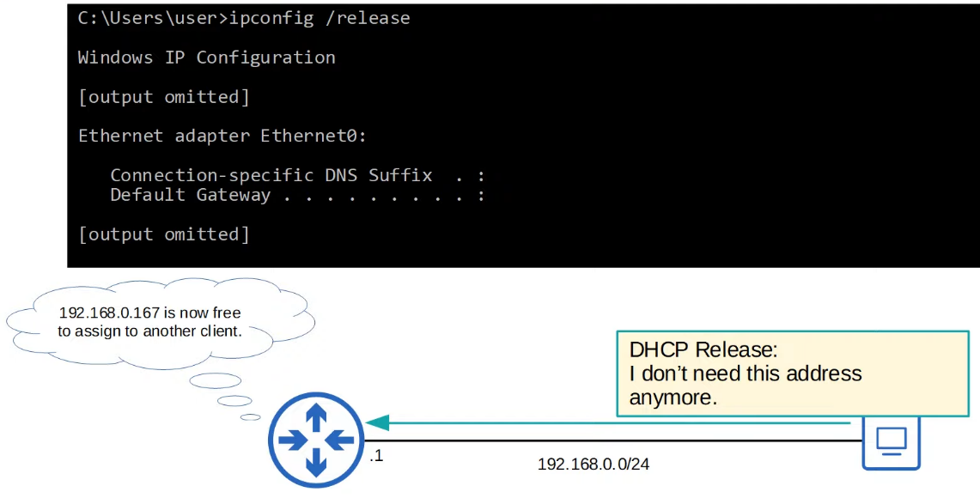

DHCP Release

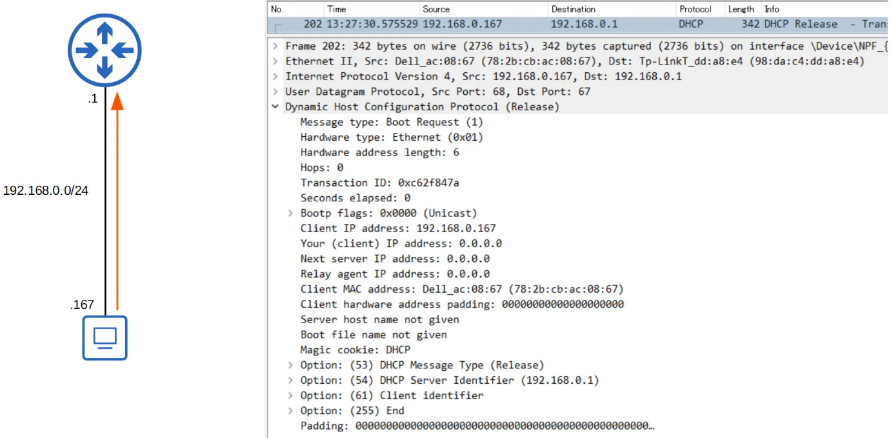

* Ports
  + DHCP Server: UDP 67
  + DHCP Client: UDP 68

**Ipconfig /renew**

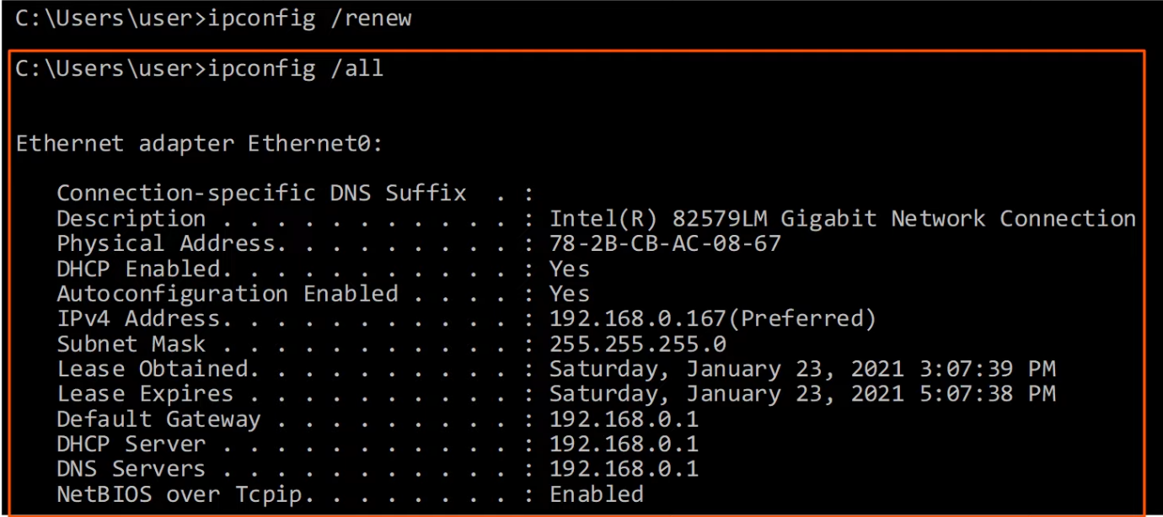

**DHCP Discover**

* Client send out "are there any DHCP servers in this network? I need an IP address"

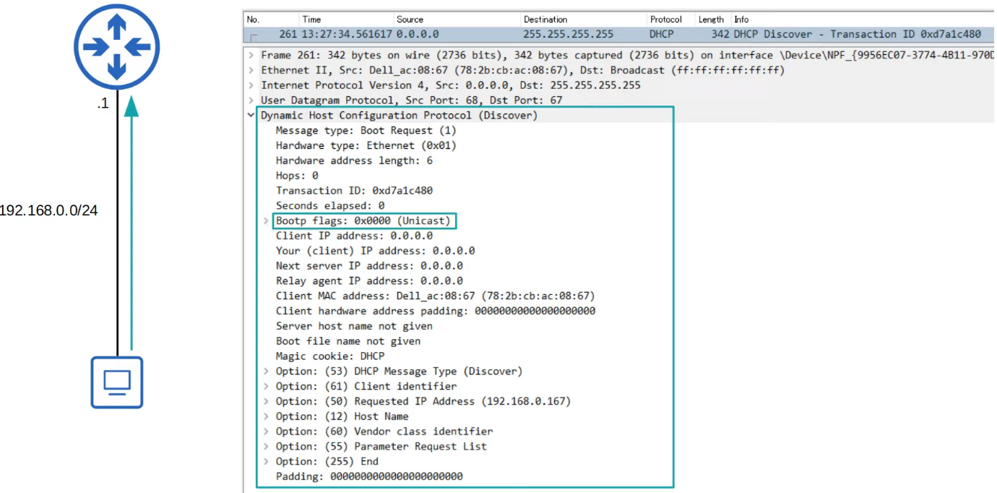

* Client (PC) sends a broadcast message
* Don't have an IP, so uses 0.0.0.0
* Option (50): Requested IP address
  + The PC previously used that IP address and now requesting to use it again

**DHCP Offer**

* Server to client: "How about this IP address?"

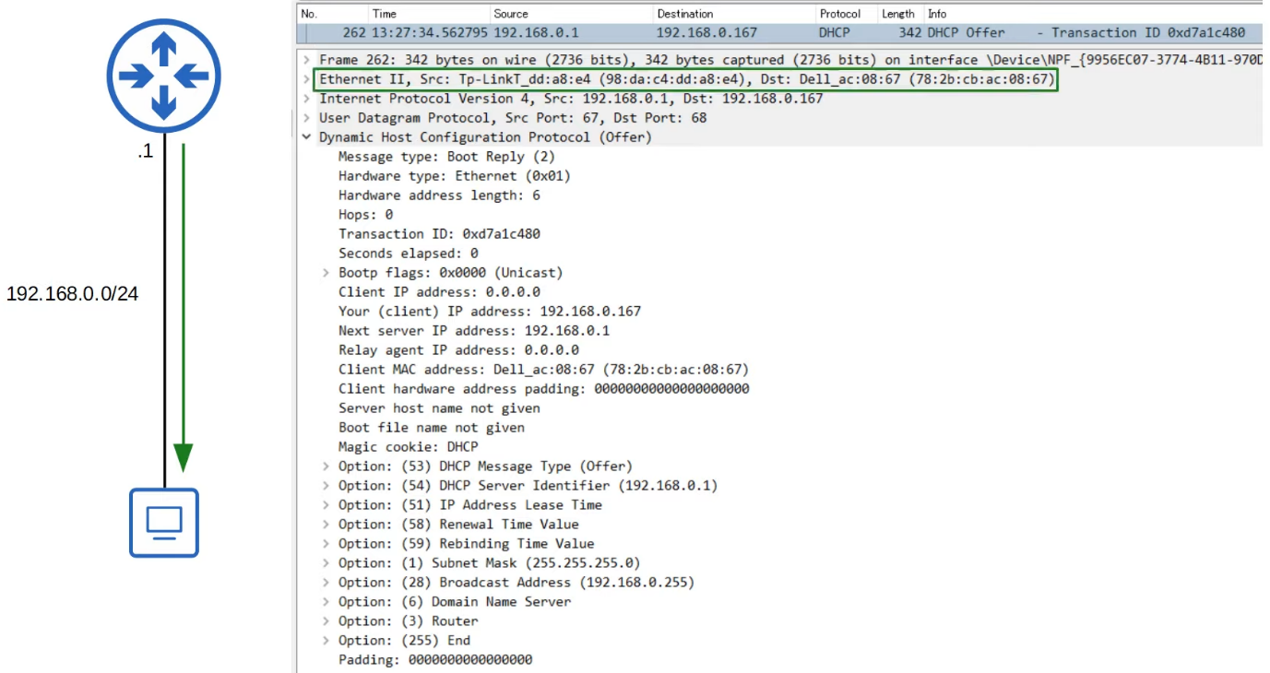

* Destination MAC: PC's MAC address
* Destination IP: Offered IP address
* Bootp flags: unicast
  + The DHCP offer message can be either unicast or broadcast
  + Requested by the PC
  + If broadcast, destination MAC is all F, and destination IP is 255.255.255.255
* The IP address of the PC is still not configured now, and some PCs would not accept unicast message as a result
  + That is why broadcast is needed

**DHCP Request**

* DHCP Client to DHCP server
  + "I want to use the IP address you offered me"
* There may be multiple DHCP server, so PC may have received multiple DHCP offers
  + Client to have tell which server it wants to accept from
  + Normally accept the first offer received

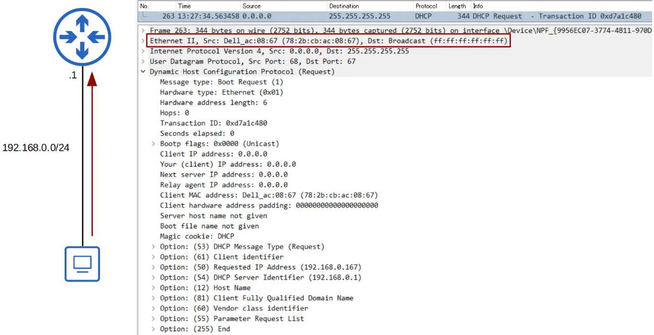

* Option (54)
  + This is how the PC specify which DHCP server to accept from

**DHCP Ack**

* DHCP server -> DHCP client
  + "Ok, you may use it"
* Once client receives this message, client will configure the IP address on its interface

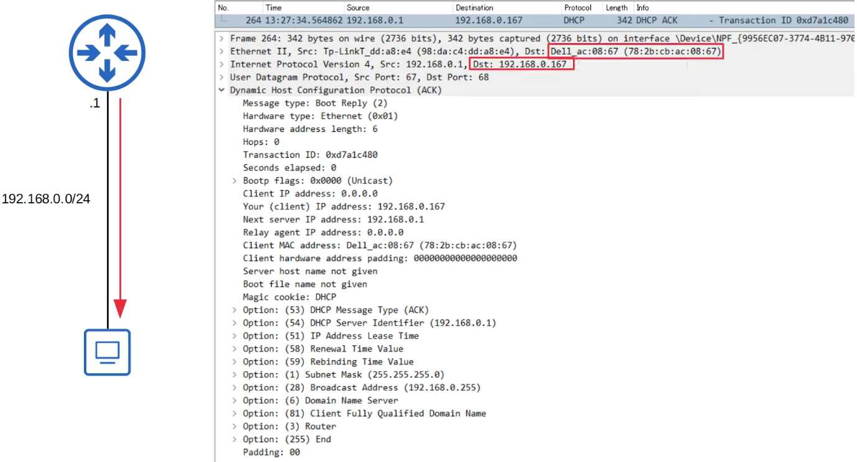

**Summary**

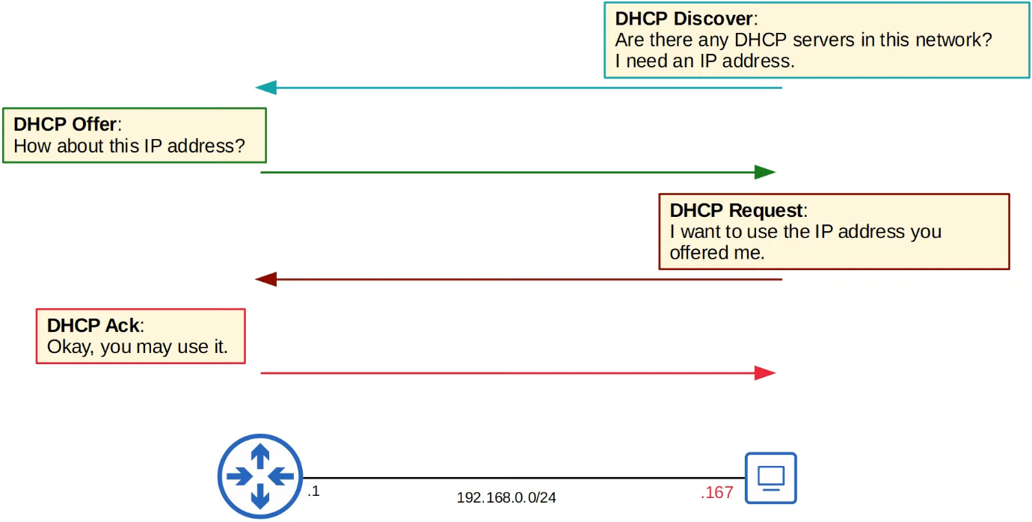

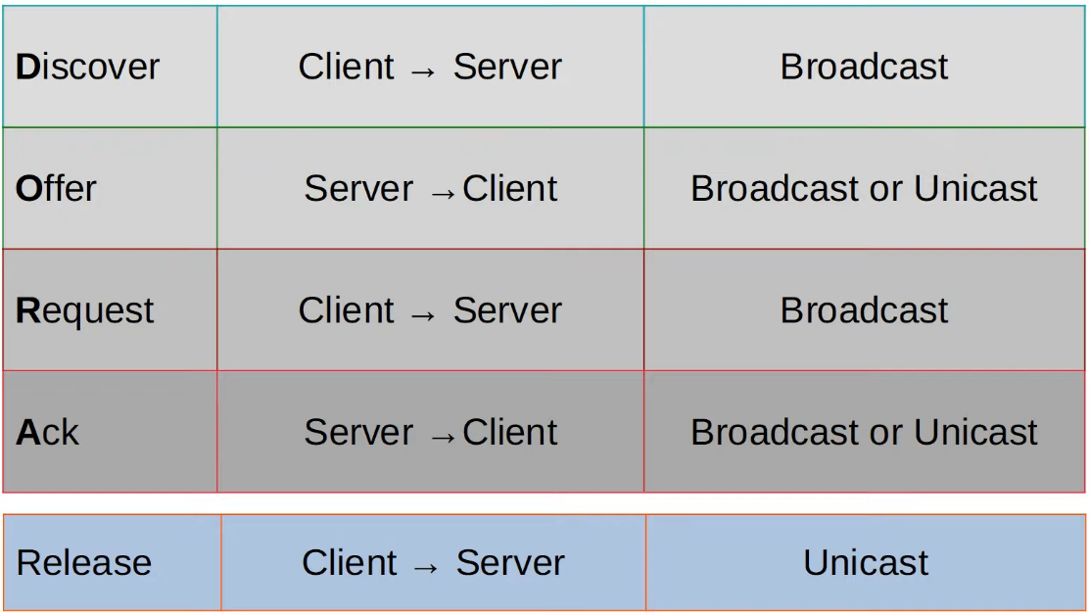

**DHCP Relay**

* Some network engineers might choose to configure each router to act as the DHCP server for its connected LANs
* However, large enterprises often choose to use a centralized DHCP server
* If the server is centralized, it won't receive the DHCP clients' broadcast messages
* To fix this, you can configure a router to act as a DHCP relay agent
* The router will forward the clients broadcast DHCP messages to the remote DHCP server as a unicast message

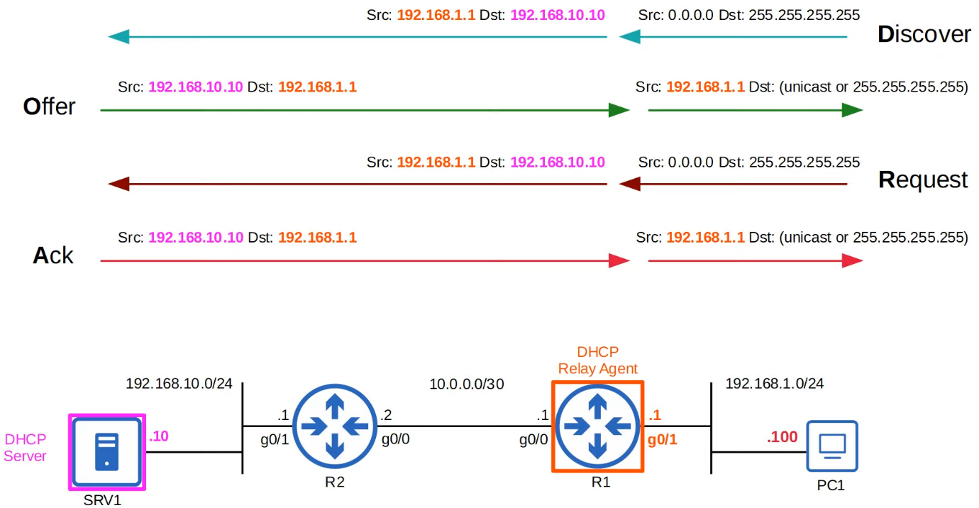

**Config**

**DHCP Server**

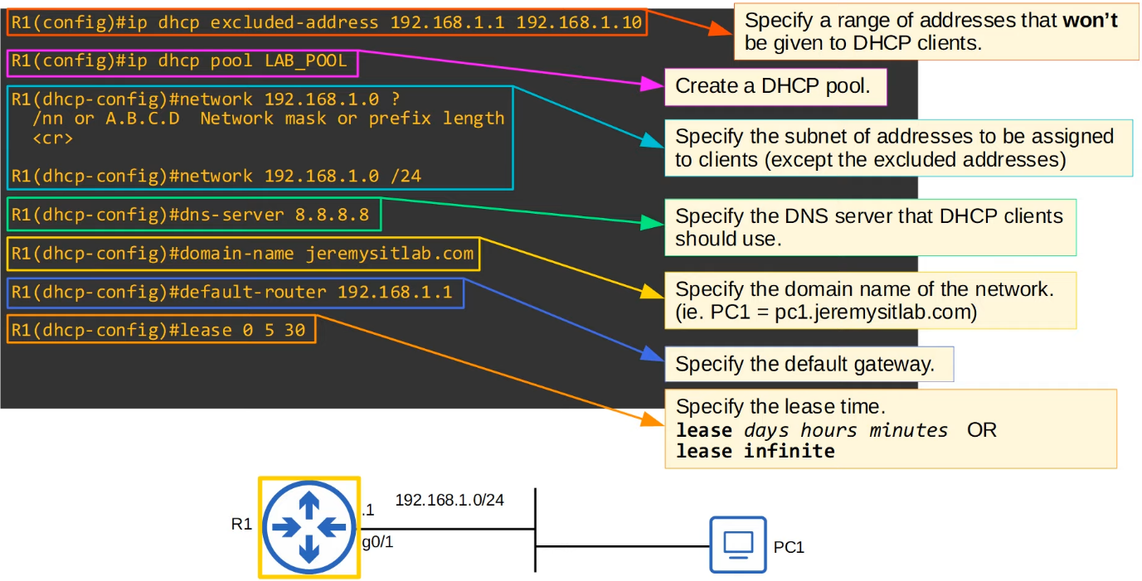

* DHCP pool
  + A subnet of addresses that can be assigned to DHCP clients and other info such as DNS server and default gateway
  + Should create a separate DHCP pool for each network the router is acting as a DHCP server

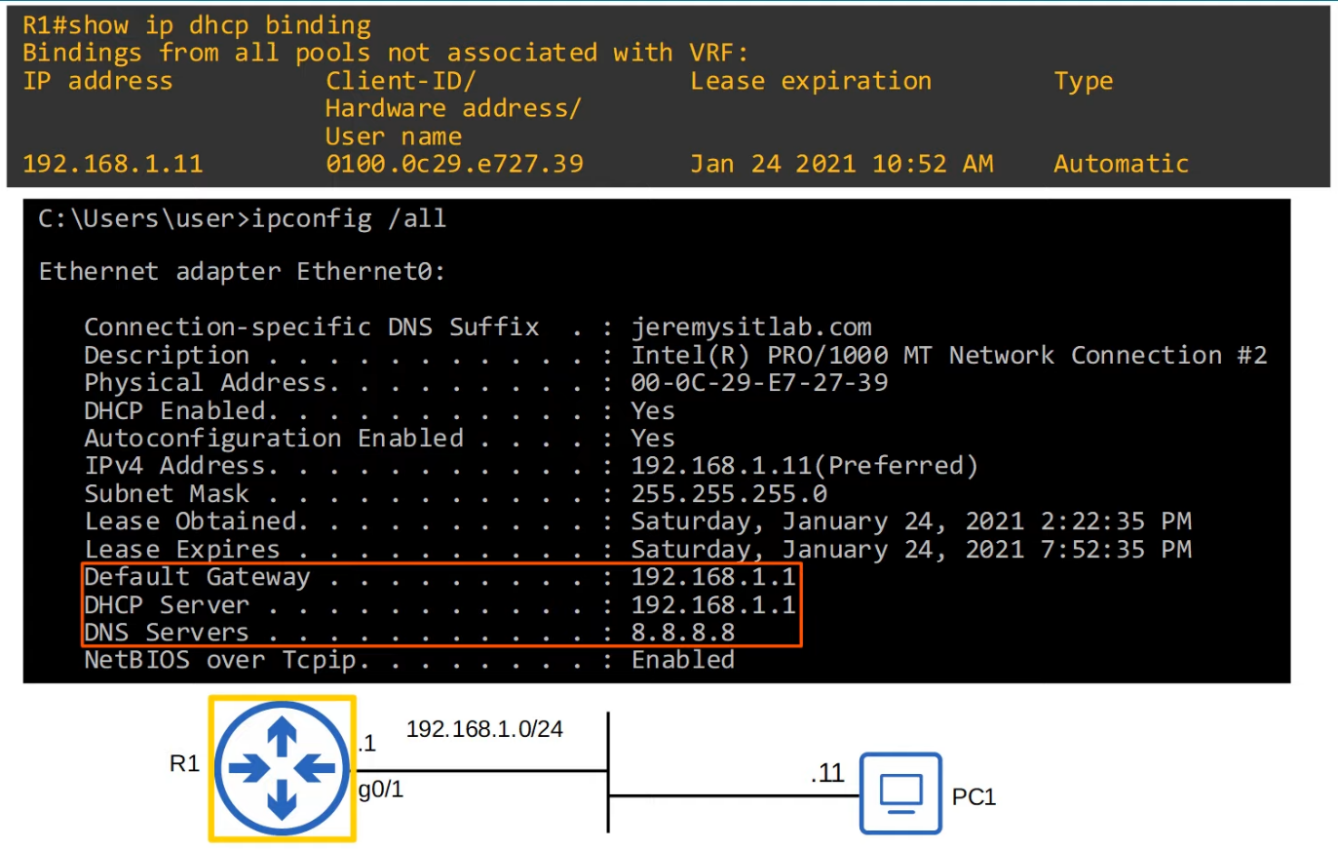

**DHCP Relay Agent**

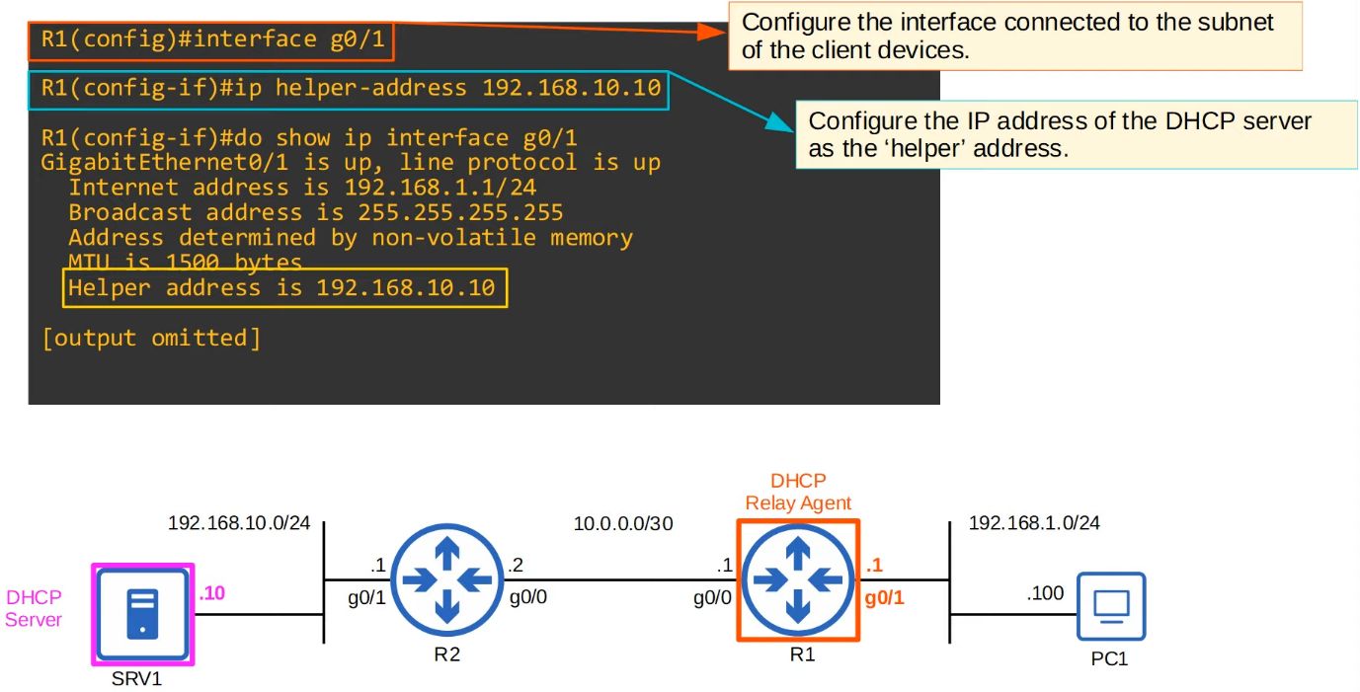

**DHCP Client**

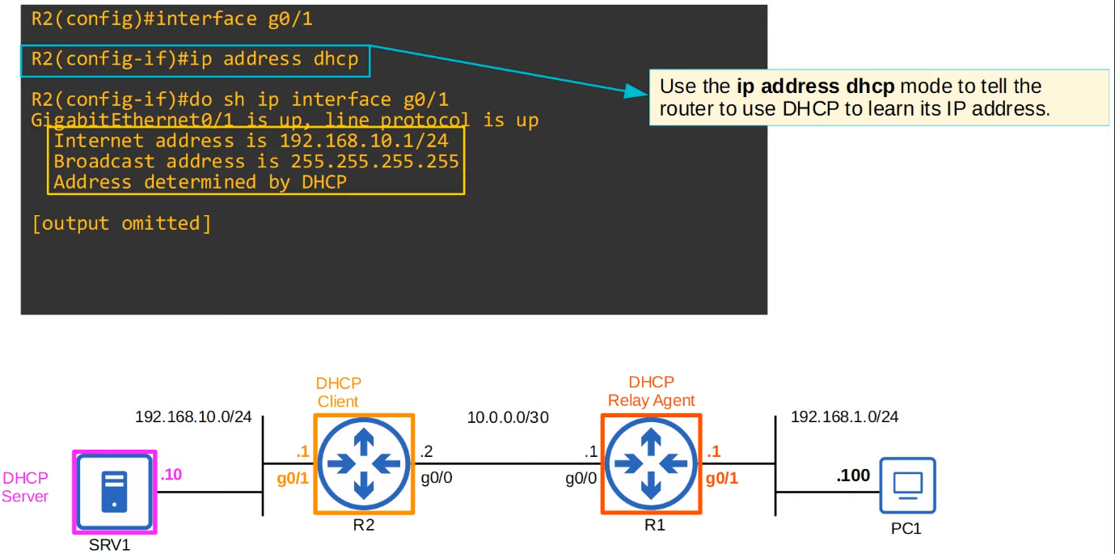

**Summary**

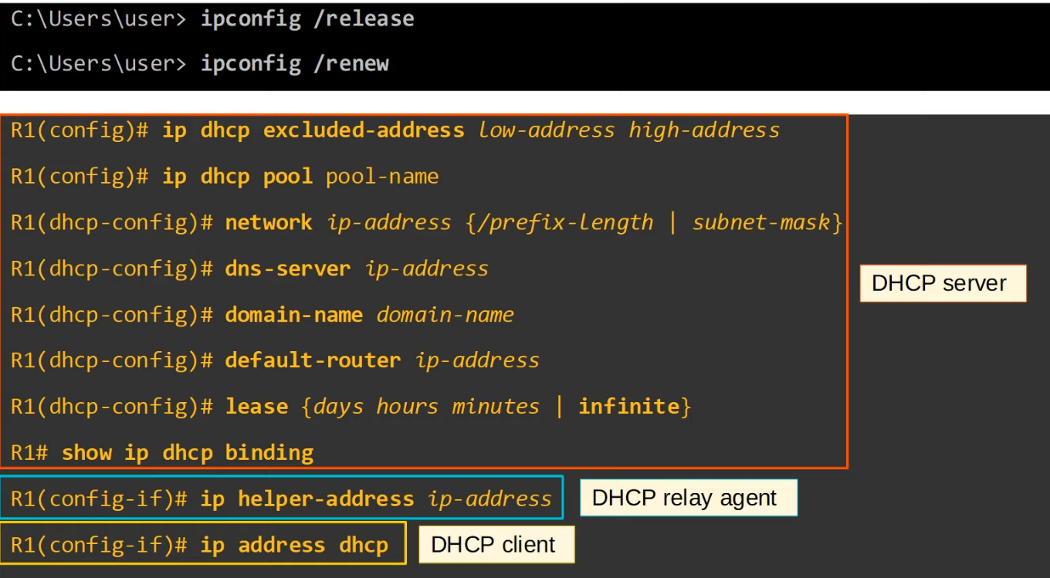

# Simple Network Management Protocol (SNMP)

Things covered

* SNMP overview
* SNMP versions
* SNMP messages
* Config

SNMP (Simple Network Management Protocol)

* SNMP is an industry-standard framework and protocol that was originally released in 1988
* SNMP can be used to monitor the status of devices, make configuration changes, etc
* There are 2 main type of devices in SNMP
  + Managed Devices
    - These are devices being managed using SNMP
    - E.g. Network devices like routers and switches
  + Network Management Station (NMS)
    - The device(s) managing the managed devices
    - This is the SNMP 'server'

**SNMP Operations**

* There are 3 main operations used in SNMP
  1. Managed devices can notify the NMS of events
  2. The NMS can ask the managed devices for information about their current status
  3. The NMS can tell the managed devices to change aspects of their configuration

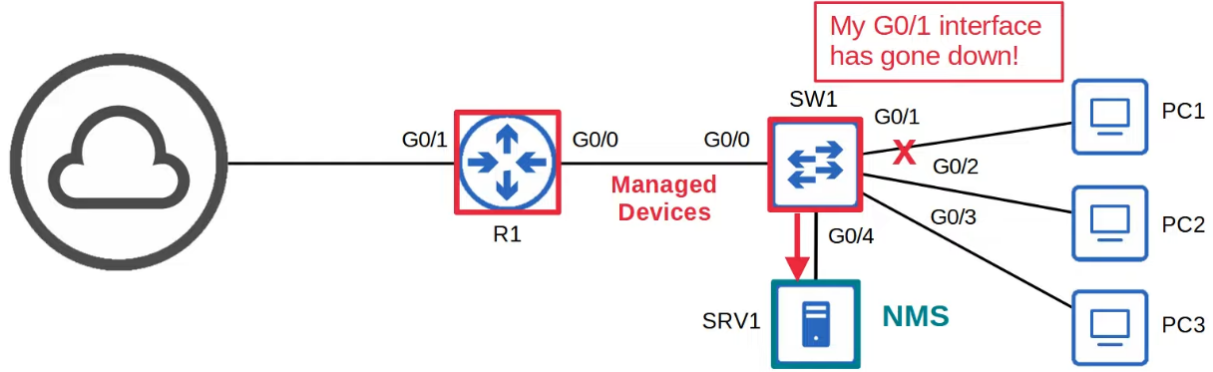

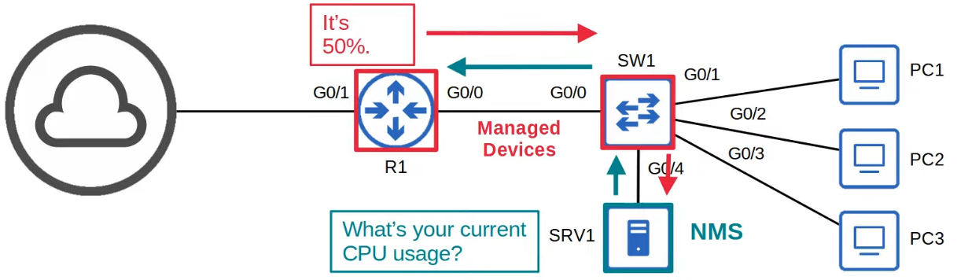

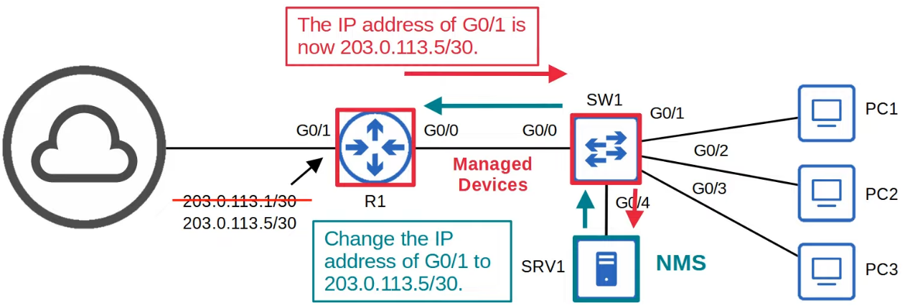

**SNMP Components**

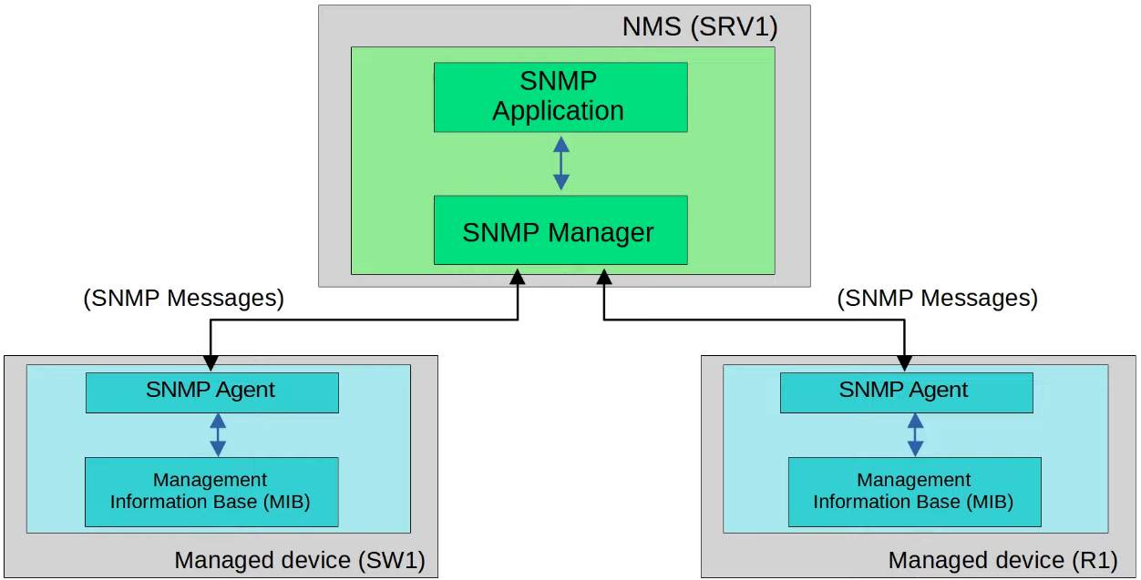

* NMS (SRV1)
  + SNMP Manager
    - The software on the NMS that interacts with the managed devices
    - It receives notifications, sends requests for information, sends configuration changes, etc
  + SNMP Application
    - Provides an interface for the network admin to interact with
    - Display alerts, statistics, charts, etc
* Managed Devices (SW1, R1)
  + SNMP Agent
    - The SNMP software running on the managed devices that interacts with the SNMP Manager on the NMS
    - It sends notifications to/receive messages from the NMS
  + Management Information Base (MIB)
    - The structure that contains the variables that are managed by SNMP
    - Each variable is identified with an object ID (OID)
    - Example variables: Interface status, traffic throughput, CPU usage, temperature, etc

**SNMP OIDs**

* SNMP Object IDs are organized in a hierarchical structure

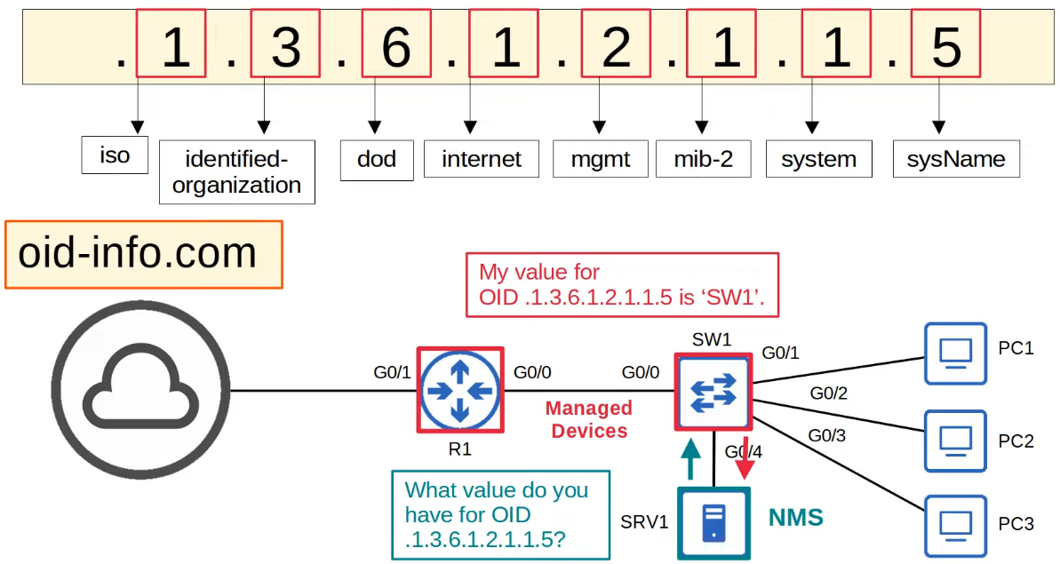

**SNMP Versions**

* Many versions of SNMP have been proposed/developed, however, only 3 major versions have achieved wide-spread use
* SNMPv1
  + Original version of SNMP
* SNMPv2c
  + Allow the NMS to retrieve large amounts of information in a single request, so it is more efficient
  + 'c' refers to the 'community strings' used as passwords in SNMPv1, removed in SNMPv2, and then added back for SNMPv2c
* SNMPv3
  + A much more secure version of SNMP that supports strong encryption and authentication
  + Should be used whenever possible

**SNMP Messages**

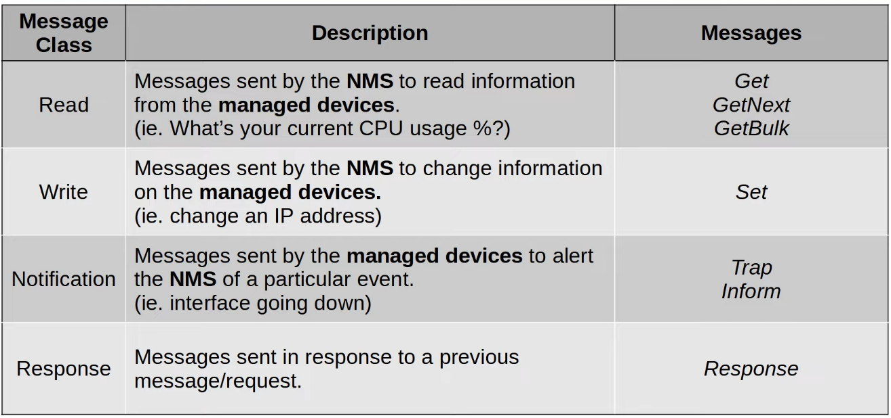

* Read
  + Get
    - A request sent from the manager to the agent to retrieve the value of a variable (OID), or multiple variables
    - The agent will send a Response message with the current value of each variable
  + GetNext
    - A request sent from the manager to the agent to discover the available variables in the MIB
    - Gets the next element from the MIB
  + GetBulk
    - A more efficient version of the GetNext message (introduced in SNMPv2)
* Write
  + Set
    - A request sent from the manager to the agent to change the value of one or more variables
    - The agent will send a Response message with the new values
* Notification
  + Trap
    - A notification sent from the agent to the manager
    - The manager does not send a Response message to acknowledge that it received the Trap, so these messages are 'unreliable'
  + Inform
    - A notification message that is acknowledged with a Response message
    - Originally used for communications btw managers, but later updates allow agents to send inform messages to managers

* Port Numbers
  + SNMP Agent = UDP 161
  + SNMP Manager = UDP 162

**SNMPv2c Config**

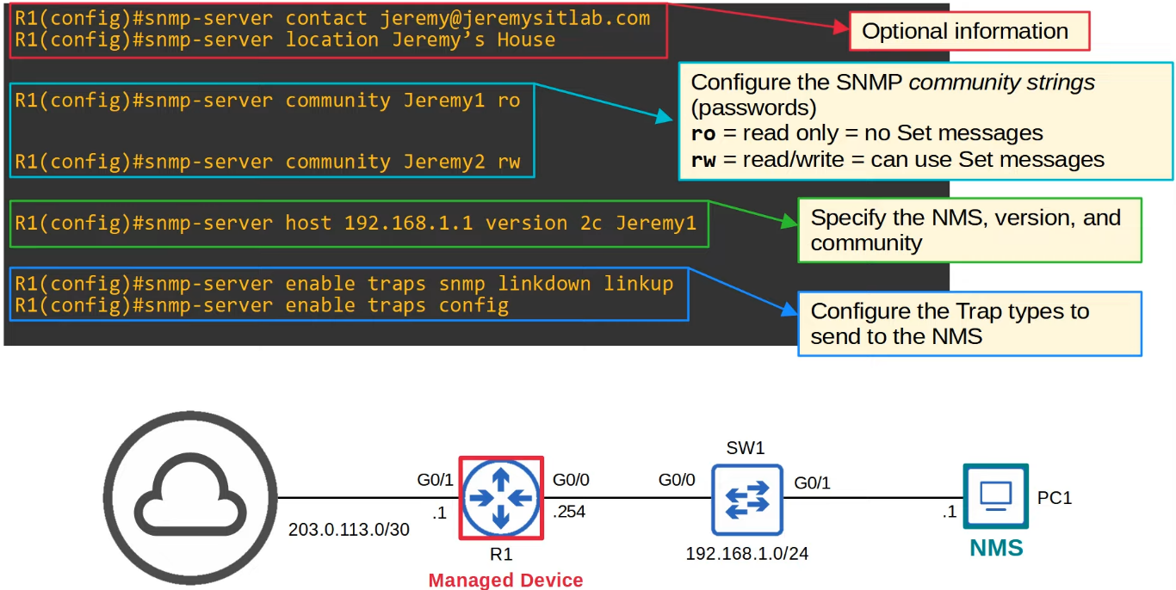

**Wireshark Capture**

* Link btw R1 and internet down

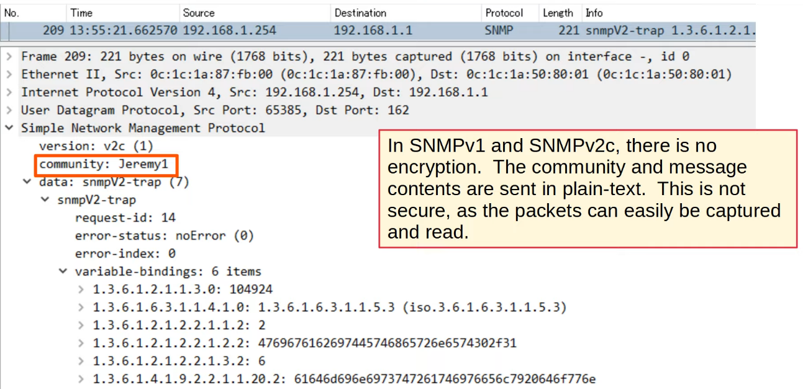

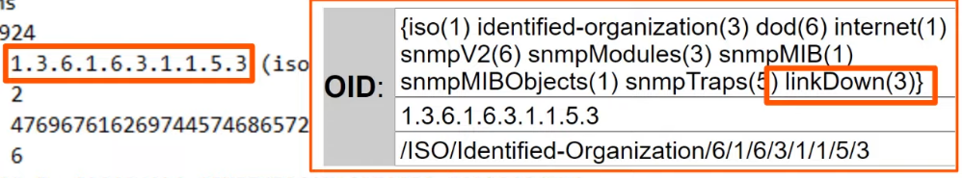

**Summary**

* SNMP help manage devices over a network
* Managed devices
  + Devices being managed using SNMP (e.g. network devices - routers, switches)
* Network Management Stations (NMS)
  + SNMP 'servers' that manage devices
  + Receive notifications from managed devices
  + Changes settings on managed devices
  + Check status of managed devices
* Variables are stored in the Management Information Base (MIB) and identified using Object IDs (OID)
* Main versions
  + SNMPv1
  + SNMPv2c
  + SNMPv3
* SNMP messages
  + Get
  + GetNext
  + GetBulk
  + Set
  + Trap
  + Inform
  + Response